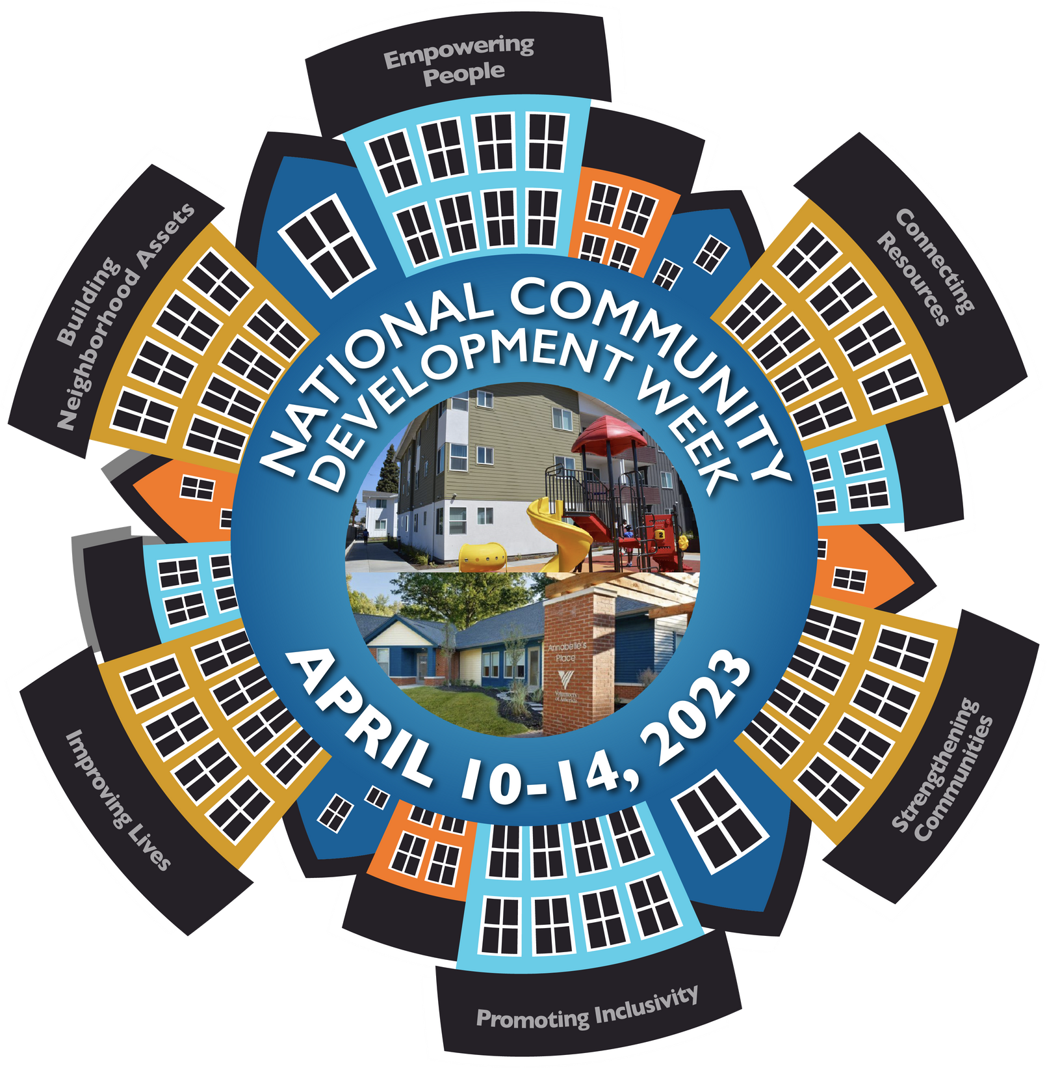
CDBG COALITION
NATIONAL COMMUNITY DEVELOPMENT WEEK

TOOL KIT

#CDWEEK2023

#CDBGWORKS

The 2023 National Community Development (CD)

Week will be celebrated April 10-14.
This tool kit is designed to help communities

in the planning of their National Community

Development Week activities.

This Tool Kit was designed and developed

by the National Community Development Association

for the CDBG Coalition.
WHY NATIONAL COMMUNITY DEVELOPMENT WEEK?
National Community Development Week was created in 1986 to bring national attention to the CDBG Program through grassroots support at a time when the program was facing scrutiny by Congress. The main objective of National Community Development Week is the education of Congressional members on the importance of CDBG, its impact and the need for increased program funding. National Community Development Week is intentionally held during the Congressional appropriations process so that the significance of CDBG can be imparted to Congressional members through local activities conducted by grantees and program partners at the grassroots level.
National Community Development Week will be held April 10-14, 2023. This is a critical time for appropriations; work on the upcoming FY 2024 HUD funding bill will be in the initial stages. National Community Development Week provides the perfect opportunity to cement the importance of CDBG in the minds of those in Washington to increase program funding.
Start planning your activities immediately. We ask you to go beyond the issuance of a proclamation this year and focus on engaging your Congressional members more fully during National Community Development Week. This engagement could be a meeting, a projects tour, or other activity that directly affords Congressional offices the opportunity to learn about the program and see firsthand how the funds are being used. Highlighting the work that occurs with CDBG dollars in your community creates a tangible connection for lawmakers between the funding they appropriate for the program and improvements to their states and districts. Congressional members like to hear directly from the organizations or people the program serves. If possible, put a face to your program by including beneficiaries and subrecipients in your activities.
Now is the time to reach out to your Congressional offices to make sure National Community Development Week is on their schedule. To contact your Congressional members, please use the links below.
U.S. House of Representatives
https://www.house.gov/representatives/find-your-representative
United States Senate https://www.senate.gov/senators/senators-contact.htm?Class=1
GOALS OF NATIONAL COMMUNITY DEVELOPMENT WEEK
MARKETING IS KEY!
Increase awareness
of the impact of the CDBG program through engagement and
education.
Organize
events that showcase CDBG-funded projects.
Involve
lawmakers, program partners, and local media in your events.
Market and amplify
your events early and often through a variety of advertising.

Proclaim, announce, promote National Community Development Week! Advertising and
promotion are critical to a successful National Community Development Week. Most
importantly, market National Community Development Week early and often throughout
your community. Use a variety of methods to reach all stakeholders – social media, print
media, radio, television, and the internet. Reach out to Congressional offices early to
guarantee their participation in your events.
NATIONAL COMMUNITY DEVELOPMENT WEEK ACTIVITIES
How program funds are invested in the community to meet critical needs and leverage
resources.
The need for more program resources.
National Community Development Week is designed to focus local as well as national
attention on the CDBG program. Public support and involvement from Congressional
offices, local and state elected officials, program subrecipients, media, community
leaders, and program beneficiaries in National Community Development Week is
important.

In whatever activities you choose, make sure to reiterate the following key
points.
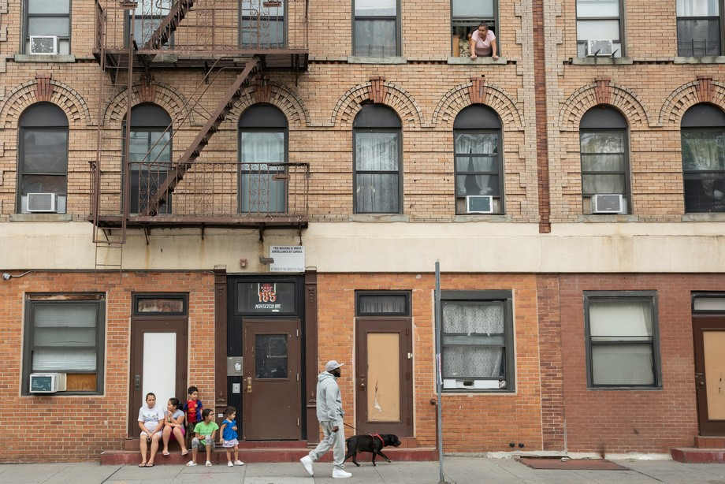
ISSUE A PRESS RELEASE

SPOTLIGHT: JERSEY CITY (NJ) 2022 PRESS RELEASE
Issue a press release announcing National Community Development Week. The press
release should include information on program impact, planned activities, and even
quotes from local dignitaries, such as the mayor or other elected officials. Again,
marketing is key to a successful National Community Development Week. Share the press
release with local media outlets and congressional offices.
Mayor Fulop & Community Development Host
Community Workshops to Mark National Community
Development Week
Tuesday, April 12, 2022

Mary McLeod Bethune Life Center
Wednesday, April 13, 2022

Hudson County Community College
Thursday, April 14, 2022

Pershing Field Community Center
JERSEY CITY – Mayor Steven M. Fulop and the Division of Community

Development (DCD) announce today that Jersey City will join communities

across the nation in honor of National Community Development Week,

April 11-15. All this week, the City will host resource fairs at multiple locations

to inform the community on how and where federal funds are being utilized to

assist low- and moderate-income residents.

The DCD funds a variety of community organizations that provide crucial services with a goal of strengthening
Jersey City through fostering strong partnerships and responsibly investing resources into the community.
Affordable housing, sustainable living environments, public spaces, public services, and expanded economic
opportunities are at the forefront of the City’s mission.

“As an administration, we strive to further develop Jersey City as a viable community by promoting integrated
approaches that focus on the community’s direct needs,” said Mayor Fulop. “We are incredibly grateful for the
Community Development Block Grants we have received over the years, which have bolstered our efforts in
supporting our most vulnerable residents.”

National Community Development Week aims to bring awareness to the powerful work already underway and
to educate the public on future opportunities as these efforts build stronger communities.

Jersey City’s Resource Fairs are free and open to the public from 2 p.m. to 6 p.m. on the following dates:
“Countless people in our community have benefited from these projects – the majority of whom are low- and
moderate-income persons,” said Deja Anderson, Director of the Division of Community Development. “With
the support of the community, influential stakeholders, and elected officials, we can build a better
community!”

Community Development Block Grant (CDBG) funds touch various community efforts such as providing rental
assistance during the pandemic, finding temporary housing for households displaced after a fire, supporting
workforce development, and assisting countless small businesses. CDBG is a versatile funding source that
helps revitalize our neighborhoods and improve our citizens’ lives.

NATIONAL COMMUNITY DEVELOPMENT WEEK

PROCLAMATION
SPOTLIGHT: CITY OF QUINCY (MA) 2022 PROCLAMATION
Follow-up the press release with the passage of a National Community Development
Week proclamation by your local elected body. Send the press release and proclamation
to local media outlets and to your Congressional delegation. This activity requires minimal
effort and can be undertaken by every grantee. Some communities also hold special
ceremonies or press briefings to announce the passage of the proclamation to gain further
media attention for National Community Development Week.

Whereas
, the
Community Development Block Grant (CDBG)
Program has existed since 1975 to
provide local governments with the resources to develop viable urban communities by providing decent
affordable housing and a suitable living environment, and expanding economic opportunities, principally
for persons of low and moderate income;
Whereas
, the
Community Development Block Grant (CDBG)
Program has strengthened
America’s communities such as the City of Quincy by addressing pressing neighborhood and human
service needs and having significant impact on our local economies through job creation and retention,
physical redevelopment, and improved local tax base;
Whereas
, the City of Quincy,Massachusetts has effectively administered and customized its
Community Development Block Grant (CDBG)
Program for over forty years to implement various
programs and projects in the areas of affordable housing, economic development, public facilities and
public works improvements, homelessness, and planning that has contributed to the improvement of the
physical, economic, and social conditions in our City;
Now Therefore
, I,
Thomas P. Koch
, by virtue of the authority vested in me as Mayor of the City of
Quincy, do hereby proclaim that the week of
April 11-15, 2022
, to be:
Community Development Week
And urge all citizens to join us in recognizing Community Development Programs and the important role
that they play in our community.
In witness Whereof
, I have hereunto set my hand and caused the
seal of the City of Quincy, Massachusetts to be fixed this 11th day of April 2022.
THOMAS P. KOCH, MAYOR
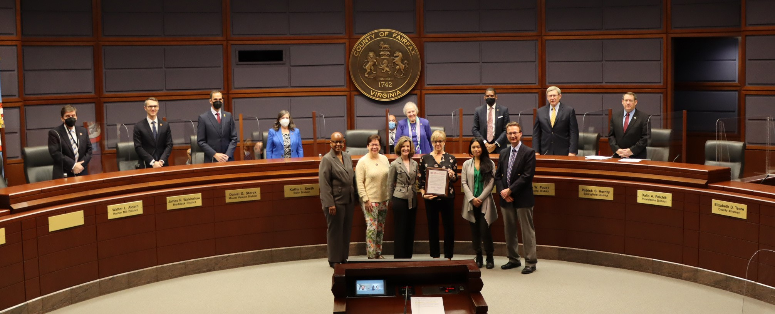
SPOTLIGHT: FAIRFAX COUNTY (VA) 2022 PROCLAMATION
COUNTY SUPERVISORS PROCLAIM APRIL 11-15 COMMUNITY DEVELOPMENT WEEK

IN FAIRFAX COUNTY

WHEREAS, April 11-15 has been designated National Community Development Week to celebrate the
federal Community Development Block Grant program now in its 47th year and the HOME Investment
Partnerships Program now in its 30th year; and
WHEREAS, Fairfax County has received over $284 million from the CDBG program over the past 47
years and $65 million from the HOME program over the past 30 years, supporting the development of
affordable housing benefiting low- to moderate-income individuals and households, including older
adults, people with disabilities, those experiencing chronic or frequent homelessness, and children; and
WHEREAS, the Community Development Block Grant and the HOME Investment Partnerships Program
foster a strong network among local government, residents, businesses and nonprofit organizations
working to meet the needs of Fairfax County residents; and
WHEREAS, Fairfax County received $8.36 million in additional program funding in fiscal years 2020 and
2021
to prevent, prepare for and respond to COVID-19, including the provision of emergency rent and
utility assistance for families who have lost income, and funding nonprofit partners to enable the
continued provision of vital public services;
WHEREAS, Fairfax County received $7.88 million in additional program funding in fiscal year 2022 to
provide housing, supportive services, and shelter to individuals experiencing homelessness, as well as
other vulnerable populations;
NOW, THEREFORE BE IT RESOLVED, that the Fairfax County Board of Supervisors, on behalf of all
residents of Fairfax County, does hereby designate April 11-15, 2022, as NATIONAL COMMUNITY
DEVELOPMENT WEEK
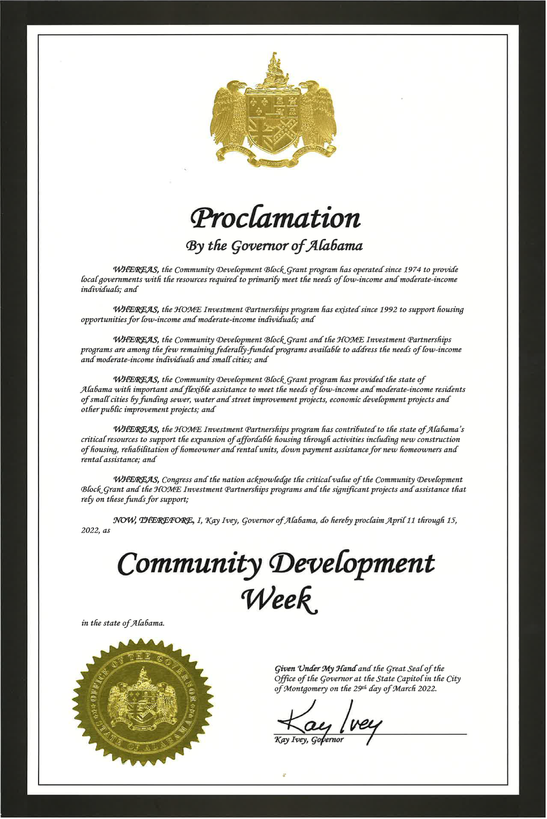
SPOTLIGHT: STATE OF ALABAMA 2022 PROCLAMATION
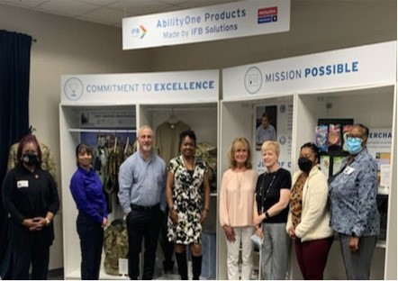
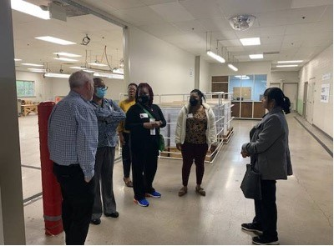
MEET WITH YOUR CONGRESSIONAL DELEGATION

SPOTLIGHT: CITY OF LITTLE ROCK (AR) HOSTS 2022 NATIONAL
COMMUNITY DEVELOPMENT WEEK KICK-OFF EVENT WITH A
REPRESENTATIVE FROM CONGRESSMAN FRENCH HILL’S OFFICE
This year, we are asking all communities that receive CDBG funding to schedule a meeting
with their Congressional offices. Meeting with your Congressional members or their staff is
the most effective way of supporting the CDBG program since it affords Congressional
members the opportunity to hear first-hand how the funds are being used. Highlighting the
work that occurs with CDBG dollars in your community creates a tangible connection for
lawmakers between the funding they appropriate for the program and improvements to
their states and districts. Events like National Community Development Week attract
positive attention and publicity for CDBG, which when shared with your lawmakers, is
instrumental in creating the next generation of CDBG champions on Capitol Hill.
Congressional members like to hear directly from the organizations or people the
program serves. If possible, put a face to your program by including beneficiaries and
subrecipients in the meeting.

Kickoff event at IFB Solutions with a representative from Congressman French Hill’s office.
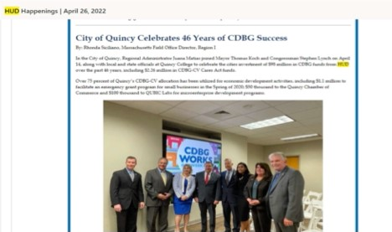
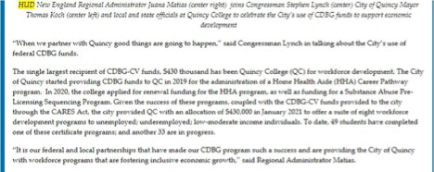
SPOTLIGHT: CITY OF QUINCY (MA) MEETS WITH CONGRESSMAN
STEPHEN LYNCH DURING 2022 NATIONAL COMMUNITY
DEVELOPMENT WEEK

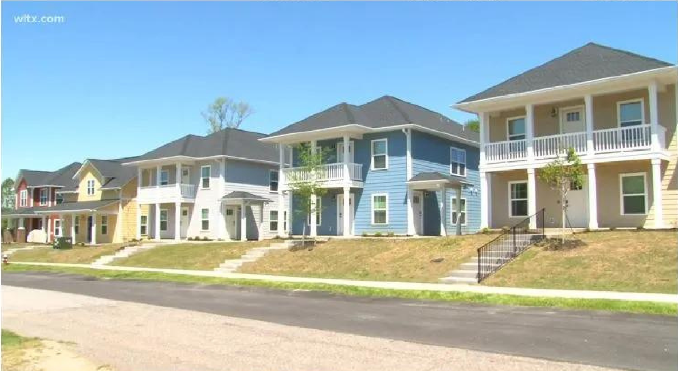
If your Congressional member or their staff are not available to meet during National
Community Development Week, then consider sending them a short YouTube video (no
more than 5 minutes) that shows recently funded/completed CDBG activities and outlines
your program accomplishments in the video remarks. Make sure to include program
beneficiaries in your meetings and videos to provide testimonials on the benefits of the
program. Creating a video in-house using YouTube is an economical and easy method of
documenting your National Community Development Week activities and sharing it with
local media and Congressional offices.

TOUR LOCAL PROJECTS
Invite Congressional offices to tour local projects. Select projects that positively
showcase the programs.

Tip:
Develop a written project description to hand out during the projects tour.
SPOTLIGHT: CITY OF COLUMBIA, SC
Last year, the Columbia (SC) Department of Community Development
hosted a
g
rand o
penin
g
of

Edisto Place to showcase a new affordable housing community during National Community
Development Week.

Tip:
Invite local media to cover your National Community Development Week events.
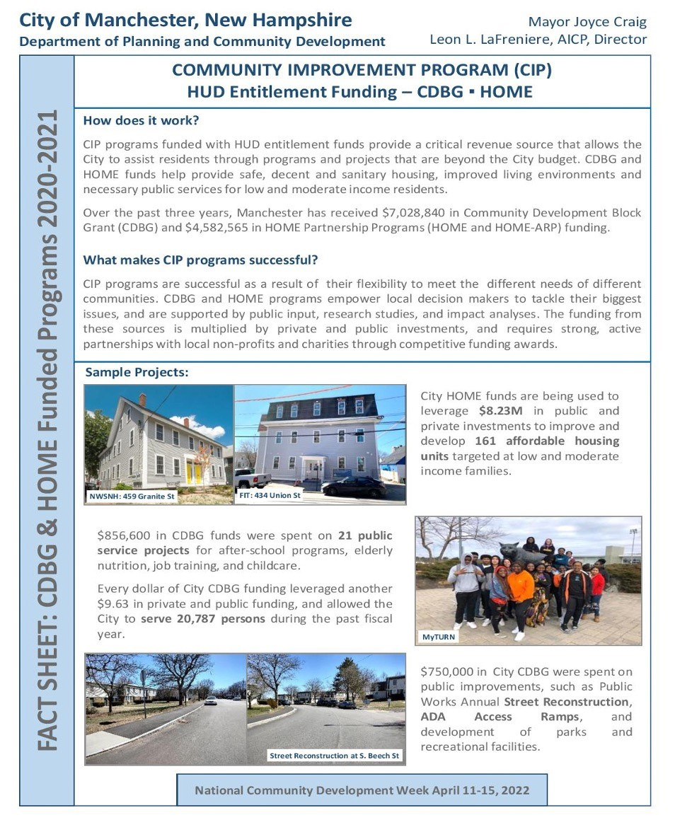
DEVELOP A PROGRAM FACT SHEET
Develop a fact sheet that outlines program accomplishments.

SPOTLIGHT: MANCHESTER (NH) FACT SHEET
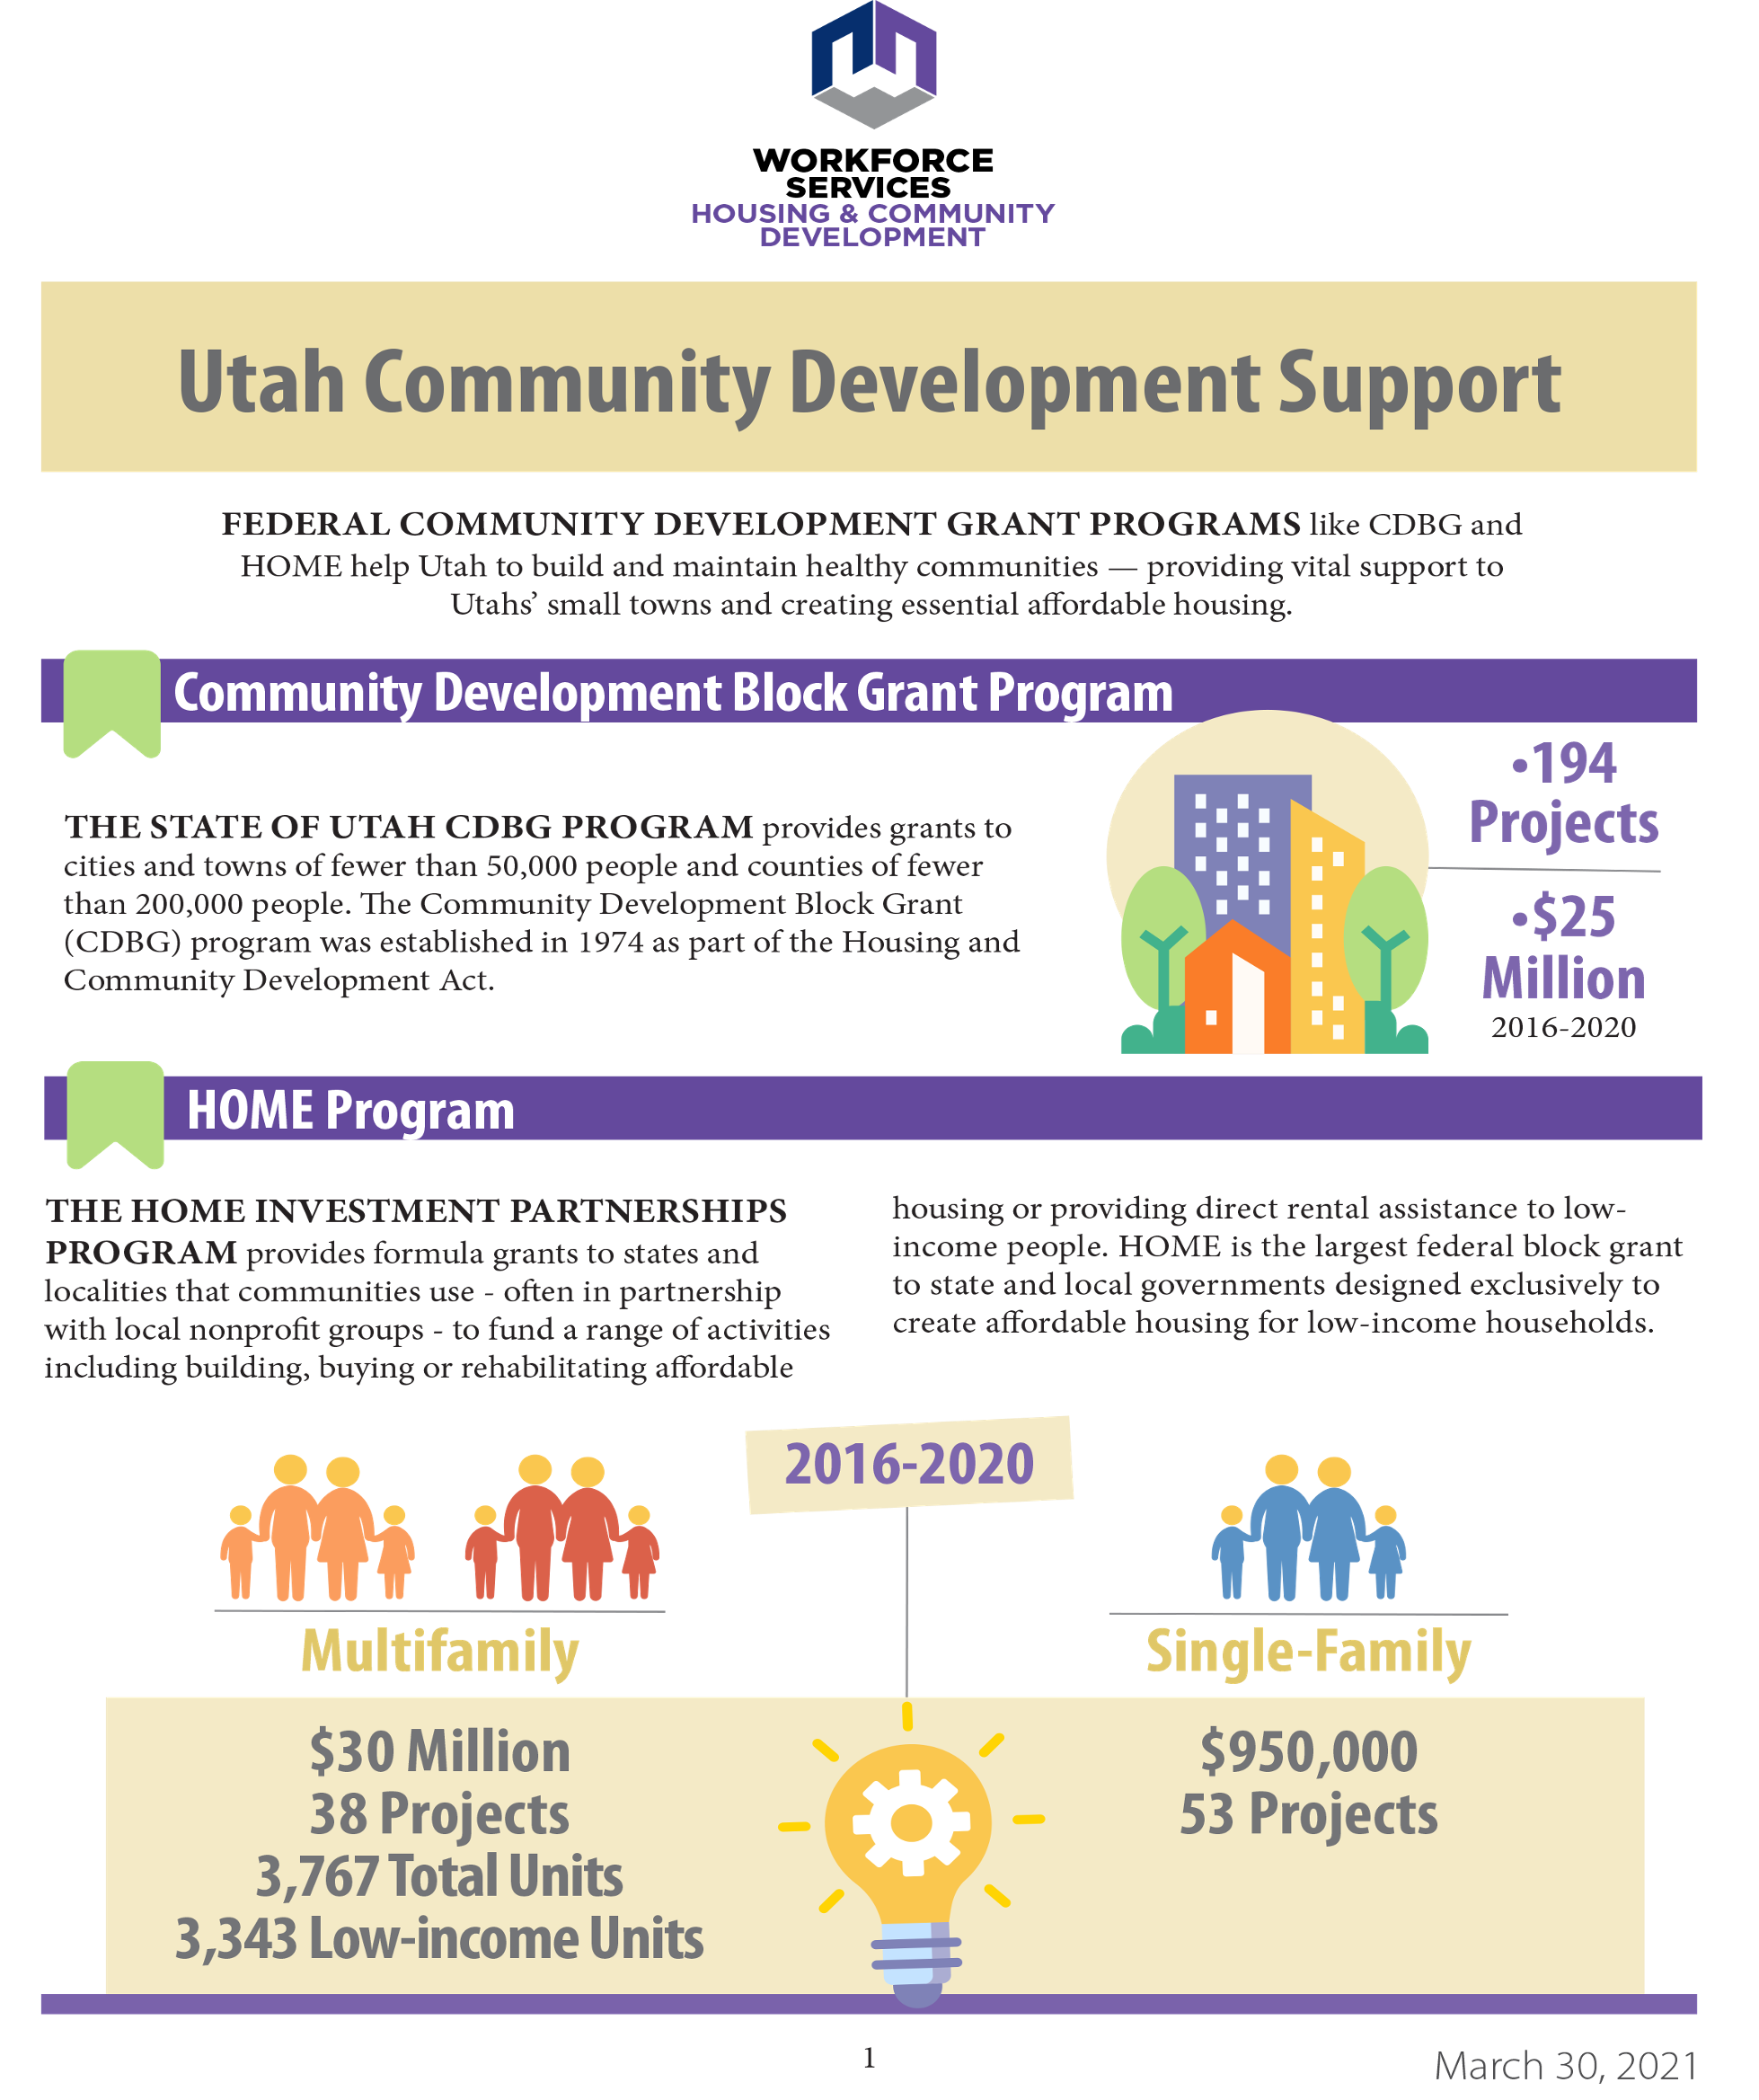
SPOTLIGHT: STATE OF UTAH FACT SHEET
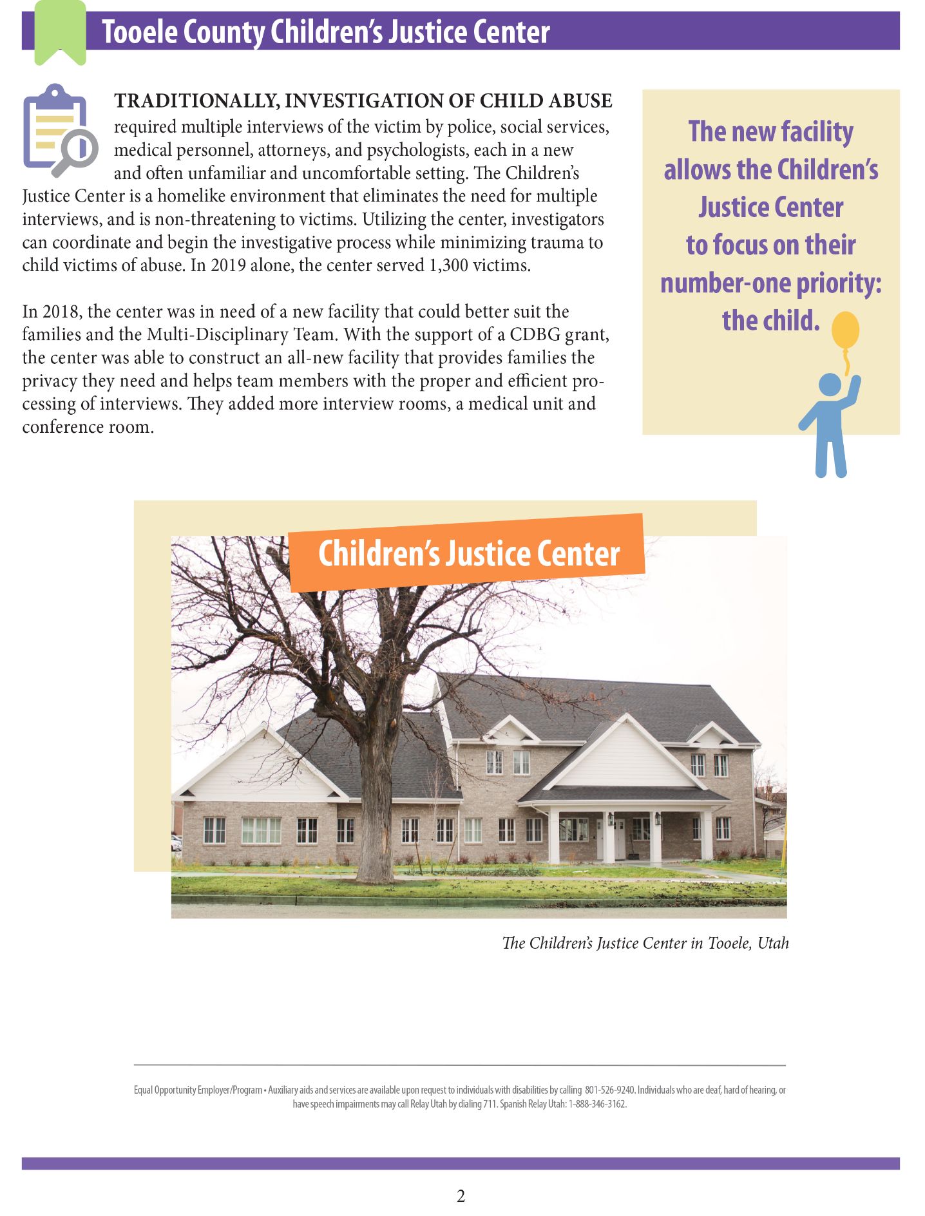
SPOTLIGHT: STATE OF UTAH FACT SHEET
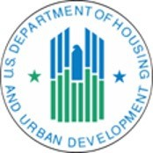
FACT SHEET:
National Community Development Week

The week of April 11 through April 15 is National Community Development Week, a time to highlight the
importance of the U.S. Department of Housing and Urban Development’s (HUD) Community
Development Block Grant (CDBG) and HOME Investment Partnerships (HOME) programs to building
strong, resilient, and vibrant communities across America. CDBG and HOME provide grants to states and
local governments to strengthen communities by delivering equitable access to decent housing and
living environments and expanding economic opportunities. These programs are unique in that they
focus primarily on people with low and moderate incomes. CDBG and HOME also play a critical role in
empowering residents by giving them a voice in the future of their neighborhoods. HUD and the Biden-
Harris Administration remain committed to building stronger and more resilient communities across
America through CDBG and HOME.
CDBG and HOME Have a Record of Success in Lifting Up Underserved Communities
CDBG and HOME increase the availability of safe, high quality, and affordable homes and communities,
ensuring equitable access to opportunities and benefiting families and communities.
CDBG and HOME have:
Provided grants to state and local governments.
In 2021, the CDBG program provided grants to
1
,235 state and local governments.
Rehabilitated housing and strengthened access to public services.
Since 2005, the CDBG
program has rehabilitated 1,300,027 units of housing, funded public infrastructure projects that have
assisted over 16 million people, and assisted over 161 million people with public services.
Expanded affordable housing.
Since 1992, the HOME program has created over 1.3 million
affordable homes and provided direct rental assistance to more than 363 thousand low-income families.
Provided Sources of Low-Cost, Long-Term Financing for Economic and Community
Development Projects.
In 2021, HUD marked over 2 thousand commitments through the CDBG
Section 108 Loan Guarantee program. The program allows local governments to leverage five times their
current CDBG grant into federally guaranteed loans large enough to pursue physical and economic
revitalization projects capable of redeveloping entire neighborhoods. The Section 108 program
primarily benefits low- and moderate-income communities.
SPOTLIGHT: HUD 2022 NATIONAL COMMUNITY DEVELOPMENT WEEK
FACT SHEET

INVOLVE PROGRAM PARTNERS AND BENEFICIARIES
The CDBG story cannot be told without the participation of the program subrecipients who help administer the program locally and without the program beneficiaries who are the direct recipients of the funding. Subrecipients and program beneficiaries are on the front lines providing and receiving CDBG assistance. They are essential to telling the CDBG story. Because of their connection to the program, they need to be part of National Community Development Week. Put a face on your programs by including beneficiaries and subrecipients in your National Community Development Week events.

SOCIAL MEDIA GUIDANCE
National Community Development Week, April 10-14, 2023 #CDWeek2023, #CDBGworks
Importance of the # (Hashtag) - #CDWeek2023, #CDBGworks
Hashtags (#) label posts for ease of searching for social media content by topic. This increases the chances of engagement with others who are posting about the same topic.
Engagement drives reach. The more reach the posts have, the more “return on investment” of the time staff is putting into social media posting.

Practical Applications
Use social media to “call to action” such as asking followers to call legislators about CDBG funding in the Federal budget.
Share exciting stories in more than one format. Give readers more than a headline by writing a blog article. Share more than one photo per post to give viewers a broader perspective of the story behind the post.
Cross-reference and utilize multiple media channels. Post links or photos of newspaper articles. Include event registration links in press release or in posts if applicable. Be aware of formatting content appropriate to each platform. Make yourself familiar with each platform and how they are different.
Post familiar faces. Include photos of Mayor, other dignitaries, and participants. Use photo release for children under 18.
Engage with individuals and organizations both in person and online. Engage with other pages to drive engagement on your page. Make the request for individuals and organizations to participate in the social media campaign and provide guidance. Consider enhanced content options such as podcasts, recorded videos, live streaming, infographics, and blogs.
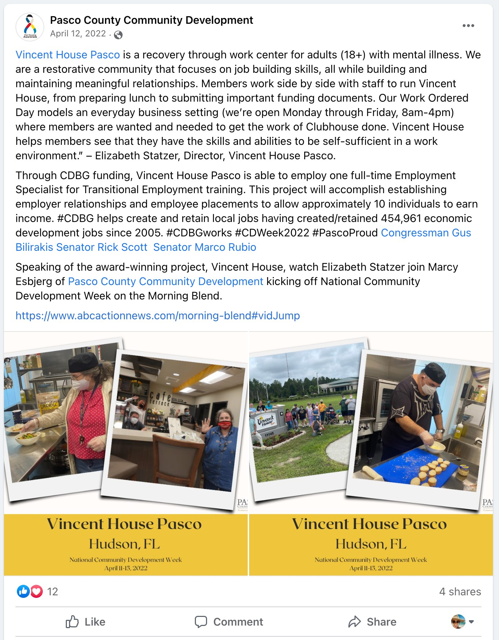
SOCIAL MEDIA SPOTLIGHT: PASCO COUNTY, FL
Keep your personal and your organization voice separate. Interact between the two
accounts if comfortable. For example, like and share the organization content as
yourself. Be aware of privacy settings. (Boilerplate: “Postings on this site are my own
and do not reflect or represent the opinions of agency for which I work.”) Do not use
your government email address for personal accounts, for various reasons.

Review agency social media policy, seek required communication reviews, permission
to disclose public information, and permission to tag.

Participate in live events (such as Twitter Chats or Facebook Live). Join or start a
group. Tweet and share using relevant hashtags. Be a thought leader.
Advice on Personal Branding

NATIONAL COMMUNITY DEVELOPMENT WEEK

AND BEYOND: MEETING AND CORRESPONDING

WITH YOUR CONGRESSIONAL MEMBERS

THROUGHOUT THE YEAR

Introductions
– introduce yourself.

Acknowledge
your Member of Congress (and their staff) and thank them for meeting
with you.

Present
your issues (e.g., importance of CDBG to your community; need for
increased funding). Bring CDBG-funded project examples. Discuss the impact of
CDBG in the community. Consider bringing a program beneficiary to the meeting to
share how CDBG-funded activities have impacted their life. Be prepared to answer
questions.

Follow-U
p
Follow-up the meeting with a thank-you email. Send along any additional
:
pertinent information and materials.

Meeting with a member of Congress, or Congressional staff, is a very effective way to
convey a message about a specific issue or legislative matter. It’s important to meet with
your Congressional members to inform them of the importance of CDBG in your
community.

A typical meeting should go as follows:

1
.
2
.
3
.
4
.

ADDRESSING CORRESPONDENCE:

To a Senator...

The Honorable (Full Name)

District Office Address

Dear Senator (Last Name):

To a Representative...

The Honorable (Full Name)

District Office Address

Dear Representative (Last Name):

CDBG COALITION
The CDBG Coalition thanks you for planning for and participating in National Community
Development Week, April 10-14, 2023.

CDBG Coalition

American Library Association
American Planning Association
Boys and Girls Clubs of America

Council of Large Public Housing Authorities

Council of State Community Development Agencies

Enterprise Community Partners
Feeding America

Habitat for Humanity International

Heartland Alliance

Housing Assistance Council
International Code Council
International Economic Development Council

KABOOM!
Local Initiatives Support Corporation

National Association for County Community and Economic Development

National Association for Latino Community Asset Builders

National Association of Counties

National Association of Development Organizations

National Association of Housing and Redevelopment Officials

National Association of Local Housing Finance Agencies

National Association of Regional Councils

National Community Development Association

National League of Cities
National Main Street Center
National NeighborWorks Association

National Recreation and Park Association

National Rural Water Association

National Urban League

Rebuilding Together

The Trust for Public Land
U.S. Conference of Mayors
YWCA USA

About the CDBG Coalition
The CDBG Coalition is dedicated to the preservation of the CDBG program. The Coalition works to
increase awareness of the program and the need for more program resources.

