REQUEST FOR PROPOSALS

for

ENVIRONMENTAL SERVICES

RFP #: 107140-058
Proposal Due Date/Time: 3:00 PM CDT, September 9, 2019

State of Louisiana
Division of Administration
Office of Community Development
Disaster Recovery Unit

August 7, 2019

Table of Contents

PART 1: ADMINISTRATIVE AND GENERAL INFORMATION 5
1.1 Purpose 5
1.2 Background 5
1.3 Goals and Objectives 6
1.4 Term of Contract 6
1.5 Definitions 6
1.6 Schedule of Events 7
1.7 Proposal Submittal 7
1.8 Qualification for Proposer 7
1.8.1 Mandatory Qualifications: 7
1.8.2 Desirable Qualifications: 8
1.9 Proposal Response Format 9
1.9.1 Cover Letter 9
1.9.2 Table of Contents 9
1.9.3 Executive Summary 9
1.9.4 Company Background and Experience 9
1.9.5 Approach and Methodology 10
1.9.6 Proposed Staff Qualifications 11
1.9.7 Cost Proposal 11
1.9.8 Certification Statement 13
1.9.9 Outsourcing of Key Internal Controls: 13
1.10 Number of Copies of Proposals 13
1.11 Technical and Cost Proposals 13
1.12 Legibility/Clarity 13
1.13 Confidential Information, Trade Secrets, and Proprietary Information 14
1.14 Proposal Clarifications Prior to Submittal 15
1.14.1 Pre-proposal Conference 15
1.14.2 Proposer Inquiries 15
1.14.3 Blackout Period 16
1.15 Error and Omissions in Proposal 17
1.16 Changes, Addenda, Withdrawals 17
1.17 Withdrawal of Proposal 17
1.18 Waiver of Administrative Informalities 17
1.19 Proposal Rejection/RFP Cancellation 17
1.20 Ownership of Proposal 17
1.21 Cost of Offer Preparation 17
1.22 Taxes 18
1.23 Determination of Responsibility 18
1.24 Prohibition ofJoint Ventures/Use of Subcontractors 18
1.25 Written or Oral Discussions/Presentations 19
1.26 Acceptance of Proposal Content 19
1.27 Evaluation and Selection 19
1.28 Contract Award and Execution 19
1.29 Notice of Intent to Award 20
1.30 Right to Prohibit Award 20
1.31 Insurance Requirements for Contractors 20
1.31.1 Contractor's Insurance 20
1.31.2 Minimum Scope and Limits of Insurance 21
1.31.3 Deductibles and Self-Insured Retentions 22
1.31.4 Other Insurance Provisions 22
1.31.5 Acceptability of Insurers 22
1.31.6 Verification of Coverage 23
1.31.7 Subcontractors 23
1.31.8 Workers Compensation Indemnity 23
1.32 Indemnification and Limitation of Liability 24
1.33 Payment 24
1.34 Termination 26
1.34.1 Termination of the Contract for Cause 26
1.34.2 Termination of the Contract for Convenience 26
1.34.3 Termination for Non-Appropriation of Funds 26
1.35 Assignment 27
1.36 Right to Audit 27
1.37 Civil Rights Compliance 27
1.38 Record Ownership 28
1.39 Entire Agreement/ Order of Precedence 28
1.40 Contract Modifications 28
1.41 Substitution of Personnel 28
1.42 Governing Law 28
1.43 Claims or Controversies 28
1.44 Code of Ethics 29
1.45 Corporate Requirements 29
1.46 Prohibition of Discriminatory Boycotts of Israel……………………………………………………………………..29
PART 2: SCOPE OF WORK/SERVICES 30
2.1 Scope of Work 30
2.2 Tasks and Services 30
2.3 Deliverables 33
2.4 Technical Requirements 34
2.5 Project Requirements 34
PART 3: EVALUATION 36
3.1 Technical Evaluation .36
3.2 Cost Evaluation...................................................................................................................37
PART 4: PERFORMANCE STANDARDS 38
4.1 Performance Requirements 38
4.2 Performance Measurement/Evaluation/Monitoring Plan 38
4.2.1 Performance Measures/Evaluation: 38
4.2.2 Monitoring Plan: 38
ATTACHMENT I: CERTIFICATION STATEMENT 39
ATTACHMENT II: SAMPLE CONTRACT 41
ATTACHMENT III: COST PROPOSAL TEMPLATE …...64
ATTACHMENT IV: TIER II SITE SPECIFIC REVIEW CHECKLIST……...............................................66
ATTACHMENT V: CATEGORICAL EXCLUSION (SUBJECT TO 58.5) REVIEW CHECKLIST................77

REQUEST FOR PROPOSALS
FOR
ENVIRONMENTAL SERVICES

ADMINISTRATIVE AND GENERAL INFORMATION

Purpose

The Louisiana Division of Administration, Office of Community Development, Disaster Recovery Unit (hereinafter referred to as “OCD” or “Agency”) is seeking proposals from qualified Proposers to provide environmental consulting services for a broad range of programs administered by OCD. Required services include, but are not limited to environmental evaluations and written analyses; lead-based paint inspections/assessments; asbestos inspections/assessments; identification of hydrogen sulfide contaminated drywall, etc. These services may also be requested by OCD to accommodate other federally funded (in whole or in part) disaster recovery or resilience/mitigation programs or initiatives currently existing or yet to be defined of which OCD administers or has a stakeholder interest, including programs occurring as a result of past and future disasters. The programs currently administered by OCD and other programs yet to be defined are collectively known as the “Program”. The programs currently administered by OCD are described in Action Plans and their amendments and may be viewed online at http://www.doa.la.gov/Pages/ocd-dru/Action_Plans.aspx.

All environmental evaluations and written analyses must follow applicable laws and regulations, which include, but are not limited to the National Environmental Policy Act (“NEPA”) Environmental Review Procedures relating to United States Department of Housing and Urban Development, Community Development Block Grant (“HUD-CDBG”) activities, and/or other applicable local, state or federal environmental laws and regulations. Please note that A joint venture shall not be eligible to be a prime contractor.

Background

OCD is dedicated to helping Louisiana’s residents recover from disasters such as hurricanes Katrina, Rita, Gustav, Ike, Isaac, and the 2016 Severe Storms and Flooding and to building resiliency and mitigating future loss through activities funded by the National Disaster Resilience (NDR) funding and the Louisiana Watershed Initiative OCD has submitted and received approval for comprehensive action plans for use of CDBG funds for a variety of disaster recovery, resiliency and mitigation including state and local government infrastructure improvement programs, economic development programs, housing programs, and resilience programs. Action plans and amendments continue to be created as funds become available or programs are modified. Generally, the actions and amendments may be viewed at https://www.doa.la.gov/Pages/ocd-dru/Action_Plans.aspx. Projects funded through OCD’s programs can have multiple sources of federal funding from different agencies.

The work to be performed is subject to the requirements of section 3 of the Housing and Urban Development Act of 1968, as amended, 12 U.S.C. 1701u (section 3). The purpose of section 3 is to ensure that employment and other economic opportunities generated by HUD assistance or HUD-assisted projects covered by section 3, shall, to the greatest extent feasible, be directed to low- and very low-income persons, particularly persons who are recipients of HUD assistance for housing.

Goals and Objectives

- To provide statutorily and regulatory required environmental assessments and analyses for all programs which OCD administers or has a stakeholder interest.

Term of Contract

The term of any contract resulting from this RFP shall begin on or about October 21, 2019 and is anticipated to end on October 20, 2022. OCD may exercise an option to extend for up to twenty-four (24) additional months at the same rates, terms and conditions of the initial contract term. Prior to the extension of the contract beyond the initial thirty-six (36) month term, prior approval by the Joint Legislative Committee on the Budget (JLCB) or other approval authorized by law shall be obtained. Such written evidence of JLCB approval shall be submitted, along with the contract amendment to the Office of State Procurement (OSP) to extend contract terms beyond the initial 3-year term. The total contract term, with extensions, shall not exceed five (5) years. The continuation of this contract is contingent upon the appropriation of funds by the legislature to fulfill the requirements of the contract.

Definitions

Agency | The Office of Community Development, Louisiana Division of Administration
CDBG | Community Development Block Grant – a federal program that provides communities with resources to address a wide range of unique community development needs.
Contractor | The selected proposer following negotiation, execution and required approvals of executed contract.
Discussions | For the purposes of this RFP, a formal, structured means of conducting written or oral communications/presentations with responsible Proposers who submit proposals in response to this RFP.
DOA | Division of Administration
HUD | United States Department of Housing and Urban Development
May and Can | The terms “may” and “can” denote an advisory or permissible action.
Must | The term “must” denotes mandatory requirements.
NEPA | National Environmental Policy Act – a United States environmental law that establishes a United States national policy promoting the enhancement of the environment and mandates consideration of the environmental effects of federal government agency decision making.
OSP | Office of State Procurement
Proposer | A firm or individual who responds to this RFP.
RFP | Request for Proposal
Shall and Will | The terms “shall” and “will” denote mandatory requirements.
Should | The term “should” denotes a desirable action.
State | The Office of Community Development, Louisiana Division of Administration (unless referenced as “State of Louisiana”)

Schedule of Events

EVENT | DATE
RFP advertised in newspapers and post to LaPAC | August 7, 2019
Deadline for receipt of written inquiries | 4:00 pm CDT, August 15, 2019
Deadline to answer written inquiries | August 29, 2019
Deadline for receipt of proposals | 3:00 pm CDT, September 9, 2019
Presentations & Discussions (if applicable) | Week of September 16, 2019
Notice of Intent to award announcement, and 14-day protest period begins, on or about | Week of September 30, 2019
Contract execution, on or about | October 21, 2019

NOTE: The State reserves the right to revise this schedule. Revisions, if any, before the proposal submission deadline will be formalized by the issuance of an addendum to the RFP.

Proposal Submittal

Firms or individuals who are interested in providing services requested under this RFP must submit a proposal containing the mandatory information specified in this RFP. The proposal, in hard copy and electronic versions as specified in Section 1.11, must be received by the Environmental Services RFP Coordinator on or before the date and time specified in the Schedule of Events. FAX or e-mail submissions shall not be acceptable. Proposers mailing their proposals should allow sufficient mail delivery time to ensure receipt of their proposal by the time specified.

The Proposer should label proposal submissions as follows:
Environmental Services
Proposer’s Name
Attention:
Environmental Services RFP Coordinator
Office of Community Development
Disaster Recovery Unit
617 N. Third Street, 6th Floor
Baton Rouge, LA 70802

Proposers should be aware of security requirements for the building and allow time to be photographed and presented with a temporary identification badge. The responsibility solely lies with each Proposer to ensure their proposal is delivered at the specified place and prior to the deadline for submission. Proposals received after the deadline will not be considered. Proposers are hereby advised that the U.S. Postal Service does not make deliveries to OCD’s physical location.

Qualification for Proposer

Mandatory Qualifications

Proposers must meet the following qualifications prior to the deadline for receipt of proposals.

- The Proposer shall provide a statement of whether, in the last ten (10) years, the Proposer has filed (or had filed against it) any bankruptcy or insolvency proceeding, whether voluntary or involuntary, or undergone the appointment of a receiver, trustee, or assignee for the benefit of creditors, and if so, the explanation providing relevant details. This statement must be provided even if there are/were no such proceedings.

- The Proposer shall provide a statement of whether there are any pending Securities Exchange Commission investigations involving the Proposer, and if such are pending or in progress, an explanation providing relevant details and an attached opinion of counsel as to whether the pending investigation(s) will impair the Proposer’s performance in a contract under this RFP. These statements must be provided even if there are/were no such proceedings.

- The Proposer shall provide a statement documenting all open or pending litigation initiated by Proposer or where Proposer is a defendant in a customer matter. These statements must be provided even if there are/were no such proceedings.

Desirable Qualifications

Proposers should meet the following qualifications prior to the deadline for receipt of proposals. Proposals that include subcontractors should include which set of qualifications will be met by each of the different subcontractors. All years of experience should be met as of the time of proposal submission.

- Working knowledge of NEPA requirements, 24 CFR Part 58 and other federal laws and authorities, including, but not limited to the National Historic Preservation Act, Executive Order 11988 (Floodplain Management), Executive Order 11990 (Wetland Protection), Clean Air Act, 24 CFR Part 51 (Noise), 24 CFR Part 55 (Floodplain Management and Protection of Wetlands), Executive Order 12898 (Environmental Justice), Coastal Zone Management Act of 1972, Coastal Barrier Resources Act of 1982, Endangered Species Act of 1973.

- Working knowledge of Louisiana laws and authorities.

- Five (5) years of experience working with state or local governments in the area of environmental clearances for federally-funded projects.

- Five (5) years of experience in preparing federally-funded environmental review records for governmental agencies.

- Completed at least twenty (20) federally-funded environmental review records in the past five (5) years.

- Experience with large, complex geographic information systems databases similar to OCD’s ESRI ArcGIS Server Geographical Information System (“GIS”), which is described in Part 2, Scope of Services.

- Experience producing publication-quality environmental reports, including GIS-based maps.

- Experience performing environment assessments using portable field kits similar to the one described in Part 2, Scope of Services.

- Experience using web-based tools to conduct and document NEPA Part 58 reviews; integrating web-based data entry with GIS mapping and field data collection; and updating online and field-based data entry tools, databases, and forms.

Proposal Response Format

Proposals submitted for consideration should follow the format and order of presentation described below:

Cover Letter

A cover letter should be submitted on the Proposer’s official business letterhead explaining the intent of the Proposer and including the signature of an authorized representative.

Table of Contents

The proposal should be organized in the order contained below.

Executive Summary

This section serves to introduce the scope of the proposal. It should include administrative information including, Proposer contact name, email address and phone number, and the stipulation that the proposal is valid for a time period of at least one hundred eighty (180) calendar days from the proposal deadline submission specified in Section 1.6, Schedule of Events. This section should also include the following:

- A summary of the Proposer’s qualifications;
- A brief statement of the Proposer’s understanding of the scope of work to be performed;
- Confirmations addressing all mandatory statements detailed in Section 1.8.1;
- Ability to meet the Agency’s overall requirements in the timeframes set by the Agency; and
- Confirmation that, if awarded a contract, the Proposer acknowledges its complete responsibility for the entire contract, including payment of any and all charges resulting from the contract.

The executive summary should include a positive statement of compliance with the contract terms, see Sample Contract, Attachment II. If the Proposer cannot comply with any of the contract terms, an explanation of each exception should be supplied. The Proposer should address the specific language in the Sample Contract, Attachment II, and submit whatever exceptions or exact contract modifications that its firm may seek. While final wording will be resolved during contract negotiations, the intent of the provisions will not be substantially altered. Selection of a Proposer(s) does not require OCD to agree to any proposed deviation(s). Negotiations may begin with the announcement of the selected Proposer(s).

Company Background and Experience

The Proposers should give a brief description of their company including brief history, corporate or organization structure, number of years in business, and copies of its latest three (3) years of financial statements, preferably audited. OCD reserves the right to request any additional information to assure itself of a Proposer’s financial status.

This section should provide a detailed discussion of the Proposer's prior experience in working on projects similar in size, scope, and function to the proposed contract. Proposers should describe their experience in other states or in corporate and governmental entities of comparable size and diversity with references from previous clients including client name, address, industry, contact person and title, telephone number, and email address. Proposers should also describe their experience in working with state or local governments in the area of environmental clearances for federally-funded projects. The Proposer should also include the information listed below in its proposal submission.

- List of environmental reviews completed in accordance with 24 CFR Part 58 within the past five (5) years
- Proof of previous experience in writing environmental review records by submitting two (2) completed federally-funded (24 CFR Part 58) environmental review records, one of which should be a Tier I/Tier II environmental review record
- Previous experience in conducting lead-based paint, asbestos and contaminated drywall inspections/assessments

The Proposer should provide a list of all public entities with which the Proposer has a current contract, either directly or as a subcontractor, with a maximum amount of $1,000,000 or greater. The listing should include the project name and the name, phone number and email address of the person managing the contract on behalf of the public entity. Proposer may similarly list current contracts and points of contact involving non-public entities.

Also, describe any other experience or characteristics of the Proposer which would be relevant in evaluating the experience of your firm to perform the proposed services.

Proposers should clearly describe their ability to meet or exceed the desired qualifications described in the Desirable Qualifications for Proposer section.

Approach and Methodology

Proposals should include enough information to satisfy evaluators that the Proposer has the appropriate experience, knowledge and qualifications to perform the scope of services as described herein. Proposers should respond to all requested areas.

The Proposer should:

- Describe Proposer’s understanding of the nature of the project and how its proposal will best meet the needs of OCD.

- Describe the approach to project management and quality assurance.

- Define the functional approach in providing the services defined in Part 2, Scope of Services.

- Define the functional approach in identifying the tasks necessary to meet requirements.

- Describe Proposer’s capability to manage paperless environmental workflows including online preparation and review of documents and maps, and management of subcontractor(s) via extranet workflow software.

- Present innovative tools and/or techniques they plan to use and how they plan to employ such tools/techniques.

- Provide a proposed project work plan that includes the implementation plans that fully detail all tasks necessary to begin performance of the contract on the date specified in Section 1.6 Schedule of Events, approach and methodology to be followed in providing the services, and all other tasks and services to be performed including the responsible party and expected dates of completion. The detail should be sufficient to show the proposer’s knowledge of and experience in providing all the services included in the RFP. Dates of completion should be specific to the service involved. Personnel title to be used, including those of any subcontractors to be employed, should be detailed.

Proposed Staff Qualifications

The Proposer should provide detailed information about the experience and qualifications of the Proposer's assigned personnel considered key to the success of the project.

This information should include education, training, technical experience, functional experience, specific dates and names of employers, relevant and related experience, past and present projects with dates and responsibilities and any applicable certifications. This should also specifically include the role and responsibilities of each person on this project, their planned level of effort, their anticipated duration of involvement, and their on-site availability. Customer references (name, title, company name, address, e-mail address and telephone number) should be provided for the cited projects in the individual resumes. Resumes should be provided for the Principal, Program Director, Program Manager, Program Specialist, Regional Manager and Project Manager. Client reference information should be provided for all projects listed on each resume.

The Proposer should also provide a staffing plan that includes proposed staff of both the Proposer and any proposed subcontractor(s) who would be assigned to the Program following award of the contract(s), roles and responsibilities (in a word or phrase) of each person assigned to the Program, planned level of effort, their anticipated duration of involvement, and where the individuals will primarily be working. The Proposer should demonstrate their ability to adequately staff and scale personnel levels to maintain agreed upon service levels throughout the life of the Program.

Proposers should clearly describe their ability to meet or exceed the qualifications described in Part 2, Section 2.5 Project Requirements.

Cost Proposal

The Proposer shall fill out Attachment III, Cost Proposal Template, in its entirety and shall include it in the Cost Proposal. All hourly rate blanks in Attachment III, Cost Proposal Template, must be filled in and no changes shall be made to the job classification titles listed. If any part of the Cost Proposal Templates, Attachment III is:

- Left blank;

- Multiple prices are proposed for any hourly rate or unit cost; or

- Any changes are made to wording in the Cost Template,

THE PROPOSAL WILL BE CONSIDERED NON-RESPONSIVE.

The successful Proposer(s) from this RFP may not charge higher than the proposed billable rates/unit prices; OCD reserves the right to negotiate lower rates/prices for all services or portions thereof. OCD requires the proposed or lower negotiated rates/prices for the entire contract term and any option period.

1.9.7.1 Hourly Fee Basis

The Proposer must provide the hourly rates for providing the services described in Scope of Services, Part 2. Desirable qualifications for each labor category are included in the Scope of Services, Part 2, under Section 2.5 labeled Project Requirements. Hourly billing rates for each labor classification listed in Attachment III, Cost Proposal Template, must be provided. Any overtime worked by Contractor personnel will be paid at the same agreed-upon billing rates listed in the aforementioned Cost Proposal Templates or lower negotiated rates. All hourly rate services must be approved in advance by the State Program Manager (SPM).
Hourly rates proposed shall be inclusive of all contract related expenses (i.e., travel expense, per diem, office space, office and field equipment, etc.) for providing the services described in the RFP. No travel expenses will paid by OCD.

1.9.7.2 Unit Price Basis

The Proposer must provide the proposed rates for each unit price task requested in Attachment III, Cost Proposal Template. The proposed rates shall be inclusive of all fees required to provide the service except Other Direct Costs (“ODCs”) as prescribed in RFP Section 1.9.7.3. Contractor may be required to travel to all parishes within the state of Louisiana to perform said services.

The proposed rates shall be inclusive of all fees required to provide the service, including labor and travel. No travel expenses will be paid in connection with any unit cost services.

1.9.7.3 Other Direct Costs

The Contractor may be reimbursed for ODCs. ODCs may include, by example:

- Copies and reproduction ($0.10 per page for black & white, $0.25 per page for color);
- Public notice fees, postage and expedited mail (billed at cost);
- Agency filing, search or copy fees;
- Laboratory testing fees (billed at cost); and
- Publication costs.

Additional ODCs, if required, must be approved in advance of purchase by the State Program Manager (SPM) and the OCD Finance Manager. Prior to purchasing or leasing with approval, any ODCs, the Contractor shall provide a list of ODCs to the SPM. The SPM will review that list and will either (a) authorize the Contractor to purchase, or lease the items or services and submit the expense for reimbursement (with proper documentation), or (b) deny the request. For any such purchases, the Contractor should obtain price quotations from a minimum of three (3) sources. ODCs do not include travel expenses.

Invoices that include ODCs shall be accompanied by evidence of the actual costs including, but not limited to, vendor statements, payment records, or other acceptable evidence of the actual cost of the ODC. The Contractor shall not attach any fee or other “mark-up” to any ODC. The SPM must approve all ODC’s prior to cost being incurred.

1.9.7.4 State Furnished Resources

The State shall appoint a principal point of contact, a State Program Manager (SPM), for this contract. The SPM will provide oversight of activities conducted hereunder. Notwithstanding the Contractor’s responsibility for management during the performance of this contract, the assigned SPM shall be the principal point of contact for the Contractor’s performance under the contract.
The State may require the Contractor to utilize state furnished e-mail addresses for all activities conducted in association with the Program and require all or a portion of the electronic data and documents to be stored in State owned or controlled systems. The State may require that any website domains, phone numbers, and post office boxes utilized in connection with the Program be provided by the State or be assigned to the State or its designee at the termination of the contract.

Certification Statement

The Proposer must sign and submit Attachment I, Certification Statement.

Outsourcing of Key Internal Controls

Not applicable to this RFP.

Number of Copies of Proposals

The State requests that the number of technical and cost proposal copies detailed in Section 1.11 be submitted to the Environmental Services RFP Coordinator at the address specified. At least one copy of the proposal should contain original signatures of those company officials or agents duly authorized to sign proposals or contracts on behalf of the organization. A certified copy of a board resolution granting such authority should be submitted if the Proposer is a corporation. The proposal containing original signatures will be retained for incorporation into any contract resulting from this RFP.

Technical and Cost Proposals

The State requests the following:

- One (1) Original (clearly marked “Original”) and eight (8) numbered copies of the technical proposal. All should be clearly marked technical proposal.

- Two (2) portable drives (i.e., USB flash drive) of the entire technical proposal in PDF and Word format. All should be clearly marked technical proposal.

- One (1) Original (clearly marked “Original”) and two (2) numbered copies of the cost proposal. All should be clearly marked cost proposal.

- Two (2) portable drives (i.e., USB flash drive) of the entire cost proposal in Word and Excel format. All should be clearly marked cost proposal.

- If applicable, Proposer should also submit one (1) paper copy and one (1) portable drive including the redacted version of the proposal. All should be clearly marked Redacted.

NOTE: Financial statements for any Proposer who is a non-publicly traded entity should be submitted separately from the technical proposal. Two (2) hard copies of the appropriate financial statements should be submitted and clearly marked “Financial Statements”.

Legibility/Clarity

Responses to the requirements of this RFP in the formats requested are desirable with all questions answered in as much detail as practicable. The Proposer’s response should demonstrate an understanding of the requirements. Proposals prepared simply and economically, providing a straightforward, concise description of the Proposer’s ability to meet the requirements of the RFP are also desired. Each Proposer shall be solely responsible for the accuracy and completeness of its proposal.

Confidential Information, Trade Secrets, and Proprietary Information

All financial, statistical, personal, technical and other data and information relating to the State's operation which are designated confidential by the State and made available to the Contractor in order to carry out this contract, or which become available to the Contractor in carrying out this contract, shall be protected by the Contractor from unauthorized use and disclosure through the observance of the same or more effective procedural requirements as are applicable to the State. The identification of all such confidential data and information as well as the State's procedural requirements for protection of such data and information from unauthorized use and disclosure shall be provided by the State in writing to the Contractor. If the methods and procedures employed by the Contractor for the protection of the Contractor's data and information are deemed by the State to be adequate for the protection of the State's confidential information, such methods and procedures may be used, with the written consent of the State, to carry out the intent of this paragraph. The Contractor shall not be required under the provisions of the paragraph to keep confidential any data or information which is or becomes publicly available, is already rightfully in the contractor's possession, is independently developed by the contractor outside the scope of the contract, or is rightfully obtained from third parties.

Under no circumstance shall the contractor discuss and/or release information to the media concerning this project without prior express written approval of OCD.

Information contained within the response that has been designated by the Proposer as trade secrets and/or privileged or confidential proprietary information shall only apply to the technical portion of the proposal. The cost proposal will not be considered confidential under any circumstance. Any offer copyrighted or marked as confidential or proprietary in its entirety may be rejected without further consideration or recourse.

For the purposes of this procurement, the provisions of the Louisiana Public Records Act (La. R.S. 44.1 et. seq.) shall be in effect. Pursuant to this Act, all proceedings, records, contracts, and other public documents relating to this procurement shall be open to public inspection. Proposers are reminded that while trade secrets and other proprietary information they submit in conjunction with this procurement may not be subject to public disclosure, protections shall be claimed by the Proposer at the time of submission of their technical proposal. Proposers should refer to the Louisiana Public Records Act for further clarification.

The Proposer shall clearly designate the part of the proposal that contains a trade secret and/or privileged or confidential proprietary information as “confidential” in order to claim protection, if any, from disclosure. The Proposer shall mark the cover sheet of the proposal with the following legend, specifying the specific section(s) of the proposal sought to be restricted in accordance with the conditions of the legend:

“The data contained in pages _____of the proposal have been submitted in confidence and contain trade secrets and/or privileged or confidential information and such data shall only be disclosed for evaluation purposes, provided that if a contract is awarded to this Proposer as a result of or in connection with the submission of its proposal, the State of Louisiana shall have the right to use or disclose the data therein to the extent provided in the contract. This restriction does not limit the State of Louisiana’s right to use or disclose data obtained from any source, including the Proposer, without restrictions.”

Further, to protect such data, each page containing such data shall be specifically identified and marked “CONFIDENTIAL”.

Proposers must be prepared to defend the reasons why the material should be held confidential. If a competing Proposer or other person seeks review or copies of another Proposer’s confidential data, the State will notify the owner of the asserted data of the request. If the State determines that the information is not confidential and the owner of the asserted data does not want the information disclosed, within two (2) business days of being notified of the State’s determination and intent to release the information, the Proposer must notify the State that it desires to seek protective relief to prevent the disclosure. Notice of the institution of legal action must be received by 5:00 pm, Louisiana central time the next business day thereafter. Neither the State nor the requesting party shall be liable for damages, attorneys’ fees or costs of the Proposer in seeking the protective order.

With respect to information which the State does agree is confidential, the Proposer must agree to indemnify the State and hold the State harmless against all actions or court proceedings that may ensue (including attorneys’ fees), which seek to order the State to disclose the information. If the owner of the asserted data refuses to indemnify and hold the State harmless, the State may disclose the information.

The State reserves the right to make any proposal, including proprietary information contained therein, available to OSP personnel, the Office of the Governor, or other State agencies or organizations for the sole purpose of assisting the State in its evaluation of the proposal. The State shall require said individuals to protect the confidentiality of any specifically identified proprietary information or privileged business information obtained as a result of their participation in these evaluations. The proposals, including proprietary information, are also subject to disclosure to and review by the respective federal agencies administering programs for which services are provided under any contract resulting from this RFP.

Additionally, any proposal that fails to follow this section and/or La. R.S. 44:3.2(D) (1) shall have failed to properly assert the designation of trade secrets and/or privileged or confidential proprietary information and the information may be considered public record.

If the proposal contains confidential information, the Proposer shall submit a redacted copy along with a non-redacted proposal. If Proposer does not submit the redacted copy, it will be assumed that any claim to keep information confidential is waived. When submitting the redacted copy, the Proposer should clearly mark the cover as such - “REDACTED COPY” - to avoid having this copy reviewed by an evaluation committee member. The redacted copy should also state which sections or information has been removed.

Proposal Clarifications Prior to Submittal

Pre-proposal Conference

Not required for this RFP.

Proposer Inquiries

Written questions or requests for clarification regarding RFP requirements or Scope of Services must be submitted to the Environmental Services RFP Coordinator at OCD.Proposals@la.gov. The subject line of the email should reference Environmental Services RFP or the questions may not receive a response.

The State will consider written inquiries and requests for clarification of the content of this RFP received from potential Proposers. To be considered, written inquiries and requests for clarification of the content of this RFP must be received via email, OCD.Proposals@la.gov, by the date and time specified in the Schedule of Events. The State shall reserve the right to modify the RFP should a change be identified that is in the best interest of the State.

Official responses to all questions submitted by potential Proposers will be posted by the date specified in the Schedule of Events at https://wwwcfprd.doa.louisiana.gov/osp/lapac/pubMain.cfm.

Only the Environmental Services RFP Coordinator or the designee has the authority to officially respond to a Proposer’s questions on behalf of the State. Any communications from any other individuals shall not be binding to the State.

Note: LaPAC is the State’s online electronic bid posting and notification system resident on the Office of State Procurement website http://www.doa.la.gov/Pages/osp/Index.aspx. In that LaPAC provides an immediate e-mail notification to subscribing Bidders/Proposers that a solicitation and any subsequent addenda have been let and posted, notice and receipt thereof is considered formally given as of their respective dates of posting. To receive the e-mail notification, Vendors/Proposers must register in the LaGov portal. Registration is intuitive at the following link: https://lagoverpvendor.doa.louisiana.gov/irj/portal/anonymous?guest_user=self_reg.

Help scripts are available on OSP website under vendor center at: http://www.doa.la.gov/Pages/osp/vendorcenter/regnhelp/index.aspx.

Blackout Period

The blackout period is a specified period of time during a competitive sealed procurement process in which any Proposer, bidder, or its agent or representative, is prohibited from communicating with any State employee or contractor of the State involved in any step in the procurement process about the affected procurement. The blackout period applies not only to State employees, but also to any contractor of the State. “Involvement” in the procurement process includes but may not be limited to project management, design, development, implementation, procurement management, development of specifications, and evaluation of proposals for a particular procurement. All solicitations for competitive sealed procurements will identify a designated contact person, as per Section 1.14.2, Proposer Inquiries of this RFP. All communications to and from potential Proposers, bidders, vendors and/or their representatives during the blackout period must be in accordance with this solicitation’s defined method of communication with the designated contact person. The blackout period will begin upon posting of the solicitation. The blackout period will end when the contract is awarded.

In those instances in which a prospective Proposer is also an incumbent contractor, the State and the incumbent contractor may contact each other with respect to the existing contract only. Under no circumstances may the State and the incumbent contractor and/or its representative(s) discuss the blacked-out procurement.

Any bidder, Proposer, or State contractor who violates the blackout period may be liable to the State in damages and/or subject to any other remedy allowed by law.

Any costs associated with cancellation or termination will be the responsibility of the Proposer or bidder.

Notwithstanding the foregoing, the blackout period shall not apply to:
- A protest to a solicitation submitted pursuant to La. R.S. 39:1671;
- Duly noticed site visits and/or conferences for bidders or Proposers;
- Oral presentations during the evaluation process; and
- Communications regarding a particular solicitation between any person and staff of the procuring agency provided the communication is limited strictly to matters of procedure. Procedural matters include deadlines for decisions or submission of proposals and the proper means of communicating regarding the procurement, but shall not include any substantive matter related to the particular procurement or requirements of the RFP.

Error and Omissions in Proposal

The State reserves the right to seek clarification of any proposal for the purpose of identifying and eliminating minor irregularities or informalities.

Changes, Addenda, Withdrawals

The State reserves the right to change the schedule of events or revise any part of the RFP by issuing an addendum to the RFP at any time. Addenda, if any, will be posted at https://wwwcfprd.doa.louisiana.gov/osp/lapac/pubMain.cfm.

It shall be the responsibility of the Proposer to check the website for addenda to the RFP.

Withdrawal of Proposal

A Proposer may withdraw a proposal that has been submitted at any time up to the date and time the proposal is due. To withdraw a proposal, a written request signed by the authorized representative of the Proposer must be submitted to the RFP coordinator identified in the RFP.

Waiver of Administrative Informalities

The State shall reserve the right, at its sole discretion, to waive minor administrative informalities contained in any proposal.

Proposal Rejection/RFP Cancellation

Issuance of this RFP in no way shall constitute a commitment by the State to award a contract. The State shall reserve the right to accept or reject, in whole or part, all proposals submitted and/or cancel this RFP if it is determined to be in the State’s best interest.

Ownership of Proposal

All materials submitted in response to this RFP shall become the property of the State. Selection or rejection of a proposal shall not affect this right.

Cost of Offer Preparation

The State shall not be liable for any costs incurred by proposers prior to issuance of or entering into a contract. Costs associated with developing the proposal, preparing for oral presentations, and any other expenses incurred by the Proposer in responding to this RFP shall be entirely the responsibility of the Proposer and shall not be reimbursed in any manner by the State.

Taxes

Contractor is responsible for payment of all applicable taxes from the funds to be received under this contract. Contractor’s federal tax identification number is ______________, DUNS number _____________, and state tax identification number _________________.

In accordance with R.S. 39:1624(A)(10), the Louisiana Department of Revenue (LDR) shall determine that the prospective Contractor is current in the filing of all applicable tax returns and reports and in payment of all taxes, interest, penalties, and fees owed to the state and collected by the LDR prior to the approval of this contract by the Office of State Procurement (OSP). The prospective Contractor hereby attests to its current and/or prospective compliance, and agrees to provide its seven-digit LDR Account Number to the Agency so that the prospective Contractor’s tax payment compliance may be verified. The prospective Contractor further acknowledges understanding that issuance of a tax clearance certificate by LDR is a necessary precondition to the approval and effectiveness of this contract by OSP. The Agency reserves the right to withdraw its consent to this contract without penalty and proceed with alternate arrangements should the Contractor fail to resolve any identified apparent outstanding tax compliance discrepancies with LDR within seven (7) days of such notification.

Determination of Responsibility

Determination of the Proposer’s responsibility relating to this RFP shall be made according to the standards set forth in LAC 34:2536. The State must find that the selected Proposer:

- Has adequate financial resources for performance, or has the ability to obtain such resources as required during performance;
- Has the necessary experience, organization, technical qualifications, skills, and facilities, or has the ability to obtain them;
- Is able to comply with the proposed or required time of delivery or performance schedule;
- Has a satisfactory record of integrity, judgment, and performance; and
- Is otherwise qualified and eligible to receive an award under applicable laws and regulations.

Proposers should ensure that their proposals contain sufficient information for the State to make its determination by presenting acceptable evidence of the above to perform the contracted services.

Prohibition of Joint Ventures/Use of Subcontractors

The State shall have a single prime contractor as the result of any contract negotiation, and that prime contractor shall be responsible for all deliverables specified in the RFP and proposal. A joint venture shall not be eligible to be a prime contractor. This general requirement notwithstanding, proposers may enter into subcontractor arrangements; however, the prime contractor shall acknowledge in their proposals total responsibility for the entire contract.

If the proposer intends to subcontract for portions of the work, the proposer shall identify in its proposal any subcontractor relationships and include specific designations of the tasks to be performed by the subcontractor. The prime contractor shall be the single point of contact for all subcontract work. Every subcontract shall incorporate and follow the terms of the contract between the prime Contractor and the State.

Unless provided for in the contract with the State, the prime contractor shall not contract with any other party for any of the services herein contracted without the express prior written approval of the State.

The prime contractor should include in the proposal an executed statement from each subcontractor affirming the following: “I have read and understand the RFP and final version of the proposal submitted by (Proposer).”

Written or Oral Discussions/Presentations

The State, at its sole discretion, may require all proposers reasonably susceptible of being selected for the award to provide an oral presentation of how they propose to meet the Agency’s program objectives. Commitments made by the Proposer at the oral presentation, if any, will be considered binding. If oral presentations are held, the OCD reserves the right to adjust the original technical scores based upon information received in the presentation, using the original evaluation criteria.

Acceptance of Proposal Content

All proposals will be reviewed to determine compliance with administrative and mandatory requirements as specified in the RFP. Proposals that are not in compliance will be rejected from further consideration.

Evaluation and Selection

The evaluation of proposals will be accomplished by an evaluation team, to be designated by the State, which will determine the proposal(s) most advantageous to the State, taking into consideration price and the other evaluation factors set forth in the RFP.

The evaluation team may consult subject matter expert(s) to serve in an advisory capacity regarding any Proposer or proposal. Such input may include, but not be limited to, analysis of Proposer financial statements, review of technical requirements, or preparation of cost score data.

Contract Award and Execution

The State reserves the right to enter into a contract(s) based on the initial offers received without further discussion of the proposals submitted. The State reserves the right to contract for all or a partial list of services offered in the proposals.

The selected Proposer(s) may not be the exclusive provider of services made the subject of this RFP and has no right to any amount of work assignments. The State reserves the right to contract with one or more Proposers or other service providers for all or a partial list of services proposed in the Proposal whether as a result of this RFP or subsequent procurement. The number of Proposers selected will be determined solely by the State.

The State reserves the right to negotiate reduced payment terms with the awarded Proposer(s). The RFP, including any addenda added, and the selected proposal shall become part of the contract initiated by the State.

The selected Proposer(s) shall be expected to enter into a contract that is substantially the same as the Sample Contract, Attachment II. A Proposer shall not submit its own standard contract terms and conditions as a response to this RFP. The Proposer should submit in its proposal any exceptions or contract deviations that its firm wishes to negotiate. Negotiations may coincide with the announcement of the selected Proposer.

If the contract negotiation period exceeds fifteen (15) business days, or if the selected Proposer fails to sign the final contract within fifteen (15) business days of delivery, the State may elect to cancel the award and award the contract to the next-highest-ranked Proposer.

Notice of Intent to Award

The evaluation team shall score the responsive proposals and make a recommendation to the head of the Agency on the basis of the responsive and responsible Proposer(s) with the highest score(s).

The State reserves the right to make multiple awards and assign different portions of the scope of work to the Contractors through the terms of their contracts.

The State will notify the successful Proposer(s) and proceed to negotiate terms for final contract(s). Unsuccessful proposers will be notified in writing accordingly.

The proposals received (except for that information appropriately designated as confidential in accordance with R.S. 44.1 et seq), selection memorandum, list of criteria used with the weight assigned each criteria, and scores of each considered proposal along with overall scores of each proposal shall be made available, upon request, to all interested parties after the “Notice of Intent to Award” letter has been issued.

Any person aggrieved by the proposed award has the right to submit a protest in writing to the Chief Procurement Officer within fourteen (14) calendar days after the Agency issues a Notice of Intent to award a contract.

The award of a contract shall be subject to the approval of the Division of Administration, Office of State Procurement.

Right to Prohibit Award

In accordance with the provisions of R.S. 39:2192, any public entity shall be authorized to reject a proposal from, or not award a contract to, a business in which any individual with an ownership interest of five percent or more, has been convicted of, or has entered a plea of guilty or nolo contendere to any state felony or equivalent federal felony crime committed in the solicitation or execution of a contract or RFP awarded under the laws governing public contracts under the provisions of Chapter 10 of Title 38 of the Louisiana Revised Statutes of 1950, and all contracts under Title 39, Chapter 17 of the Louisiana Procurement Code, including contracts for professional, personal, consulting, and social services.

Insurance Requirements for Contractors

Insurance shall be placed with insurers with an A.M. Best’s rating of no less than A-: VI. This rating requirement shall be waived for Workers Compensation coverage only.

Contractor's Insurance

The Contractor shall purchase and maintain for the duration of the contract insurance against claims for injuries to persons or damages to property which may arise from or in connection with the performance of the work hereunder by the Contractor, its agents, representatives, employees or subcontractors. The cost of such insurance shall be included in the total contract amount.

Minimum Scope and Limits of Insurance

Workers Compensation

Workers Compensation insurance shall be in compliance with the Workers Compensation law of the state of the Contractor’s headquarters. Employers Liability is included with a minimum limit of $1,000,000 per accident/per disease/per employee. If work is to be performed over water and involves maritime exposure, applicable LHWCA, Jones Act, or other maritime law coverage shall be included. A.M. Best's insurance company rating requirement may be waived for Workers Compensation coverage only.

Commercial General Liability

Commercial General Liability insurance, including Personal and Advertising Injury Liability and Products and Completed Operations, shall have a minimum limit per occurrence of $1,000,000 and a minimum general annual aggregate of $2,000,000. The Insurance Services Office (ISO) Commercial General Liability occurrence coverage form CG 00 01 (current form approved for use in Louisiana), or equivalent, is to be used in the policy. Claims-made form is unacceptable.

Professional Liability (Errors and Omissions)

Professional Liability (Error & Omissions) insurance, which covers the professional errors, acts, or omissions of the Contractor, shall have a minimum limit of $1,000,000. Claims-made coverage is acceptable. The date of the inception of the policy must be no later than the first date of the anticipated work under this contract. It shall provide coverage for the duration of this contract and shall have an expiration date no earlier than thirty (30) days after the anticipated completion of the contract. The policy shall provide an extended reporting period of not less than thirty-six (36) months from the expiration date of the policy, if the policy is not renewed.

Automobile Liability

Automobile Liability Insurance shall have a minimum combined single limit per accident of $1,000,000. ISO form number CA 00 01 (current form approved for use in Louisiana), or equivalent, is to be used in the policy. This insurance shall include third-party bodily injury and property damage liability for owned, hired and non-owned automobiles.

Cyber Liability

Cyber liability insurance, including first-party costs, due to an electronic breach that compromises the State’s confidential data shall have a minimum limit per occurrence of $1,000,000. Claims-made coverage is acceptable. The date of the inception of the policy must be no later than the first date of the anticipated work under this contract. It shall provide coverage for the duration of this contract and shall have an expiration date no earlier than thirty (30) days after the anticipated completion of the contract. The policy shall provide an extended reporting period of not less than thirty-six (36) months from the expiration date of the policy, if the policy is not renewed. The policy shall not be cancelled for any reason, except non-payment of premium.

Deductibles and Self-Insured Retentions

Any deductibles or self-insured retentions must be declared to and accepted by OCD. The Contractor shall be responsible for all deductibles and self-insured retentions.

Other Insurance Provisions

The policies are to contain, or be endorsed to contain, the following provisions:

Commercial General Liability, Automobile Liability, and Cyber Liability Coverages

OCD, its officers, agents, employees and volunteers shall be named as an additional insured as regards negligence by the Contractor. ISO Forms CG 20 10 (for ongoing work) AND CG 20 37 (for completed work) (current forms approved for use in Louisiana), or equivalents, are to be used when applicable. The coverage shall contain no special limitations on the scope of protection afforded to OCD.

The Contractor’s insurance shall be primary as respects the OCD, its officers, agents, employees and volunteers for any and all losses that occur under the contract. Any insurance or self-insurance maintained by the OCD shall be excess and non-contributory of the Contractor’s insurance.

Workers Compensation and Employers Liability Coverage

To the fullest extent allowed by law, the insurer shall agree to waive all rights of subrogation against the OCD, its officers, agents, employees and volunteers for losses arising from work performed by the Contractor for the OCD.

All Coverages

All policies must be endorsed to require thirty (30) days written notice of cancellation to the OCD. Ten-day (10) written notice of cancellation is acceptable for non-payment of premium. Notifications shall comply with the standard cancellation provisions in the Contractor’s policy. In addition, Contractor is required to notify OCD of policy cancellations or reductions in limits.

The acceptance of the completed work, payment, failure of the OCD to require proof of compliance, or OCD’s acceptance of a non-compliant certificate of insurance shall not release the Contractor from the obligations of the insurance requirements or indemnification agreement.

The insurance companies issuing the policies shall have no recourse against the OCD for payment of premiums or for assessments under any form of the policies.

Any failure of the Contractor to comply with reporting provisions of the policy shall not affect coverage provided to the OCD, its officers, agents, employees and volunteers.

Acceptability of Insurers
All required insurance shall be provided by a company or companies lawfully authorized to do business in the jurisdiction in which the project is located. Insurance shall be placed with insurers with an A.M. Best's rating of A-:VI or higher. This rating requirement may be waived for Workers Compensation coverage only.

If at any time an insurer issuing any such policy does not meet the minimum A.M. Best rating, the Contractor shall obtain a policy with an insurer that meets the A.M. Best rating and shall submit another Certificate of Insurance within thirty (30) days.

Verification of Coverage

Contractor shall furnish OCD with Certificates of Insurance reflecting proof of required coverage. The Certificates for each insurance policy are to be signed by a person authorized by that insurer to bind coverage on its behalf. The Certificates are to be received and approved by OCD before work commences and upon any contract renewal or insurance policy renewal thereafter.

The Certificate Holder shall be listed as follows:

State of Louisiana
Office of Community Development, Its Officers, Agents, Employees and Volunteers
617 N. Third Street, 6th Floor
Environmental Services

In addition to the Certificates, Contractor shall submit the declarations page and the cancellation provision for each insurance policy. OCD reserves the right to request complete certified copies of all required insurance policies at any time.

Upon failure of the Contractor to furnish, deliver and maintain required insurance, this contract, at the election of the OCD, may be suspended, discontinued or terminated. Failure of the Contractor to purchase and/or maintain any required insurance shall not relieve the Contractor from any liability or indemnification under the contract.

Subcontractors

Contractor shall include all subcontractors as insureds under its policies OR shall be responsible for verifying and maintaining the Certificates provided by each subcontractor. All tiers of subcontractors shall be subject to all of the requirements stated herein. Exceptions to the insurance requirements prescribed herein may be made with the written approval of OCD. Contractor shall furnish OCD with Certificates reflecting proof of required coverage for all first tier subcontractors. OCD reserves the right to request copies of all subcontractor’s Certificates at any time.

Workers Compensation Indemnity

In the event Contractor is not required to provide or elects not to provide workers compensation coverage, the parties hereby agree that Contractor, its owners, agents and employees will have no cause of action against, and will not assert a claim against, the State of Louisiana, its departments, agencies, agents and employees as an employer, whether pursuant to the Louisiana Workers Compensation Act or otherwise, under any circumstance. The parties also hereby agree that the State of Louisiana, its departments, agencies, agents and employees shall in no circumstance be, or considered as, the employer or statutory employer of Contractor, its owners, agents and employees. The parties further agree that Contractor is a wholly independent contractor and is exclusively responsible for its employees, owners, and agents. Contractor hereby agrees to protect, defend, indemnify and hold the State of Louisiana, its departments, agencies, agents and employees harmless from any such assertion or claim that may arise from the performance of this contract.

Indemnification and Limitation of Liability

Neither party shall be liable for any delay or failure in performance beyond its control resulting from acts of God or force majeure. The parties shall use reasonable efforts to eliminate or minimize the effect of such events upon performance of their respective duties under contract.

Contractor shall be fully liable for the actions of its agents, employees, partners or subcontractors and shall fully indemnify and hold harmless the State and its Authorized Users from suits, actions, damages and costs of every name and description relating to personal injury and damage to real or personal tangible property caused by Contractor, its agents, employees, partners or subcontractors, without limitation; provided, however, that the Contractor shall not indemnify for that portion of any claim, loss or damage arising hereunder due to the negligent act or failure to act of the State. If applicable, Contractor will indemnify, defend and hold the State and its Authorized Users harmless, without limitation, from and against any and all damages, expenses (including reasonable attorneys' fees), claims, judgments, liabilities and costs which may be finally assessed against the State in any action for infringement of a United States Letter Patent with respect to the Products furnished, or of any copyright, trademark, trade secret or intellectual property right, provided that the State shall give the Contractor: (i) prompt written notice of any action, claim or threat of infringement suit, or other suit, (ii) the opportunity to take over, settle or defend such action, claim or suit at Contractor's sole expense, and (iii) assistance in the defense of any such action at the expense of Contractor. Where a dispute or claim arises relative to a real or anticipated infringement, the State or its Authorized Users may require Contractor, at its sole expense, to submit such information and documentation, including formal patent attorney opinions, as the Commissioner of Administration shall require.

The Contractor shall not be obligated to indemnify that portion of a claim or dispute based upon: i) Authorized User's unauthorized modification or alteration of a Product, Material or Service; ii) Authorized User's use of the Product in combination with other products not furnished by Contractor; iii) Authorized User's use in other than the specified operating conditions and environment.

In addition to the foregoing, if the use of any item(s) or part(s) thereof shall be enjoined for any reason or if Contractor believes that it may be enjoined, Contractor shall have the right, at its own expense and sole discretion as the Authorized User's exclusive remedy to take action in the following order of precedence: (i) to procure for the State the right to continue using such item(s) or part (s) thereof, as applicable; (ii) to modify the component so that it becomes non-infringing equipment of at least equal quality and performance; or (iii) to replace said item(s) or part(s) thereof, as applicable, with non-infringing components of at least equal quality and performance, or (iv) if none of the foregoing is commercially reasonable, then provide monetary compensation to the State up to the dollar amount of the contract.

Unless otherwise specifically enumerated herein or in the work order mutually agreed between the parties, neither party shall be liable to the other for special, indirect or consequential damages, including lost data or records (unless the Contractor is required to back-up the data or records as part of the work plan), even if the party has been advised of the possibility of such damages. Neither party shall be liable for lost profits, lost revenue or lost institutional operating savings.

The State and Authorized User may, in addition to other remedies available to them at law or equity and upon notice to the Contractor, retain such monies from amounts due Contractor, or may proceed against the performance and payment bond, if any, as may be necessary to satisfy any claim for damages, penalties, costs and the like asserted by or against them.

Payment
The maximum amount of this contract is to be determined after contract award and negotiation (the “Funds”). Invoices shall be submitted on a monthly basis using a standard invoice format provided by OCD. Invoices shall be organized so that services associated with program administration services and/or individual work orders are clearly identified in separate detailed listings of charges. Invoices that include ODCs shall be accompanied by evidence of the actual costs including, but not limited to, vendor statements, payment records, or other acceptable evidence of the actual cost of the ODC. Contractor shall not attach any fee or “mark-up” to any ODC.
Payment of invoices must be approved by the Financial Manager of the Disaster Recovery Unit of OCD or his designee. The State will make every reasonable effort to make payments within thirty (30) work days of receipt of invoice. If invoices are disputed or clarifications are required, OCD will notify the Contractor of its questions and Contractor shall make a reasonable effort to respond to such questions within five (5) business days.
It is understood that should Contractor fail to submit invoices within sixty (60) days following the end of each month, the State shall not be responsible for payment thereof under this contract or in quantum meruit, unless an exception is granted by the SPM prior to the end of the sixty (60) day period. Any exception granted by the SPM shall include a 25% reduction to the amount of the invoice submitted late.
Invoices shall be submitted to Office of Community Development, Disaster Recovery Unit, P.O. Box 94095, Baton Rouge, LA 70804-9095.
Prohibition against Advance Payments: No compensation or payment of any nature will be made in advance of Services actually performed and/or supplies furnished.

Payment for Services Provided on an Hourly Fee Basis

Payment for services performed on an hourly fee basis will be made based on invoices submitted to the State documenting hours expended multiplied by the applicable hourly rate. All invoices will be supported by documentation including, but not limited to, the name of the person, labor description, hours worked, function, billable rate, description of work provided, timesheets and such other information as determined by the SPM.

Hourly rates shall be inclusive of all contract related expenses (i.e., travel, per diem, office space, office and field equipment, etc.) for providing the services described herein. Hourly rates will be invoiced in accordance with the rate schedule in Attachment III, Cost Proposal Template, or lower negotiated rates and shall not exceed the maximum amount of the contract. The pricing and fee schedules in Attachment III, Cost Proposal Template, or lower negotiated rates are made part of the contract and will remain in effect for the term of the contract.

Payment for Services Provided on a Unit Price Basis

Payment for services completed on a unit price basis will be made on the basis of invoices submitted to the State documenting the number of unit price tasks performed multiplied by the applicable unit price per task. All invoices are to be supported by documentation including, but not limited to, a description of the service, the authorized billable rate, the work order to which the charges are related any other documentation deemed necessary by OCD. No hourly rates or travel expenses will be paid in connection with any services performed on a unit price basis.

Payment for Other Direct Costs

Contractor may be reimbursed for Other Direct Cost (ODC) expenses within the scope of the contract which are specifically provided for in the resulting contract(s), as described in Section 1.9.7.3. Invoices that include ODCs shall be accompanied by evidence of the actual costs including, but not limited to, vendor statements, payment records, or other acceptable evidence of the actual cost of the ODC along with the pre-approval from the SPM. The Contractor shall not attach any fee or other “mark-up” to the ODC. ODC expenses do not include any contract related expenses (i.e., per diem, office space, office and field equipment, etc.) ODC expenses do not include travel expenses.

Termination

Termination of the Contract for Cause

State may terminate this contract for cause based upon the failure of Contractor to comply with the terms and/or conditions of the contract; provided that the State shall give the Contractor written notice specifying the Contractor’s failure. If within thirty (30) days after receipt of such notice, the Contractor shall not have either corrected such failure or, in the case of failure which cannot be corrected in thirty (30) days, begun in good faith to correct said failure and thereafter proceeded diligently to complete such correction, then the State may, at its option, place the Contractor in default and the contract shall terminate on the date specified in such notice. Failure to perform within the time specified in this contract will constitute a default and may cause cancellation of the contract. Where the State has determined the Contractor to be in default, the State reserves the right to obtain any or all products or services covered by the contract on the open market and to charge the Contractor with cost in excess of the contract price. Until such assessed charges have been paid, no subsequent offer from the defaulting Contractor will be considered.

Contractor may terminate this contract for cause based upon the failure of State to comply with the terms and/or conditions of the contract; provided that the Contractor shall give the State written notice specifying the State’s failure. If within thirty (30) days after receipt of such notice, the State shall not have either corrected such failure or, in the case of failure which cannot be corrected in thirty (30) days, begun in good faith to correct said failure and thereafter proceeded diligently to complete such correction, then the Contractor may, at its option, place the State in default and the contract shall terminate on the date specified in such notice. Failure to perform within the time specified in this contract will constitute a default and may cause cancellation of the contract. Contractor shall be paid for all authorized services properly performed prior to termination.

Any payment to Contractor shall be limited to the compensation provided in this paragraph. Contractor shall not be entitled to lost profits, lost revenue or any other compensation or damages.

Termination of the Contract for Convenience

State may terminate the contract at any time without penalty by giving thirty (30) days written notice to the Contractor of such termination or negotiating with the Contractor an effective date. Contractor shall be entitled to payment for deliverables in progress; to the extent work has been performed as required by the contract. Contractor shall not be entitled to lost profits, lost revenue or any other compensation or damages.

Termination for Non-Appropriation of Funds

The continuation of this contract is contingent upon the appropriation of funds by the legislature to fulfill the requirements of the contract by the legislature. If the legislature fails to appropriate sufficient monies to provide for the continuation of the contract, or if such appropriation is reduced by the veto of the Governor or by any means provided in the appropriations act of Title 39 of the Louisiana Revised Statutes of 1950 to prevent the total appropriation for the year from exceeding revenues for that year, or for any other lawful purpose, and the effect of such reduction is to provide insufficient monies for the continuation of the contract, the contract shall terminate on the date of the beginning of the first fiscal year for which funds have not been appropriated. Contractor shall not be entitled to lost profits, lost revenue or any other compensation or damages.

Assignment

No Contractor shall assign any interest in this contract by assignment, transfer, or novation, without prior written consent of the State. This provision shall not be construed to prohibit the Contractor from assigning to a bank, trust company, or other financial institution any money due or to become due from approved contracts without such prior written consent. Notice of any such assignment or transfer shall be furnished promptly to the State.

Right to Audit

It is hereby agreed that OCD, the DOA, the Legislative Auditor of the State of Louisiana, HUD, Office of Inspector General, HUD monitors, and auditors contracted by any of them shall have the option of auditing all records and accounts of the Contractor and/or its subcontractors that relate to this contract at any time during normal business hours, as often as deemed necessary, to audit, examine, and make excerpts or transcripts of all relevant data upon providing the Contractor or subcontractors, as appropriate, with reasonable advance notice. The Contractor and its subcontractors shall comply with all relevant provisions of state law pertaining to audit requirements, including LA R.S. § 24:513 et seq. Any deficiencies noted in audit reports must be fully cleared within thirty (30) days after receipt by the Contractor or subcontractor, as appropriate.

Failure of the Contractor and/or its subcontractor to comply with the above audit requirements will constitute a violation of this contract and may, at the OCD’s option, result in the withholding of future payments and/or return of funds paid under the contract.

The Contractor shall retain all financial records, supporting documents, statistical records, and all other records pertinent to the contract for a period of five (5) years after closeout of OCD’s federal grant providing the funds for the contract. Contractor will be notified of the grant closeout date by OCD.

Civil Rights Compliance

The Contractor and its subcontractors shall abide by the requirements of the following as applicable: Title VI of the Civil Rights Act of 1964 and Title VII of the Civil Rights Act of 1964, as amended by the Equal Employment Opportunity Act of 1972; Federal Executive Order 11246 as amended; the Rehabilitation Act of 1973, as amended; the Vietnam Era Veterans’ Readjustment Assistance Act of 1974; Title IX of the Education Amendments of 1972; the Age Discrimination Act of 1975; the Fair Housing Act of 1968 as amended; Section 109 of the Housing and Community Development Act of 1974; the requirements of the Americans with Disabilities Act of 1990; 41 CFR 60-4 et seq.; 41 CFR 60-1.4; 41 CFR 60-1.8; 24 CFR Part 35; the Flood Disaster Protection Act of 1973; and Federal Labor Standards Provisions (form HUD-4010), as well as all applicable provisions not mentioned are deemed inserted herein.

The Contractor and its subcontractors shall not discriminate unlawfully in its employment practices, and will perform its obligations under this contract without regard to race, color, religion, sex, sexual orientation, national origin, veteran status, political affiliation, or disabilities.

Any act of unlawful discrimination committed by the Contractor or its subcontractors, or failure to comply with these statutory obligations when applicable shall be grounds for termination of this contract or other enforcement action.

Record Ownership

All records, reports, documents, or other material or data, including electronic data, related to this contract and/or obtained or prepared by Contractor, and all repositories and databases compiled or used, regardless of the source of information included therein, in connection with performance of the services contracted by herein shall become the property of OCD, and shall, upon request, be returned by Contractor to the OCD at termination or expiration of this contract. Cost incurred by Contractor to compile and transfer information for return to OCD shall be billed on a time and material basis, subject to the maximum amount of this contract. Software and other materials owned by Contractor prior to the date of this contract and not related to this contract shall be and remain the property of Contractor. Costs to deliver and transmit such records, reports, documents and materials shall be billed to State in accordance with Attachment III, Cost Proposal Template, or lower negotiated rates. Contractor may retain a copy of its work product, subject to the requirements of the Confidentiality of Data Section.

Entire Agreement/ Order of Precedence

This contract, together with the RFP and addenda issued thereto by the State, the proposal submitted by the Contractor in response to the State’s RFP, and any exhibits specifically incorporated herein by reference, shall constitute the entire agreement between the parties with respect to the subject matter.

In the event of any inconsistent or incompatible provisions, this signed agreement (excluding the RFP and the Contractor’s proposal) shall take precedence, followed by the provisions of the RFP, and then by the terms of the Contractor’s proposal.

Contract Modifications

No amendment or variation of the terms of this contract shall be valid unless made in writing, signed by the parties and approved as required by law. No oral understanding or agreement not incorporated in the contract shall be binding on any of the parties.

Substitution of Personnel

The Contractor's personnel assigned to this contract shall not be replaced without the prior written consent of the State. Such consent shall not be unreasonably withheld or delayed provided an equally qualified replacement is offered. In the event that any State or Contractor personnel become unavailable due to resignation, illness, or other factors, excluding assignment to a project outside this contract, outside of the State's or Contractor's reasonable control, as the case may be, the State or the Contractor shall be responsible for providing an equally qualified replacement in time to avoid delays in completing tasks. The contractor will make every reasonable attempt to assign the personnel listed in his proposal.

Governing Law

This contract shall be governed by and interpreted in accordance with the laws of the State of Louisiana. Venue of any action brought with regard to this contract shall be in the Nineteenth Judicial District Court, Parish of East Baton Rouge, State of Louisiana.

Claims or Controversies
Any claim or controversy arising out of the contract shall be resolved by the provisions of Louisiana Revised Statutes 39:1672.2-1672.4.

Code of Ethics

Proposers shall be responsible for determining that there will be no conflict or violation of the Louisiana Ethics Code if their company is awarded the contract. The Louisiana Board of Ethics shall be the only entity which can officially rule on ethics issues.

Corporate Requirements

If the contractor is a corporation not incorporated under the laws of the State of Louisiana, the contractor shall have obtained a certificate of authority pursuant to R. S. 12:301-302 from the Louisiana’s Secretary of State. If the contractor is a for-profit corporation whose stock is not publicly traded, the contractor shall ensure that a disclosure of ownership form has been properly filed with the Louisiana’s Secretary of State.

Prohibition of Discriminatory Boycotts of Israel

In preparing its response, the Proposer has considered all proposals submitted from qualified, potential subcontractors and suppliers, and has not, in the solicitation, selection, or commercial treatment of any subcontractor or supplier, refused to transact or terminated business activities, or taken other actions intended to limit commercial relations, with a person or entity that is engaging in commercial transactions in Israel or Israeli-controlled territories, with the specific intent to accomplish a boycott or divestment of Israel. Proposer also has not retaliated against any person or other entity for reporting such refusal, termination, or commercially limiting actions. The State reserves the right to reject the response of the Proposer if this certification is subsequently determined to be false, and to terminate any contract awarded based on such a false response.

SCOPE OF WORK/SERVICES

Scope of Work

The Contractor(s) will provide environmental consulting services for a broad range of programs administered by OCD. All environmental evaluations and written analyses must follow applicable laws and regulations, which include, but are not limited to the National Environmental Policy Act (“NEPA”) environmental review procedures relating to United States Department of Housing and Urban Development, Community Development Block Grant (“HUD-CDBG”) activities, and/or other applicable local, state or federal environmental laws and regulations. In addition, the Contractor(s) shall also work with OCD staff and its other consultants to consult on environmental matters that may arise in connection with the planning, development, redevelopment, and revitalization of Louisiana. The Contractor(s) must be familiar with federal regulations, including HUD regulations. These services may also be requested by OCD to accommodate other federally funded (in whole or in part) disaster recovery or resilience/mitigation programs or initiatives, currently existing or yet to be defined, which OCD administers or has a stakeholder interest, including programs occurring as a result of past and future disasters. The programs currently administered by OCD and other programs yet to be defined are collectively known as the “Program”. The programs currently administered by OCD are described in Action Plans and their amendments and may be viewed online at http://www.doa.la.gov/Pages/ocd-dru/Action_Plans.aspx.

The Contractor(s) will be directly responsible for ensuring the accuracy, timeliness, and completion of all tasks assigned under the resulting contract(s). Work for specific tasks for properties requiring environmental reviews, lead-based paint inspections/assessments, asbestos inspections/assessments, contaminated drywall and other inspections/assessments will be initiated and performed through work orders issued by OCD to Contractor(s). The scope of services presented is based upon circumstances existing currently. The State reserves the right to modify or delete the scopes listed and, if appropriate, add additional scopes prior to and during the term of the contract, subject to the approval of the State Program Manager (SPM) and the Office of State Procurement (OSP).

The Contractor is encouraged to maximize use of Section 3 low- and very low-income residents and eligible businesses to the greatest extent feasible. See https://portalapps.hud.gov/Sec3BusReg/BRegistry/SearchResults.action?metropolitanArea=METRO12940M12940 for a list of Section 3 businesses.

The Contractor is encouraged to take all necessary affirmative steps to assure that small and minority businesses women’s business enterprises, and labor surplus area firms, are used when possible.

Tasks and Services

OCD reserves the right to adjust staffing levels depending on the actual needs of the Program. Under the supervision of and in collaboration with OCD, the selected Contractor(s) shall perform the following tasks and services as requested by OCD:

- Conduct HUD-mandated Environmental Reviews per 24 CFR Part 58

In consultation with SPM, Contractor shall, upon request of OCD, recommend the level of clearance required for all projects listed in Action Plans and Action Plan amendments issued by OCD, http://www.doa.la.gov/Pages/ocd-dru/Action_Plans.aspx, now and in the future, according to 24 CFR Part 58. The Contractor shall conduct the environmental reviews (including required publication of notices) for all assigned Program activities according to the required level of clearance. The Contractor shall provide environmental reviews with tiering (preliminary environmental review on a geographic area or neighborhood when the specific sites or addresses are currently unknown), depending on the circumstances of the activity, when required.

The Contractor will provide Tier I and II reviews on assigned projects, as appropriate. (A Tier II Site Specific Review for Properties is also referred to in this document as a Tier II review.) The Contractor shall make every reasonable effort to ensure that all Tier II reviews are completed within thirty (30) calendar days or less from the time the particular Tier II review is requested in writing by OCD. This deadline may be extended with the written approval of the SPM prior to the expiration of the thirty (30) days.

- Assist in the coordination with oversight/regulatory agencies etc. special studies, additional assessments, environmental permitting, and/or compliance resolution to secure environmental clearances

Contractor shall consult with all required reviewers and agencies regarding the receipt of all necessary documents and permits for compliance resolution. This shall include liaison to resolve Section 106 review and requirements between the homeowner and the State Historic Preservation Office (SHPO), the Historic Preservation Landmark Commission (HPLC), and the Neighborhood Conservation District Committee (NCDC), as well as liaison with tribal councils where archeological concerns exist.

- Perform lead-based paint inspections and risk assessments

- Perform asbestos inspections and risk assessments

- Assist OCD with responding to public comments

- Assist with the management of OCD’s Environmental Review Program

- Use of OCD Application Software

OCD owns the custom developed, web-based software that supports the Disaster Recovery Environmental Review Program, including a GIS database repository of environmental data. The Contractor will use this software or equivalent software approved by OCD to produce its deliverables. In coordination with the Division of Administration, Office of Technology Services, OCD will evaluate the proposed system and make certain it meets OCD’s needs before granting approval. All software maintenance and operations, including for any alternative software used by proposer, will be provided by OCD through the Division of Administration, Office of Technology Services.

Contractor will manage and update data residing in OCD’s ESRI ArcGIS Server Geographical Information System (“GIS”); and will use the data to perform NEPA reviews in accordance with federal laws and authorities outlined in 24 CFR Part 58. Contractor may propose use of alternate GIS systems for OCD’s consideration. If OCD approves he use of such a system, no compensation or ODC will be paid for use of such alternate GIS system.

Contractor will use a web-based, workflow-enabled project management software approved by OCD to complete work orders and produce deliverables. Contractor will administer and manage secure access to all data and application components for all users in accordance with state’s security policy, https://www.doa.la.gov/OTS/InformationSecurity/InformationSecurityPolicy-LA-v.1.0.pdf.

- Provide technical assistance

Various parishes, cities, and other political subdivisions within the state of Louisiana may become eligible to receive federal funding as subrecipients of OCD and be responsible for the environmental review for each activity they identify. OCD may request Contractor to assist in providing technical assistance regarding the environmental review process for training of these entities and other stakeholders.

- Perform ASTM-1527-05 Environmental Site Assessments

Contractor shall perform ASTM-1527-05 environmental site assessments on federally-funded acquisitions of property, as assigned by OCD.

- Perform contaminated drywall inspection and risk assessments

Upon request of OCD, Contractor shall be responsible for inspections to determine whether hydrogen sulfide contaminated drywall is present in housing units which received federal funding (in whole or in part) through a Program OCD administers or has a stakeholder interest. Inspections will be in accordance with then-current protocols of the consumer safety product commission, any testing mandated by law or regulation and requested by OCD in compliance with any relevant court issued case management order.

- Perform Program administration services

As requested by OCD, Contractor will work with OCD on a daily basis to assist in the overall management of the Program with respect to preparing work orders, facilitating and expediting environmental reviews, assimilating data to be used in the preparation of the environmental databases and records for the management of the GIS repository, facilitating all work orders from OCD, and acting as the liaison with various government agencies that are responsible for providing responses or approvals as part of the environmental review process.

These services will include managerial tasks necessary for the management and administrative aspects of the project that shall include the following elements:

- Program planning, organization, contracting, scheduling and reporting to OCD;
- Assistance with organizing and scoping of work orders issued under various programs within OCD;
- Liaise with agencies as necessary to facilitate environmental reviews;
- Research, analysis, acquisition, and maintenance of GIS data;
- Administrative, accounting and recordkeeping functions;
- Training for specific workflow procedures;
- Regular or requested meetings with OCD, other affected agencies and other parties; and
- Development of programmatic agreements.

- Coordination with OCD - Contractor will maintain close coordination with OCD as needed, with anticipated communication on a daily basis. OCD will have “real time” access to all Program data through web-based tools and management systems. In addition, Contractor will coordinate with OCD on a site-specific work order basis to assure the appropriate level of environmental review is performed and no work is conducted without OCD concurrence or authorization.

- Comment Assistance - Contractor shall assist OCD in comment phases of environmental reviews, including:

- Initial contact with state/federal agency resulting in further consultation and/or study;
- More definitive comments from state/federal agency following completion and submittal of detailed study;
- Comments by federal agency following receipt of the “Combined Notice of Finding of No Significant Impact” and “Intent to Request a Release of Grant Funds”; and
- Comments from public or private entities during the public comment period.

- Prepare Programmatic Agreements – Contractor will assist OCD in developing and implementing a programmatic agreement with regulatory agencies as necessary in order to provide for streamlined Program implementation and compliance resolutions.

- Perform any other job duty that relates to 24 CFR Part 58 HUD Environmental Review Procedures For Entities Assuming HUD Environmental Responsibilities, as requested by OCD.

Deliverables

Work for specific tasks for properties requiring environmental reviews, lead-based paint inspections/assessments, asbestos inspections/assessments, contaminated drywall and other inspections/assessments will be initiated and performed through work orders. One or more work orders will be issued by OCD to Contractor for each task to be performed. Multiple properties for environmental review/inspection/assessment may be listed on a single work order. Work orders will conform to a form and content provided by OCD. Work involving any exempted clearance and any special studies required for a specific property will be initiated through specification in a work order. For each environmental review/inspection/assessment to be performed, the SPM will prepare and transmit to Contractor a work order which will include property information and project information to Contractor necessary to accomplish the work such as property site descriptions, physical address(es), nature and description of request(s), anticipated level of review needed, property contact information (i.e., grant applicant, owner, knowledgeable party, etc.) as necessary to access the interior and exteriors of properties under review, site descriptions, proposed recovery plan and anticipated level of clearance. Failure of third parties to allow access or to be present for necessary site reviews shall not be the responsibility of Contractor.

For each environmental review/inspection/assessment, Contractor will:

- Review each work order issued by OCD, ascertain the level of environmental review/inspection/assessment required, and request an amendment to the work order to reflect a higher tier of review if needed.
- Proceed with the preparation of the environmental review/inspection/assessment once OCD affirms the level of review/inspection/assessment.
- Coordinate with OCD to determine all additional consultations, permits, etc. required to complete the environmental review/inspection/assessment.
- Complete and electronically submit the environmental review/inspection/assessment to OCD.
- Provide to OCD proof of publication of all necessary public notices published in the official journal of the affected political jurisdiction as required by 24 CFR 58 - Environmental Review Procedures For Entities Assuming HUD Environmental Responsibilities.
- Advise OCD in writing accordingly and request an amendment to the work order before beginning any additional work at any time that Contractor has evidence that a further level of review is needed, or that additional assessments or studies are required.

For each work order indicating an environmental assessment with a site visit needed, Contractor will:

- Visit the site and obtain a GPS location reading, upload picture(s) of the property along with a checklist to be completed by Contractor regarding the site.
- Download from the GIS platform relevant available information prior to and during the initial assessment.
- Record any environmentally relevant spatial points (i.e., fuel storage tanks) which are observed in the field but not present in the downloaded GIS data. These observations will be digitized and attached to the shapefile by OCD through the Division of Administration, Office of Technology Services.
- Contact the appropriate public officials to obtain information to complete the required checklists as needed.
- Submit all public notices and the Notice of Finding of No Significant Impact (NOFONSI) and Request for Release of Funds for publication in the required order and sequence. Costs for publication will be paid by Contractor and billed to OCD for reimbursement of actual costs as an ODC.
- Upload all information obtained and reports developed to the designated system of record for reference by OCD.
- Evaluate the need for environmental permits and compliance demonstrations or authorizations during the environmental assessment.

Technical Requirements

Not applicable to this RFP.

Project Requirements

The selected Contractor(s) will provide the following:

- Project Management: Oversight of all activities provided under the resulting contract(s) is to be performed by the program director. Day-to-day direction, guidance, and decision making is to be performed by the program director and/or program manager.

- Monthly Meetings: OCD may require formal monthly conferences no later than ten (10) calendar days following month end via teleconference or in person, at OCD’s election, to discuss the progress of any work, problems encountered and proposed solutions.

- Reporting: OCD will require a monthly progress report submitted in conjunction with invoices that include the status of all work orders in a format to be approved by OCD.

- Staffing Utilization Plan: OCD may require an initial staffing utilization plan within thirty (30) days of contract award and quarterly thereafter. All staffing utilization plans must be approved and accepted by OCD, to include but not limited to the assignment of work levels to different labor categories. All personnel and their associated job classifications, including job classification changes for existing personnel, must be approved by OCD prior to billing.

- Certificates of Insurance: OCD will require Certificates of Insurance for the Contractor and all of its first-tier subcontractors that reflects the coverage required by the contract prior to commencing work and upon any insurance policy renewals thereafter.

The Contractor(s) shall provide adequate staffing in number and qualifications to successfully complete the Scope of Services described herein in a timely fashion. The Contractor(s) will be responsible for the management of staff and subcontractors and all personnel issues related thereto. All staff will be reviewed and are subject to approval by OCD. Staff changes from one job classification title to another are subject to OCD approval.

Program Management Staff

- Principal - Responsible for commitment of resources and personnel for execution of the project.

- Program Director - Responsible for overall coordination and execution of the project including quality, deliverables, scheduling and invoicing as well as oversight of Program Managers and staff conducting environmental reviews and performing environmental management consulting services.

- Program Manager - Responsible for implementation and coordination of field teams and quality review, finalization of assessment forms and consultations with agencies. Program Managers work directly with OCD staff in charge of the various grant Programs to facilitate work orders.

- Program Specialist - Critical role team members serving specific functions including assignment to key agencies such as State Historic Preservation Officer, Coastal Management Zone Division, U.S. Army Corps of Engineers and manager of GIS platform systems. These functions include those of an architectural historian, a lead-based paint inspector and risk assessor and an asbestos inspector and risk assessor.

Project Field Staff

- Regional Manager – Typically, Principals of the subcontractor firms performing the field assessments and providing reviews of deliverables, and consistency with regulatory requirements of federal, state and local laws.

- Project Manager - Management of multiple Project Field Staff, coordination of activities, data consolidation and reporting.

- Project Professional - Field team leaders responsible for conducting field assessments and review of available site specific historical and land use agency databases.

- Project Associate - Field team members assisting in site visits and environmental reviews.

- Project Assistant - Technicians and professional assistance to Project Managers – compilation and report preparation assistance.

- Administrative Assistants/Clerical – Support for professional staff.

NOTE: All personnel and their associated job classifications, including job classification title changes for existing personnel, must be approved by OCD prior to billing. If, during the course of the contract, the Contractor adds personnel to the contract team, the Contractor will submit each individual’s resume and proposed job classification to OCD for prior review and approval. Once approved by OCD, the individual will be added to the Contractor’s roster. Personnel must be associated with one of the job classifications provided above and rate shall not exceed contract rate(s).

EVALUATION

Proposals that pass the preliminary screening and mandatory requirements review will be evaluated based on information provided in the proposal. The evaluation will be conducted according to the following.

CRITERIA | Maximum Score
phase 1: technical approach
Company Background and Experience | 30
Approach and Methodology | 20
Staff Qualifications | 25
technical approach score | 75
phase 2: cost proposal
Labor Costs | 10
Unit Costs | 15
cost proposal score | 25
TOTAL PROPOSAL SCORE | 100

The proposal will be evaluated in light of the material and the substantiating evidence presented to the State, not on the basis of what may be inferred.

Technical Evaluation

Proposer must receive a minimum score of thirty seven and one-half (37.5) points (50%) of the total available points in the Technical Approach categories of 1) Company Background and Experience, 2) Approach and Methodology and 3) Staff Qualifications to be considered responsive to the RFP. Proposals not meeting the minimum score shall be rejected and not proceed to further Cost Proposal evaluation.

Corporate Background and Experience

- Demonstration of successful past experience, including Proposer and any subcontractor(s), that is similar to that necessary to perform services included in Part 2, Scope of Services.

- Evidence that the organization has the current capabilities and can assure performance for this requirement.

- Demonstrated experience with state and/or local governments in the area of environmental clearance reviews for federally-funded projects and preparing subsequent environmental review records.

Approach and Methodology

- Demonstrated effectiveness of Proposer’s approach and methodology to performing the various services outlined in Part 2, Scope of Services.

- Quality, depth, and completeness of the project work plan.

- Understanding of the work, including a thoroughness shown in understanding the objectives of the Scope of Services (Part 2), specific services and planned execution of the project.

- Effectiveness of Proposer’s approach to transitioning activities from the incumbent Contractors.

Staff Qualifications

- Current and relevant knowledge, quality and depth of experience of the Principal, Program Director, Program Manager, Program Specialist. Regional Manager and Project Manager through completed and ongoing efforts similar in nature to this effort.

- Demonstrated knowledge of NEPA requirements, 24 CFR Part 58 and other federal laws and authorities, including, but not limited to the National Historic Preservation Act, Executive Order 11988 (Floodplain Management), Executive Order 11990 (Wetland Protection), Clean Air Act, 24 CFR Part 51 (Noise), 24 CFR Part 55 (Floodplain Management and Protection of Wetlands), Executive Order 12898 (Environmental Justice), Coastal Zone Management Act of 1972, Coastal Barrier Resources Act of 1982, Endangered Species Act of 1973.

- Effectiveness of the proposed organization and staffing plan.

Cost Evaluation

Cost proposals for all Proposers will be evaluated and an absolute score calculated. Points will be assigned for cost using a calculation-based evaluation process based on the total costs from the pricing submitted by each Proposer on the Cost Proposal Template, Attachment III. See below for explanation.
Each component of the Cost Proposal (“cost component”, i.e. hourly rates, unit costs) will be scored separately using the following methodology:
- The Lowest cost Proposal will receive 100% of the available points for the cost component
- Remaining Proposals will receive points based on application of the following formula:

Points per Component = (Cost of Lowest Cost Proposal for the cost component / Cost of Proposal Being Evaluated for the cost component) x points for that cost component
(A/B) * C = D where A is the lowest proposed cost element, B is the cost element being graded, C is the maximum cost points assigned to that cost element and D is the number of cost points awarded to that cost element.

Scores for the two components (hourly rates and unit costs) will be added together to determine the total Cost Proposal Score.

If any part of the Attachment III, Cost Proposal Template, is:

- Left blank;
- Multiple prices are proposed for any hourly rate or unit cost; or
- Any changes are made to wording in the Cost Templates,

THE PROPOSAL WILL BE CONSIDERED NON-RESPONSIVE.

PERFORMANCE STANDARDS

Performance Requirements

See Part 2, Scope of Services

Performance Measurement/Evaluation/Monitoring Plan

Performance Measures/Evaluation:

The performance of the resulting contract(s) will be measured by the State Program Manager (SPM), who is authorized on behalf of the State to evaluate the Contractor’s performance. The performance measures for the resulting contract(s) shall include the successful performance and completion of the Contractor’s obligations as provided in the resulting contract(s) and in each individual work order. Work orders will be monitored monthly to measure progress toward finalizing deliverables.

Monitoring Plan:

OCD will monitor the services provided by the Contractor(s) under work orders and the expenditures of funds under the resulting contract(s). The SPM will be primarily responsible for routine contact with the Contractor(s) and the monitoring of the Contractor’s performance. Monitoring of performance under the resulting contract(s) will be conducted through tracking of progress on work orders as well as through regular meetings between OCD and the Contractor and any additional monitoring plans and/or performance standards developed by OCD and agreed to by the Contractor.

Work order progress tracking will be accomplished through monthly work order tracking reports submitted in conjunction with invoices that include the percent completion of the work order and the amount invoiced to date. Percentage of completion estimates may be confirmed by OCD by a review of deliverables received. Analysis and comparison of percent work complete and amount invoiced to date against the work order budgets for these items will provide the monitoring information necessary to ensure the continued successful performance of the Contractor. OCD will closeout completed work orders using a quality/quantity control process to ensure that the work has been properly completed and all deliverables have been received.

ATTACHMENT I: CERTIFICATION STATEMENT

The undersigned hereby acknowledges she/he has read and understands all requirements and specifications of the Request for Proposals (RFP), including attachments.

OFFICIAL CONTACT. The State requests that the Proposer designate one person to receive all documents and the method in which the documents are best delivered. Identify the contact name and fill in the information below: (Print Clearly)

Date |  |  | Official Contact Name:
A. | E-mail Address:
B. | Facsimile Number with area code: |  |  | ( )
C. | US Mail Address:

Proposer certifies that the above information is true and grants permission to the State or Agencies to contact the above named person or otherwise verify the information provided.

By its submission of this proposal and authorized signature below, Proposer certifies that:

- The information contained in its response to this RFP is accurate.
- Proposer complies with each of the mandatory requirements listed in the RFP and will meet or exceed the functional and technical requirements specified therein.
- Proposer accepts the procedures, evaluation criteria, mandatory contract terms and conditions, and all other administrative requirements set forth in this RFP.
- Proposer’s quote is valid for at least 180 calendar days from the date of the proposal submission deadline specified in the RFP.
- Proposer understands that if selected as the successful Proposer, he/she will have 15 business days from the date of delivery of final Contract in which to complete contract negotiations, if any, and execute the final contract document.
- Proposer certifies, by signing and submitting a Proposal for $25,000 or more, that their company, any subcontractors, or principals are not suspended or debarred by the General Services Administration (GSA) in accordance with the requirements in 2 CFR 200. (A list of parties who have been suspended or debarred can be viewed via the internet at www.sam.gov.)
- There is no litigation or any suspension or debarment proceedings that could affect the services to be supplied in any contract resulting from this RFP, or a list of such litigation/ proceedings is attached to this Certification.
- In the last ten (10) years, the Proposer has not filed (or had filed against it) any bankruptcy or insolvency proceeding, whether voluntary or involuntary, or undergone the appointment of a receiver, trustee, or assignee for the benefit of creditors, or if such proceedings exist, an explanation providing relevant details is attached.
- There are no pending Securities Exchange Commission investigations involving the Proposer, or, if such are pending or in progress, an explanation providing relevant details and an attached opinion of counsel as to whether the pending investigation(s) will impair the Proposer’s performance in a contract under this RFP is attached.
- Proposer understands that, if selected as a Contractor, the Louisiana Department of Revenue (LDR) must determine that it is current in the filing of all applicable tax returns and reports and in payment of all taxes, interest, penalties, and fees owed to the State and collected by the LDR. Proposer shall comply with R.S. 39:1624(A)(10) by providing its seven-digit LDR account number in order for tax payment compliance status to be verified.
- Proposer further acknowledges its understanding that issuance of a tax clearance certificate by LDR is a necessary precondition to the approval of any contract by the Office of State Procurement. Agency reserves the right to withdraw its consent to any contract without penalty and proceed with alternate arrangements, should a prospective Contractor fail to resolve any identified outstanding tax compliance discrepancies with the LDR within seven (7) days of such notification.
- There is no open or pending litigation initiated by Proposer or where Proposer is a defendant in a customer matter, or if such proceedings exist, an explanation providing relevant details is attached.
- Proposer certifies and agrees that the following information is correct: In preparing its response, the Proposer has considered all proposals submitted from qualified, potential subcontractors and suppliers, and has not, in the solicitation, selection, or commercial treatment of any subcontractor or supplier, refused to transact or terminate business activities, or taken other actions intended to limit commercial relations, with a person or entity that is engaging in commercial transactions in Israel or Israeli-controlled territories, with the specific intent to accomplish a boycott or divestment of Israel. Proposer also has not retaliated against any person or other entity for reporting such refusal, termination, or commercially limiting actions. The State reserves the right to reject the response of the proposer if this certification is subsequently determined to be false, and to terminate any contract awarded based on such a false response.

Authorized Signature:
Typed or Printed Name:
Title:
Company Name:
Address:
City: |  |  | State: |  | Zip:
SIGNATURE of Proposer’s Authorized Representative |  |  |  |  |  | DATE

ATTACHMENT II: SAMPLE CONTRACT

STATE OF LOUISIANA
CONTRACT
PO# _______________________________________
The State of Louisiana, Division of Administration, Office of Community Development, Disaster Recovery Unit, hereinafter sometimes referred to as “OCD” or the “State”, and ___________________________________________, hereinafter sometimes referred to as the “Contractor”, do hereby enter into a Contract under the following terms and conditions. Contractor and OCD may sometimes hereinafter be collectively referred to as the “Parties” and individually as a “Party.”
        - GENERAL AND ADMINISTRATIVE INFORMATION
This agreement addresses the environmental consulting services needed to facilitate the implementation of a broad range of programs administered by OCD. These services may also be requested by OCD to accommodate other federally funded (in whole or in part) disaster recovery or resilience/mitigation programs or initiatives, currently existing or yet to be defined, which OCD administers or has a stakeholder interest, including programs occurring as a result of past and future disasters. The programs currently administered by OCD and other programs yet to be defined are collectively known as the “Program”.
          - SCOPE OF SERVICES
Contractor hereby agrees to furnish services to State as specified in the Scope of Services, Attachment I. It is contemplated that Contractor will, from time to time, be requested by OCD, through its State Program Manager (SPM), to perform certain services for OCD. A full description of the Scope of Services and payment schedule is contained in the following attachments which are made a part of this Contract:
Attachment I: Scope of Services (See RFP Part 2, Scope of Services)
Attachment II: Rate Schedule (See RFP Attachment III: Cost Proposal Template)
          - GOALS AND OBJECTIVES
The goals and objectives under this Contract include the following:
- To provide statutorily and regulatory required environmental assessments and analyses for all programs which OCD administers or has a stakeholder interest.

          - PERFORMANCE MEASURES
The performance of the resulting Contract(s) will be measured by the State Program Manager (SPM), who is authorized on behalf of the State to evaluate the Contractor’s performance. The performance measures for the resulting Contract(s) shall include the successful performance and completion of the Contractor’s obligations as provided in the resulting Contract(s) and in each individual work order. Work orders will be monitored monthly to measure progress toward finalizing deliverables.

          - MONITORING PLAN
OCD will monitor the services provided by the Contractor(s) under work orders and the expenditures of funds under the resulting Contract(s). The SPM will be primarily responsible for routine contact with the Contractor(s) and the monitoring of the Contractor’s performance. Monitoring of performance under the Contract will be conducted through tracking of progress on work orders as well as through regular meetings between OCD and the Contractor and any additional monitoring plans and/or performance standards developed by OCD and agreed to by the Contractor.
Work order progress tracking will be accomplished through monthly work order tracking reports submitted in conjunction with invoices that include the percent completion of the work order and the amount invoiced to date. Percentage of completion estimates may be confirmed by OCD by a review of deliverables received. Analysis and comparison of percent work complete and amount invoiced to date against the work order budgets for these items will provide the monitoring information necessary to ensure the continued successful performance of the Contractor.
          - CONTRACTOR TASKS AND RESPONSIBILITIES
See Attachment I: Scope of Services (See RFP Part 2, Scope of Services)
          - DELIVERABLES
Work for specific tasks for properties requiring environmental reviews, lead-based paint inspections/assessments, asbestos inspections/assessments, contaminated drywall and other inspections/assessments will be initiated and performed through work orders. One or more work orders will be issued by OCD to Contractor for each task to be performed. Multiple properties for environmental review/inspection/assessment may be listed on a single work order. Work orders will conform to a form and content provided by OCD. Work involving any exempted clearance and any special studies required for a specific property will be initiated through specification in a work order. For each environmental review/inspection/assessment to be performed, the SPM will prepare and transmit to Contractor a work order which will include property information and project information to Contractor necessary to accomplish the work such as property site descriptions, physical address(es), nature and description of request(s), anticipated level of review needed, property contact information (i.e., grant applicant, owner, knowledgeable party, etc.) as necessary to access the interior and exteriors of properties under review, site descriptions, proposed recovery plan and anticipated level of clearance. Failure of third parties to allow access or to be present for necessary site reviews shall not be the responsibility of Contractor.

For each environmental review/inspection/assessment, Contractor will:

- Review each work order issued by OCD, ascertain the level of environmental review/inspection/assessment required, and request an amendment to the work order to reflect a higher tier of review if needed.
- Proceed with the preparation of the environmental review/inspection/assessment once OCD affirms the level of review/inspection/assessment.
- Coordinate with OCD to determine all additional consultations, permits, etc. required to complete the environmental review/inspection/assessment.
- Complete and electronically submit the environmental review/inspection/assessment to OCD.
- Provide to OCD proof of publication of all necessary public notices published in the official journal of the affected political jurisdiction as required by 24 CFR 58 - Environmental Review Procedures For Entities Assuming HUD Environmental Responsibilities.
- Advise OCD in writing accordingly and request an amendment to the work order before beginning any additional work at any time that Contractor has evidence that a further level of review is needed, or that additional assessments or studies are required.

For each work order indicating an environmental assessment with a site visit needed, Contractor will:

- Visit the site and obtain a GPS location reading, upload picture(s) of the property along with a checklist to be completed by Contractor regarding the site.
- Download from the GIS platform relevant available information prior to and during the initial assessment.
- Record any environmentally relevant spatial points (i.e., fuel storage tanks) which are observed in the field but not present in the downloaded GIS data. These observations will be digitized and attached to the shapefile by OCD through the Division of Administration, Office of Technology Services.
- Contact the appropriate public officials to obtain information to complete the required checklists as needed.
- Submit all public notices and the Notice of Finding of No Significant Impact (NOFONSI) and Request for Release of Funds for publication in the required order and sequence. Costs for publication will be paid by Contractor and billed to OCD for reimbursement of actual costs as an Other Direct Cost (ODC).
- Upload all information obtained and reports developed to the project website for reference by OCD.
- Evaluate the need for environmental permits and compliance demonstrations or authorizations during the environmental assessment.

          - SUBSTITUTION OF KEY PERSONNEL
Personnel identified in the proposal and other key personnel, including the Contractor’s Program Director, assigned during the term of this Contract may not be replaced without the written consent of the State. Such consent shall not be unreasonably withheld or delayed provided an equally qualified replacement is proposed. In the event that any Contractor personnel become unavailable due to resignation, illness or other factors which are beyond the Contractor’s reasonable control, (excluding assignment to a project outside this Contract), the Contractor shall provide an equally qualified replacement in time to avoid delays in services or deliverables specified by this Contract or by the State Program Manager. The Contractor will make every reasonable attempt to assign the personnel listed in the submitted proposal.

        - ADMINISTRATIVE REQUIREMENTS
          - TERM OF CONTRACT
The Contract shall begin on October 21, 2019 and shall end October 20, 2022, unless terminated earlier in accordance with the provisions herein. Prior to the extension of the Contract(s) beyond the initial thirty-six (36) month term, prior approval by the Joint Legislative Committee on the Budget (JLCB) and/or other approval authorized by law shall be obtained. Written evidence of JLCB approval shall be submitted, along with the Contract amendment, to the Office of State Procurement (OSP) to extend Contract terms beyond the initial 3-year term. The total Contract term, with extensions, shall not exceed five (5) years.

          - STATE FURNISHED RESOURCES
The State shall appoint a principal point of contact, a State Program Manager (SPM), for this Contract. The SPM will provide oversight of activities conducted hereunder. Notwithstanding the Contractor’s responsibility for management during the performance of this Contract, the assigned SPM shall be the principal point of contact for the Contractor’s performance under the Contract.
The State may require the Contractor to utilize state furnished e-mail addresses for all activities conducted in association with the Program and require all or a portion of the electronic data and documents to be stored in State owned or controlled systems. The State may require that any website domains, phone numbers, and post office boxes utilized in connection with the Program be provided by the State or be assigned to the State or its designee at the termination of the Contract.
          - LICENSES AND PERMITS
Throughout the term of the Contract, the Contractor shall secure and maintain any and all licenses and permits required by law, as well as pay inspection fees required to perform the work required to complete this Contract.
          - SECURITY
Contractor’s personnel and subcontractors shall always comply with any applicable security regulations in effect at the State’s premises, and externally for materials belonging to the State or to the Program. The State is responsible for providing written copies of the State’s security regulations to the Contractor. The Contractor is responsible for reporting any known breach of security to the State promptly.
Contractor shall monitor the effectiveness of all required and agreed upon production security controls and promptly notify the State’s information security team as soon as becoming aware of an actual or suspected:
- system or application compromise; or
- control failure; or
- unauthorized access or modification of a State system, application, data, content, or service.

Note: State Information Security Policy located at the link below. http://www.doa.la.gov/Pages/ots/InformationSecurity.aspx
          - TAXES

Contractor is responsible for payment of all applicable taxes from the funds to be received under this Contract. Contractor’s federal tax identification number is ______________, DUNS number _____________, and state tax identification number _________________.

In accordance with R.S. 39:1624(A)(10), the Louisiana Department of Revenue (LDR) shall determine that the prospective Contractor is current in the filing of all applicable tax returns and reports and in payment of all taxes, interest, penalties, and fees owed to the state and collected by the LDR prior to the approval of this Contract by the Office of State Procurement (OSP). The prospective Contractor hereby attests to its current and/or prospective compliance, and agrees to provide its seven-digit LDR Account Number to Agency so that the prospective Contractor’s tax payment compliance may be verified. The prospective Contractor further acknowledges understanding that issuance of a tax clearance certificate by LDR is a necessary precondition to the approval and effectiveness of this Contract by OSP. Agency reserves the right to withdraw its consent to this Contract without penalty and proceed with alternate arrangements should the Contractor fail to resolve any identified apparent outstanding tax compliance discrepancies with LDR within seven (7) days of such notification.
        - CONFIDENTIALITY

All financial, statistical, personal, technical and other data and information relating to the State's operation and made available to the Contractor in order to carry out this Contract, or which become available to the Contractor in carrying out this Contract, shall be protected by the Contractor from unauthorized use and disclosure through the observance of the same or more effective procedural requirements as are applicable to the State. The identification of all such confidential data and information as well as the State's procedural requirements for protection of such data and information from unauthorized use and disclosure shall be provided by the State in writing to the Contractor. If the methods and procedures employed by the Contractor for the protection of the Contractor's data and information are deemed by the State to be adequate for the protection of the State's confidential information, such methods and procedures may be used, with the written consent of the State, to carry out the intent of this paragraph.

The Contractor shall not be required under the provisions of the paragraph to keep confidential any data or information which is or becomes publicly available, is already rightfully in the Contractor's possession, is independently developed by the Contractor outside the scope of the Contract, or is rightfully obtained from third parties.

All of the reports, information, data, et cetera, prepared or assembled by Contractor under this Contract are confidential and Contractor agrees that they shall not be made available to any individual or organization without the prior written approval of the OCD. This does not extend to information that was obtained from the public domain such as public agencies or sources of information available to the general public. Under no circumstance shall the Contractor discuss and/or release information concerning this project without prior express written approval of OCD.

The obligations under Section 3 and its Subsections shall survive the termination or expiration of the Contract.

3.1.1 CONFIDENTIAL INFORMATION OF APPLICANTS
All information (including, but not limited to, an applicant’s photograph or photographic likeness) acquired by the Contractor or its subcontractors, from whatever source, relating to individual applicant’s application and related processing for any grant, or other Program administered under this Contract (“Confidential Applicant Data”) shall be deemed confidential and protected from access, disclosure or use other than in compliance with this Contract. Confidential Applicant Data is included within the term Confidential Information and shall be entitled to all protections provided Confidential Information, as well as all other increased protections provided herein.
Summaries of applicant information compiled in an aggregate fashion which cannot be used to identify an individual may be reported as directed by the State by the Contractor in its performance of this Contract.
Other than as directed in writing by the State, only the Contractor’s employees and subcontractors’ employees with a defined need to know (established in the written protocols and procedures specified in Section 3.1.2 below) shall be granted access to Confidential Applicant Data and only after they have been informed of the confidential nature of the Confidential Applicant Data. The level of access of such individuals shall be dictated by the level of their defined need to know.

3.1.2 STATE’S PROCEDURAL REQUIREMENTS
The State has provided to the Contractor: (a) the State Information Security Policy and (b) the Procedures for Information Requests from Restore Database or Open Records Requests. As mutually agreed by the Parties, the Contractor shall implement these policies and procedures, including revisions thereto, as well as the Contractor’s own policies and procedures and other appropriate technical, physical and administrative safeguards in order to protect Confidential Information against accidental or unlawful destruction or accidental loss, alteration, unauthorized use, disclosure of access, in particular where the processing involves the transmission of data over a network, and against all other unlawful forms of use. The Contractor shall submit its written policies and procedures required under this part to the State for approval. As the State may revise its policies and procedures, the Contractor shall continue to provide the necessary updates and upgrades for compliance with Section 3 and the Subsections thereof. The obligations under Section 3 are in addition to, and not in place of, the items outlined under Part 2, Scope of Services.

3.1.3 DUTIES TO MONITOR AND REPORT SECURITY BREACH OR UNAUTHORIZED RELEASE, USE OR RELEASE OF INFORMATION
The Contractor and its subcontractors shall implement monitoring plans to detect unauthorized access to or use of Confidential Information or any attempts to gain unauthorized access to Confidential Information. The Contractor and its subcontractors shall provide State Program Manager (SPM) with immediate notification (not more than 24 hours) of the Contractor’s awareness of any security incident (“Security Incident”) involving Confidential Information. The reference to Security Incident herein may include, but not be limited to the following: successful attempts at gaining unauthorized access to Confidential Information or the unauthorized use of a system for the processing or storage of Confidential Information, or the unauthorized use or disclosure, whether intentional or otherwise, of Confidential Information.
In the event of unauthorized access to or disclosure of information, the Contractor, as well as any subcontractor, involved in a Security Incident, shall consult with the State regarding the necessary steps to address the factors giving rise to the Security Incident and to address the consequences of such Security Incident.
Nothing in this Contract shall be deemed to affect any rights an individual applicant may have under any applicable state or federal law concerning the unauthorized access, use or disclosure of Confidential Applicant Data.

3.1.4 THIRD PARTY REQUESTS FOR RELEASE OF INFORMATION
Should third parties request the Contractor to submit Confidential Information to them pursuant to a public records request, subpoena, summons, search warrant or governmental order, the Contractor will notify the State immediately upon receipt of such request. Notice shall be forwarded via e-mail and via facsimile to the representative designated in writing by the State as the State contact for requests for release of information. Protocols for the handling of such requests are found in the Procedures for Information Requests from Restore Database or Open Records Requests, as promulgated or as hereafter modified by the State. The Contractor shall cooperate with the State with respect to defending against any such requested release of information or obtaining any necessary judicial protection against such release if, in the opinion of OCD, the information contains Confidential Information which should be protected against such disclosure. The legal fees and related expenses incurred by the Contractor or its subcontractor in resisting the release of information under this provision shall constitute reimbursable expenses under this Contract.
Legal service fees of law firms associated with this Section may not be “marked up” by the Contractor as it is against the law for a non-law firm to share in legal fees.

3.1.5 SUBCONTRACT AGREEMENTS
The Contractor shall require agreements with all subcontractors include the provisions of Confidentiality, Section 3 and its Subsections. OCD shall be provided copies of such subcontractor agreements upon request. All subcontractor agreements will follow the provisions of this Contract and incorporate same by reference.

3.1.6 NON-CONFIDENTIAL DATA AND DATA OBTAINED FROM THIRD PARTIES
In the event Confidential Applicant Information is or becomes part of the public domain, other than as a result of a Security Incident, the Contractor and subcontractors shall continue to treat such information as private and avoid the unnecessary use or release of such information unrelated to the performance under the Contract. The State agrees that some portions of Confidential Applicant Data may be obtained from insurance companies and other third parties.

3.1.7 LIMITATIONS ON COPYING: DELIVERY OF CONFIDENTIAL INFORMATION TO THE STATE; DESTRUCTION OF DATABASE; OBLIGATIONS AGAINST USE AND DISCLOSURE
No copies or reproductions shall be made of any Confidential Information except to effectuate the purposes of this Contract or upon the prior approval of the State. The Contractor and subcontractors shall not make use of any Confidential Information for their own benefit or for the benefit of any third party, except as directed by the State in writing.
In accordance with Sections 30 of the Contract, as between the Contractor and the State, all Confidential Information is deemed to be the property of the State.
Upon termination or expiration of the Contract, all databases and other storage media containing Confidential Applicant Data shall be delivered to the State, who shall retain such information for the periods of time then required in accordance with any applicable state and federal statutes and regulations controlling such record retention. The Contractor and subcontractors shall not keep any copies of the Confidential Applicant Data in any medium format; upon delivery of the Confidential Applicant Data to the State under this provision, the Contractor and applicable subcontractors shall certify under penalty of perjury that no copies of the Confidential Applicant Data have been retained. Any exceptions to this provision must be approved in writing by SPM, and shall set forth the scope of the data required to be retained, the reasons justifying such retention, and the terms and conditions of such retention.

4 COMPENSATION AND MAXIMUM AMOUNT OF CONTRACT
The Contractor will not be paid more than the maximum amount of the Contract. In consideration of the services required by this Contract, State hereby agrees to pay to Contractor a maximum amount to be determined after Contract award and negotiation.
4.1 PAYMENT TERMS
Invoices shall be submitted on a monthly basis using a standard invoice format provided by OCD. Invoices shall be organized so that services associated with program administration services and/or individual work orders are clearly identified in separate detailed listings of charges. Invoices that include ODCs shall be accompanied by evidence of the actual costs including, but not limited to, vendor statements, payment records, or other acceptable evidence of the actual cost of the ODC. Contractor shall not attach any fee or “mark-up” to any ODC.
Payment of invoices must be approved by the Financial Manager of OCD or designee. The State will make every reasonable effort to make payments within thirty (30) work days of receipt of invoice. If invoices are disputed or clarifications are required, OCD will notify the Contractor of its questions and Contractor shall make a reasonable effort to respond to such questions within five (5) business days.
It is understood that should Contractor fail to submit invoices within sixty (60) days following the end of each month, the State shall not be responsible for payment thereof under this Contract or in quantum meruit, unless an exception is granted by the SPM prior to the end of the sixty (60) day period. Any exception granted by the SPM shall include a 25% reduction to the amount of the invoice submitted late.
Invoices shall be submitted to Office of Community Development, Disaster Recovery Unit, P.O. Box 94095, Baton Rouge, LA 70804-9095.
Prohibition against Advance Payments: No compensation or payment of any nature will be made in advance of Services actually performed and/or supplies furnished.
4.2 PAYMENT FOR SERVCES PROVIDED ON AN HOURLY FEE BASIS
Payment for services performed on an hourly fee basis will be made based on invoices submitted to the State documenting hours expended multiplied by the applicable hourly rate. All invoices will be supported by documentation including, but not limited to, the name of the person, labor description, hours worked, function, billable rate, description of work provided, timesheets and such other information as determined by the SPM.

Hourly rates shall be inclusive of all Contract related expenses (i.e., per diem, office space, office and field equipment, etc.) for providing the services described herein. Hourly rates will be invoiced in accordance with the rate schedule in Attachment II, Rate Schedule (Attachment III, Cost Proposal Template of the RFP or lower negotiated rates) and shall not exceed the maximum amount of the Contract. The pricing and fee schedules in in Attachment II, Rate Schedule (Attachment III, Cost Proposal Template of the RFP, or lower negotiated rates) are made part of the Contract and will remain in effect for the term of the Contract. No travel expenses will be paid by OCD.

4.3 PAYMENT FOR SERVICES PROVIDED ON A UNIT PRICE BASIS
Payment for services performed on a unit price basis will be made on the basis of invoices submitted to the State documenting the number of unit price tasks completed multiplied by the applicable unit price per task. All invoices are to be supported by documentation including, but not limited to, a description of the service, the authorized billable rate, the work order to which the charges are related any other documentation deemed necessary by OCD. No hourly rates or travel expenses will be paid in connection with any services performed on a unit price basis.

4.4 PAYMENT FOR OTHER DIRECT COSTS

The Contractor may be reimbursed for Other Direct Costs (“ODCs”). ODCs may include, by example:

- Copies and reproduction ($0.10 per page for black & White, $0.25 per page for color);
- Public notice fees, postage and expedited mail (billed at cost);
- Agency filing, search or copy fees;
- Laboratory testing fees (billed at cost); and
- Publication costs.

Additional ODCs, if required, must be approved in advance of purchase by the SPM and the OCD Finance Manager. Prior to purchasing or leasing with approval, any ODCs, the Contractor shall provide a list of ODCs to the SPM. The SPM will review that list and will either (a) authorize the Contractor to purchase, or lease the items or services and submit the expense for reimbursement (with proper documentation), or (b) deny the request. For any such purchases, the Contractor should obtain price quotations from a minimum of three (3) sources.

Invoices that include ODCs shall be accompanied by evidence of the actual costs including, but not limited to, vendor statements, payment records, or other acceptable evidence of the actual cost of the ODC along with the pre-approval from the SPM. The Contractor shall not attach any fee or other “mark-up” to the ODC. ODC expenses do not include travel expenses.

4.5 DISPOSAL OF ODC EQUIPMENT, LICENSES ETC.

The Contractor shall have any new contractual agreement to be paid as an ODC, including software licenses, assignable to the State at the termination of the Contract. The Contractor shall make timely and diligent efforts to have all existing contracts and software licenses amended, if necessary, to make the existing contract or software license assignable to the State at the termination of the Contract.
All items, movable or immovable, corporeal or incorporeal, which constitute Other Direct Costs under any part of the Contract or any exhibit thereto, or were otherwise paid by the State, which have not by their nature been entirely consumed by the date of the termination or expiration of the Contract, shall at the State’s direction be delivered to the State, including but not limited to all furniture, equipment , and any unexpired licenses or contractual rights, which shall be assigned to the State or its assignee at the State’s direction.
For any unexpired license or contractual right, in the event that the license or contractual right has been paid for by the State as an ODC but is not assigned to the State at the termination of the Contract, the Contractor must remit to the State the replacement cost at the time of Contract termination relating to the license or contractual right.

4.6 NO GUARANTEE OF QUANTITIES

The scope and quantities referenced in the Contract are estimated to be the amount needed. The State does not obligate itself to contract for or to accept more than its actual requirements during the period of this Contract, as determined by actual needs and availability of appropriated funds. The State reserves the right to increase or decrease quantities, as appropriate, at the prices stated in the Contract. Contractor has no right to any amount of work to be assigned under this Contract.
4.7 PENALTIES
For each deliverable due date in a work order agreed to by SPM and Contractor, a penalty of $100 per day will be assessed for each business day that the deliverable exceeds the agreed upon due date. The penalty will be assessed against accounts payable to the Contractor under this Contract. The penalty shall be limited to the dollar amount for the deliverable delayed, agreed to by both the Contractor and OCD, or $5,000, whichever is less. In the event that penalties exceed payments due to the Contractor, the Contractor shall remit the balance to OCD. The Contractor shall not be assessed a penalty for delays due to circumstances not subject to its control.

Penalties under this Section are for performance purposes and do not represent any form of damage payment.

5 TERMINATION
5.1 TERMINATION FOR CAUSE
State may terminate this Contract for cause based upon the failure of Contractor to comply with the terms and/or conditions of the Contract; provided that the State shall give the Contractor written notice specifying the Contractor’s failure. If within thirty (30) days after receipt of such notice, the Contractor shall not have either corrected such failure or, in the case of failure which cannot be corrected in thirty (30) days, begun in good faith to correct said failure and thereafter proceeded diligently to complete such correction, then the State may, at its option, place the Contractor in default and the Contract shall terminate on the date specified in such notice. Failure to perform within the time specified in this Contract will constitute a default and may cause cancellation of the Contract. Where the State has determined the Contractor to be in default, the State reserves the right to obtain any or all products or services covered by the Contract on the open market and to charge the Contractor with cost in excess of the Contract price. Until such assessed charges have been paid, no subsequent offer from the defaulting Contractor will be considered.

Contractor may terminate this Contract for cause based upon the failure of State to comply with the terms and/or conditions of the Contract; provided that the Contractor shall give the State written notice specifying the State’s failure. If within thirty (30) days after receipt of such notice, the State shall not have either corrected such failure or, in the case of failure which cannot be corrected in thirty (30) days, begun in good faith to correct said failure and thereafter proceeded diligently to complete such correction, then the Contractor may, at its option, place the State in default and the Contract shall terminate on the date specified in such notice. Failure to perform within the time specified in this Contract will constitute a default and may cause cancellation of the Contract. Contractor shall be paid for all authorized services properly performed prior to termination.

Any payment to Contractor shall be limited to the compensation provided in this paragraph. Contractor shall not be entitled to any other compensation, lost profits, lost revenue or damages.

5.2 TERMINATION FOR CONVENIENCE
State may terminate the Contract at any time without penalty by giving thirty (30) days written notice to the Contractor of such termination or negotiating with the Contractor an effective date. Contractor shall be entitled to payment for deliverables in progress; to the extent work has been performed as required by the Contract. Contractor shall not be entitled to any other compensation, lost profits, lost revenue or damages.

5.3 TERMINATION FOR NON-APPROPRIATION OF FUNDS
The continuation of this Contract is contingent upon the appropriation of funds by the legislature to fulfill the requirements of the Contract by the legislature. If the legislature fails to appropriate sufficient monies to provide for the continuation of the Contract, or if such appropriation is reduced by the veto of the Governor or by any means provided in the appropriations act of Title 39 of the Louisiana Revised Statutes of 1950 to prevent the total appropriation for the year from exceeding revenues for that year, or for any other lawful purpose, and the effect of such reduction is to provide insufficient monies for the continuation of the Contract, the Contract shall terminate on the date of the beginning of the first fiscal year for which funds have not been appropriated. Contractor shall not be entitled to lost profits, lost revenue or any other compensation or damages.

6 INDEMNIFICATION
6.1 GENERAL INDEMNITY LANGUAGE

Neither Party shall be liable for any delay or failure in performance beyond its control resulting from acts of God or force majeure. The Parties shall use reasonable efforts to eliminate or minimize the effect of such events upon performance of their respective duties under the Contract.

Contractor shall be fully liable for the actions of its agents, employees, partners or subcontractors and shall fully indemnify and hold harmless the State of Louisiana, all state Departments, Agencies, Boards and Commission, its officers, agents, servants, employees and volunteers, from and against all suits, claims, actions, damages, expenses and liability of every name and description relating to personal injury or death of any person and damage, loss or destruction of any real or personal tangible property which may occur, or in any way grow out of, any act or omission of the Contractor, its agents, employees, servants, partners or subcontractors, without limitation, or any and all costs, expenses and/or attorney fees incurred by Contractor as a result of any claims, demands, suits or causes of action, except those claims , demands, suits, or causes of action arising out of the negligence of the State of Louisiana, all state Departments, Agencies, Boards, Commission, its officers agents, servants, employees and volunteers.

Contractor agrees to investigate, handle, respond to, provide defense for and defend any such claims, demands, suits, or causes of action at its sole expense and agrees to bear all other costs and expenses related thereto, even if the claims, demands, suits, or causes of action are groundless, false or fraudulent. The State of Louisiana may, but is not required to, consult with the Contractor in the defense of claims, but this shall not affect the Contractor’s responsibility for the handling of and expenses for all claims.

At the State’s option, counsel providing the defense of the State shall be selected by the State.

6.2 INDEMNITY RELATING TO USE OF PROTECTED PROCESS OR PRODUCT

Contractor will indemnify, defend and hold the State and its Authorized Users harmless, without limitation, from and against any and all damages, expenses (including reasonable attorneys’ fees), claims, judgments, liabilities and costs which may be finally assessed against the State in any action for infringement of a United States Letter Patent with respect to the Products furnished, or of any copyright, trademark, trade secret or intellectual property right, provided that the State shall give the Contractor: (i) prompt written notice of any action, claim or threat of infringement suit, or other suit, (ii) the opportunity to take over, settle or defend such action, claim or suit at Contractor’s sole expense, and (iii) assistance in the defense of any such action at the expense of Contractor. Where a dispute or claim arises relative to a real or anticipated infringement, the State or its Authorized Users may require Contractor, at its sole expense, to submit such information and documentation, including formal patent attorney opinions, as the Commissioner of Administration shall require. The Contractor shall not be obligated to indemnify that portion of a claim or dispute based upon: (i) Authorized User’s unauthorized modification or alteration of a Product; (ii) Authorized User’s use of the Product in combination with other products not furnished by Contractor; and (iii) Authorized User’s use in other than the specified operating conditions and environment.

In addition to the foregoing, if the use of any item(s) or part(s) thereof shall be enjoined for any reason or if Contractor believes that it may be enjoined, Contractor shall have the right, at its own expense and sole discretion, as the Authorized User’s and the State’s exclusive remedy, to take action in the following order of precedence: (i) to procure for the State the right to continue using such item(s) or part (s) thereof, as applicable; (ii) to modify the component so that it becomes non-infringing equipment of at least equal quality and performance; or (iii) to replace said item(s) or part(s) thereof, as applicable, with non-infringing components of at least equal quality and performance, or (iv) if none of the foregoing is commercially reasonable, then provide monetary compensation to the State up to the dollar amount of the Contract.

Neither party shall be liable to the other for special, indirect or consequential damages, including lost data or records (unless the Contractor is required to back-up the data or records as part of the work plan), even if the party has been advised of the possibility of such damages. Neither party shall be liable for lost profits, lost revenue or lost institutional operating savings. The State and Authorized User may, in addition to other remedies available to them at law or equity and upon notice to the Contractor, retain such monies from amounts due Contractor, or may proceed against the performance and payment bond, if any, as may be necessary to satisfy any claim for damages, penalties, costs and the like asserted by or against them.

7 CONTRACT CONTROVERSIES

Any claim or controversy arising out of the Contract shall be resolved by the provisions of Louisiana Revised Statutes 39:1672.2-1672.4.

8 FUND USE

Contractor agrees not to use Contract proceeds to urge any elector to vote for or against any candidate or proposition on an election ballot nor shall such funds be used to lobby for or against any proposition or matter having the effect of law being considered by the Louisiana Legislature or any local governing authority. This provision shall not prevent the normal dissemination of factual information relative to a proposition on any election ballot or a proposition or matter having the effect of law being considered by the Louisiana Legislature or any local governing authority.
Contractor and all subcontractors shall certify that they have complied with the Byrd Anti-Lobbying Amendment (31 U.S.C. 1352) and that it will not and has not used Federal appropriated funds to pay any person or organization for influencing or attempting to influence an officer or employee of any agency, a member of Congress, officer or employee of Congress, or an employee of a member of Congress in connection with obtaining any federal contract, grant or any other award covered by 31 U.S.C. 1352. Contractor and each subcontractor shall also disclose any lobbying with non-Federal funds that takes place in connection with obtaining any federal award.

9 ASSIGNMENT
No Contractor shall assign any interest in this Contract by assignment, transfer, or novation, without prior written consent of the State. This provision shall not be construed to prohibit the Contractor from assigning to a bank, trust company, or other financial institution any money due or to become due from approved contracts without such prior written consent. Notice of any such assignment or transfer shall be furnished promptly to the State.

10 RIGHT TO AUDIT
Contractor shall grant to the Office of the Legislative Auditor, Inspector General's Office, the Federal Government (including HUD, FEMA, HUD-OIG, FEMA-OIG, the Comptroller General), the Division of Administration, the OCD or others so designated by them, and any other duly authorized agencies of the State the right to inspect, examine, audit, review and make excerpts or transcripts of all relevant data and records for a period of five (5) years after the closeout of OCD’s federal grant providing the funds for the Contract. Contractor will be notified of the grant closeout date by OCD.

Records, including direct read access to databases and all tables, shall be made available during normal working hours for this purpose. The State Records, including direct read access to databases and all tables, shall be made available during normal working hours for this purpose. The State may require the Contractor to submit to an independent SSAE 18 SOC 1 and/or type II audit of its internal controls for the Contractor’s activities performed under the Contract.

In the event that an examination of records results in a determination that previously paid invoices included charges which were improper or beyond the scope of the Contract, Contractor agrees that the amounts paid to the Contractor shall be adjusted accordingly, and that the Contractor shall within 30 days thereafter issue a remittance to State of any payments declared to be improper or beyond the scope of the Contract. The State may offset the amounts deemed improper or beyond the scope of the Contract against Contractor’s outstanding invoices, if any.
Failure of the Contractor and/or its subcontractor to comply with the above audit requirements will constitute a violation of this Contract and may, at the OCD’s option, result in the withholding of future payments and/or return of funds paid under the Contract.

11 CONTRACT MODIFICATION
No amendment or variation of the terms of this Contract shall be valid unless made in writing, signed by the parties and approved as required by law. No oral understanding or agreement not incorporated in the Contract is binding on any of the parties.

12 SUBCONTRACTORS
The Contractor may, with prior written permission from the State, enter into subcontracts with third parties for the performance of any part of the Contractor’s duties and obligations. In no event shall the existence of a subcontract operate to release or reduce the liability of neither the Contractor nor the subcontractor to the State and/or Agency for any breach in the performance of the Contractor’s or subcontractor duties. Contingent on verification that no subcontractor has been debarred, the State hereby approves the following subcontractors to provide or perform any part of the services under the Contract as provided for in the Proposal:
(Insert list of subcontractors)
Subcontracts shall not include language which restricts the Contractor’s obligation to pay for services performed or materials provided under a subcontract to when the Contractor has been paid under this Contract, except for circumstances where the reason for the lack of payment to the Contractor is due to deficient performance or lack of performance by the particular subcontractor from which the Contractor seeks to withhold payment. In the event a subcontract contains such language in contravention of this requirement, Contractor shall not enforce such language.

13 COMPLIANCE WITH CIVIL RIGHTS LAWS
The Contractor and its subcontractors shall abide by the requirements of the following as applicable: Title VI of the Civil Rights Act of 1964 and Title VII of the Civil Rights Act of 1964, as amended by the Equal Employment Opportunity Act of 1972; Federal Executive Order 11246 as amended; the Rehabilitation Act of 1973, as amended; the Vietnam Era Veterans’ Readjustment Assistance Act of 1974; Title IX of the Education Amendments of 1972; the Age Discrimination Act of 1975; the Fair Housing Act of 1968 as amended; Section 109 of the Housing and Community Development Act of 1974; the requirements of the Americans with Disabilities Act of 1990; 41 CFR 60-4 et seq.; 41 CFR 60-1.4; 41 CFR 60-1.8; 24 CFR Part 35; the Flood Disaster Protection Act of 1973; and Federal Labor Standards Provisions (form HUD-4010), as well as all applicable provisions not mentioned are deemed inserted herein.

The Contractor and its subcontractors shall not discriminate unlawfully in its employment practices, and will perform its obligations under this Contract without regard to race, color, religion, sex, sexual orientation, national origin, veteran status, political affiliation, or disabilities.

Any act of unlawful discrimination committed by the Contractor or its subcontractors, or failure to comply with these statutory obligations when applicable shall be grounds for termination of this Contract or other enforcement action.

14 PROHIBITION OF DISCRIMINATORY BOYCOTTS OF ISRAEL
In accordance with R.S. 39:1602.1, for any Contract for $100,000 or more and for any contractor with five or more employees, the Contractor certifies that neither it nor its subcontractors are engaged in a boycott of Israel, and that the Contractor or any subcontractors shall, for the duration of this Contract, refrain from a boycott of Israel.

The State reserves the right to terminate this Contract if the Contractor, or any subcontractor, engages in a boycott of Israel during the term of this Contract.

15 SECTION 109 OF THE HOUSING AND COMMUNITY DEVELOPMENT ACT OF 1974
No person in the United States shall on the grounds of race, color, national origin, or sex be excluded from participation in, be denied the benefits of, or be subjected to discrimination under any program or activity funded in whole or in part with funds made available under Section 109 of Title I of the Housing and Community Development Act of 1974. Section 109 further provides that discrimination on the basis of age under the Age Discrimination Act of 1975 or with respect to an otherwise qualified handicapped individual as provided in Section 504 of the Rehabilitation Act of 1973, as amended, is prohibited.

16 GENERAL COMPLIANCE
The Contractor will comply with all applicable Federal, state, and local laws and Codes, and all applicable Office of Management and Budget Circulars https://www.whitehouse.gov/search/?s=omb+circulars.

17 FINANCIAL MANAGEMENT
Contractor shall agree to comply with 2 CFR § 200 and agree to adhere to the accounting principles and procedures required therein, utilize adequate internal controls, and maintain necessary source documentation for all costs incurred.
These principles shall be applied for all costs incurred whether charged on a direct or indirect basis. Indirect costs may not be charged under this Contract.

18 DOCUMENTATION AND RECORD KEEPING
The Contractor shall maintain all records required by the federal regulations specified in 2 CFR §200 that are pertinent to the activities to be funded as proposed. The Contractor is responsible for having all subcontractors maintain all records required by the federal regulations specified in 2 CFR §200, which are pertinent to the activities to be funded as proposed.
The Contractor shall retain all financial records, supporting documents, statistical records, and all other records pertinent to the Contract for a period of five (5) years after closeout of OCD’s federal grant providing the funds for this Contract. Contractor will be notified of the grant closeout date by OCD. The Contractor is responsible for having all subcontractors retain all financial records, supporting documents, statistical records, and all other pertinent records for this same period.
19 PROHIBITED ACTIVITY
Contractors are prohibited from using funds provided herein or personnel employed in the administration of the program for: political activities, inherently religious activities, lobbying, political patronage, and nepotism activities. The Contractor is responsible for ensuring that all subcontractors understand and comply with the prohibitions from using funds provided herein or personnel employed in the administration of the program for political activities, inherently religious activities, lobbying, political patronage, and nepotism activities.

19.1 HATCH ACT
Contractor shall comply with the provisions of the Hatch Act (5 U.S.C. §§1501-1508 and 7324-7328) which limit the political activities of employees whose principal employment activities are funded in whole or in part with federal funds.

20 CONFLICT OF INTEREST
In accordance with the conflict of interest provisions and other related regulations contained in 24 CFR §570.611, 24 CFR §84.42, and 24 CFR §570.603, the Contractor shall warrant that based on reasonable inquiries and due diligence to the best of its knowledge no member, officer, or employee of Contractor, or agents, consultant, member of the governing body of Contractor or the locality in which the program is situated, or other public official who exercises or has exercised any functions or responsibilities with respect to this Agreement during his or her tenure, shall have any interest, direct or indirect, in any contract or subcontract, or the proceeds thereof, for work to be performed in connection with the Agreement or in any activity or benefit, which is part of this Agreement.
However, upon written request of Contractor, the State may agree in writing to grant an exception for a conflict otherwise prohibited by this provision whenever there has been full public disclosure of the conflict of interest, and the State determines that undue hardship will result either to Contractor or the person affected by applying the prohibition and that the granting of a waiver is in the public interest. No such request for exception shall be made by Contractor, which would, in any way, permit a violation of state or local law or any statutory or regulatory provision.

21 LABOR STANDARDS

Contractor shall agree to comply with the requirements of 29 CFR Part 5 and CFR Part 30 and shall be in conformity with Executive Order 11246, entitled “Equal Employment Opportunity; Copeland “Anti-Kickback” Act (29 CFR Part 3), the Davis-Bacon and Related Acts (29 CFR Parts 1, 3 and 5), the Contract Work Hours and Safety Standards Act (40 U.S.C. 3701 et seq.), 24 CFR 570.603, and all other applicable Federal, state and local laws and regulations pertaining to labor standards insofar as those acts apply to the performance of this Contract.

22 ENVIRONMENTAL CONDITIONS
Contractor shall comply, insofar as they apply to the performance of this agreement, with all applicable environmental standards, orders or regulations issued pursuant to HUD Environmental Review Procedures, 24 CFR Part 58. Contractor shall also comply with the Clean Air Act (42 U.S.C. 7401 et seq.) and the Federal Water Pollution Control Act as amended (33 U.S.C. 1251 et seq.), Executive Order 11738, and Environmental Protection Agency regulations (40 CFR part 15). The OCD recognizes that the Contractor is not responsible for environmental or safety compliance that grant recipients and their contractors may be subject to that are outside of the scope of services to be conducted under this Agreement.

23 HISTORIC PRESERVATION
Contractor shall assist the Office of Community Development in assuring compliance with Section 106 of the National Historic Preservation Act of 1966, as amended (16 U.S.C. §470), E.O. 11593 (identification and protection of historic properties), and the Archaeological and Historic Preservation Act of 1974 (16 U.S.C. §469a-1 et seq.).
24 UNIFORM RELOCATION ACT
Contractor will comply, or has already complied, with the requirements of Titles II and III of the Uniform Relocation Assistance and Real Property Acquisition Policies Act of 1970 (P.L. 91-646) which provide for fair and equitable treatment of persons displaced or whose property is acquired as a result of federal and federal-assisted programs. These requirements apply to all interests in real property acquired for project purposes regardless of federal participation in purchases.
25 CLOSE-OUTS
Contractor shall agree to comply with the requirements of 24 CFR §570.509 for project closure. Contractor’s obligation to OCD-DRU shall not end until all close out requirements are complete. These may include but are not limited to:
- Final performance or progress report
- Financial Status Report (SF 269) or Outlay Report and Request for Reimbursement for Construction Programs (SF 271) (as applicable)
- Final request for payment (SF 270) (if applicable)
- Invention disclosure (if applicable)
- Federally-owned property report
- Disposing of program assets
26 INSURANCE
Insurance shall be placed with insurers with an A.M. Best’s rating of no less than A-: VI. This rating requirement shall be waived for Worker’s Compensation coverage only.

Contractor's Insurance:

The Contractor shall purchase and maintain for the duration of the Contract insurance against claims for injuries to persons or damages to property which may arise from or in connection with the performance of the work hereunder by the Contractor, its agents, representatives, employees or subcontractors. The cost of such insurance shall be included in the total Contract amount.

Minimum Scope and Limits of Insurance

Workers’ Compensation: Workers Compensation insurance shall be in compliance with the Workers Compensation law of the State of the Contractor’s headquarters. Employers Liability is included with a minimum limit of $1,000,000 per accident/per disease/per employee. If work is to be performed over water and involves maritime exposure, applicable LHWCA, Jones Act, or other maritime law coverage shall be included. A.M. Best's insurance company rating requirement may be waived for workers compensation coverage only.

Commercial General Liability Insurance: Commercial General Liability insurance, including Personal and Advertising Injury Liability and Products and Completed Operations, shall have a minimum limit per occurrence of $1,000,000 and a minimum general annual aggregate of $2,000,000. The Insurance Services Office (ISO) Commercial General Liability occurrence coverage form CG 00 01 (current form approved for use in Louisiana), or equivalent, is to be used in the policy. Claims-made form is unacceptable.

Professional Liability (Errors and Omissions): Professional Liability (Error & Omissions) insurance, which covers the professional errors, acts, or omissions of the Contractor, shall have a minimum limit of $1,000,000. Claims-made coverage is acceptable. The date of the inception of the policy must be no later than the first date of the anticipated work under this Contract. It shall provide coverage for the duration of this Contract and shall have an expiration date no earlier than 30 days after the anticipated completion of the Contract. The policy shall provide an extended reporting period of not less than 36 months from the expiration date of the policy, if the policy is not renewed.

Automobile Liability: Automobile Liability Insurance shall have a minimum combined single limit per accident of $2,000,000. ISO form number CA 00 01 (current form approved for use in Louisiana), or equivalent, is to be used in the policy. This insurance shall include third-party bodily injury and property damage liability for owned, hired and non-owned automobiles.

Cyber Liability: Cyber liability insurance, including first-party costs, due to an electronic breach that compromises the State’s confidential data shall have a minimum limit per occurrence of $1,000,000. Claims-made coverage is acceptable. The date of the inception of the policy must be no later than the first date of the anticipated work under this contract. It shall provide coverage for the duration of this Contract and shall have an expiration date no earlier than 30 days after the anticipated completion of the Contract. The policy shall provide an extended reporting period of not less than 36 months from the expiration date of the policy, if the policy is not renewed. The policy shall not be cancelled for any reason, except non-payment of premium.

Deductibles and Self-Insured Retentions

Any deductibles or self-insured retentions must be declared to and accepted by OCD. The Contractor shall be responsible for all deductibles and self-insured retentions. For purposes of this Contract, the Contractor may carry deductibles in the amount for $250,000 or less.

26.1 OTHER INSURANCE PROVISIONS
The policies are to contain, or be endorsed to contain, the following provisions:
- Commercial General Liability, Automobile Liability, and Cyber Liability Coverages – OCD, its officers, agents, employees and volunteers shall be named as an additional insured as regards negligence by the Contractor. ISO Forms CG 20 10 (for ongoing work) AND CG 20 37 (for completed work) (current forms approved for use in Louisiana), or equivalents, are to be used when applicable. The coverage shall contain no special limitations on the scope of protection afforded to OCD.
The Contractor’s insurance shall be primary as respects the OCD, its officers, agents, employees and volunteers for any and all losses that occur under the Contract. Any insurance or self-insurance maintained by the OCD shall be excess and non-contributory of the Contractor’s insurance.
- Workers' Compensation and Employers Liability Coverage – To the fullest extent allowed by law, the insurer shall agree to waive all rights of subrogation against the OCD, its officers, agents, employees and volunteers for losses arising from work performed by the Contractor for the OCD.
- All Coverages – All policies must be endorsed to require 30 days written notice of cancellation to the OCD. Ten-day written notice of cancellation is acceptable for non-payment of premium. Notifications shall comply with the standard cancellation provisions in the Contractor’s policy. In addition, Contractor is required to notify OCD of policy cancellations or reductions in limits.
The acceptance of the completed work, payment, failure of the OCD to require proof of compliance, or OCD’s acceptance of a non-compliant certificate of insurance shall not release the Contractor from the obligations of the insurance requirements or indemnification agreement.
The insurance companies issuing the policies shall have no recourse against the OCD for payment of premiums or for assessments under any form of the policies.
Any failure of the Contractor to comply with reporting provisions of the policy shall not affect coverage provided to the OCD, its officers, agents, employees and volunteers.
- Acceptability of Insurers – All required insurance shall be provided by a company or companies lawfully authorized to do business in the jurisdiction in which the Project is located. Insurance shall be placed with insurers with an A.M. Best's rating of A-:VI or higher. This rating requirement may be waived for workers compensation coverage only.
If at any time an insurer issuing any such policy does not meet the minimum A.M. Best rating, the Contractor shall obtain a policy with an insurer that meets the A.M. Best rating and shall submit another Certificate of Insurance within 30 days.
- Verification of Coverage - Contractor shall furnish OCD with Certificates of Insurance reflecting proof of required coverage. The Certificates for each insurance policy are to be signed by a person authorized by that insurer to bind coverage on its behalf. The Certificates are to be received and approved by OCD before work commences and upon any Contract renewal or insurance policy renewal thereafter.
The Certificate Holder shall be listed as follows:
State of Louisiana
Office of Community Development, Its Officers, Agents, Employees and Volunteers
617 N. Third Street, 6th Floor
Environmental Services

In addition to the Certificates, Contractor shall submit the declarations page and the cancellation provision for each insurance policy. OCD reserves the right to request complete certified copies of all required insurance policies at any time.
Upon failure of the Contractor to furnish, deliver and maintain required insurance, this Contract, at the election of the OCD, may be suspended, discontinued or terminated. Failure of the Contractor to purchase and/or maintain any required insurance shall not relieve the Contractor from any liability or indemnification under the Contract.
- Subcontractors - Contractor shall include all subcontractors as insureds under its policies OR shall be responsible for verifying and maintaining the Certificates provided by each subcontractor. Subcontractors shall be subject to all of the requirements stated herein. Exceptions to the insurance requirements prescribed herein may be made with the written approval of OCD. Contractor shall furnish OCD with Certificates reflecting proof of required coverage for all first tier subcontractors. OCD reserves the right to request copies of all subcontractor’s Certificates at any time.
27 SECTION 3 COMPLIANCE IN EMPLOYMENT AND TRAINING
The work to be performed under this Contract is subject to the requirements of Section 3 of the Housing and Urban Development Act of 1968, as amended, 12 U.S.C. 1701u (Section 3). The purpose of Section 3 is to ensure that employment and other economic opportunities generated by HUD assistance or HUD-assisted projects covered by Section 3, shall, to the greatest extent feasible, be directed to low- and very low-income persons, particularly persons who are recipients of HUD assistance for housing.
The parties to this Contract agree to comply with HUD’s regulations in 24 CFR part 135, which implement Section 3. As evidenced by their execution of this Contract, the parties to this Contract certify that they are under no contractual or other impediment that would prevent them from complying with the part 135 regulations.
The Contractor agrees to send to each labor organization or representative of workers with which the Contractor has a collective bargaining agreement or other understanding, if any, a notice advising the labor organization or workers’ representative of the Contractor’s commitments under this Section 3 clause, and will post copies of the notice in conspicuous places at the work site where both employees and applicants for training and employment positions can see the notice. The notice shall describe the Section 3 preference, shall set forth minimum number and job titles subject to hire, availability of apprenticeship and training positions, the qualifications for each; and the name and location of the person(s) taking applications for each of the positions; and the anticipated date the work shall begin.
The Contractor agrees to include this Section 3 clause in every subcontract subject to compliance with regulations in 24 CFR part 135, and agrees to take appropriate action, as provided in an applicable provision of the subcontract or in this Section 3 clause, upon a finding that the subcontractor is in violation of the regulations in 24 CFR part 135. The Contractor will not subcontract with any subcontractor where the Contractor has notice or knowledge that the subcontractor has been found in violation of the regulations in 24 CFR part 135.
The Contractor will certify that any vacant employment positions, including training positions, that are filled (1) after the Contractor is selected but before the contract is executed, and (2) with persons other than those to whom the regulations of 24 CFR part 135 require employment opportunities to be directed, were not filled to circumvent the Contractor’s obligations under 24 CFR part 135.
Noncompliance with HUD’s regulations in 24 CFR part 135 may result in sanctions, termination of this contract for default, and debarment or suspension from future HUD assisted contracts.
With respect to work performed in connection with Section 3 covered Indian housing assistance, Section 7(b) of the Indian Self-Determination and Education Assistance Act (25 U.S.C. 450e) also applies to the work to be performed under this Contract. Section 7(b) requires that to the greatest extent feasible (i) preference and opportunities for training and employment shall be given to Indians, and (ii) preference in the award of contracts and subcontracts shall be given to Indian organizations and Indian-owned Economic Enterprises. Parties to this Contract that are subject to the provisions of Section 3 and Section 7(b) agree to comply with Section 3 to the maximum extent feasible, but not in derogation of compliance with Section 7(b).
28 APPLICABLE LAW
This Contract shall be governed by and interpreted in accordance with the laws of the State of Louisiana, including but not limited to La. R.S. 39:1551-1736; rules and regulations; executive orders; standard terms and conditions, special terms and conditions, and specifications listed in the RFP (if applicable); and this Contract. Exclusive venue of any action brought with regard to this Contract shall be in the Nineteenth Judicial District Court, Parish of East Baton Rouge, State of Louisiana.
29 DRUG-FREE WORKPLACE REQUIREMENT
At the time of execution, Contractor and, each tier of subcontractors, certify that they have provided a drug-free workplace in compliance with The Drug-Free Workplace Act of 1988 (42 U.S.C. 701).
30 OWNERSHIP OF DOCUMENTS
All records, reports, documents, or other material or data, including electronic data, related to this Contract and/or obtained or prepared by Contractor, and all repositories and databases compiled or used, regardless of the source of information included therein, in connection with performance of the Services contracted for herein shall become the property of the OCD, and shall, upon request, be returned by Contractor to the OCD at termination or expiration of this Contract. Cost incurred by Contractor to compile and transfer information for return to the OCD shall be billed on a time and materials basis, is subject to the maximum amount of this Contract. Software and other materials owned by Contractor prior to the date of this Contract and not related to this Contract shall be and remain the property of Contractor. The OCD will provide specific project information to Contractor necessary to complete Services described herein.
All records, reports, documents and other material delivered or transmitted to Contractor by the OCD shall remain the property of the OCD and shall be returned by Contractor to the OCD, upon request, at termination, expiration or suspension of this Contract.
31 DELAY OR OMISSION
No delay or omission in the exercise or enforcement of any right or remedy accruing to a Party under this Agreement shall impair such right or remedy or be construed as a waiver of any breach theretofore or thereafter occurring. The waiver of any condition or the breach of any term, covenant, or condition herein or therein contained shall not be deemed to be a waiver of any other condition or of any subsequent breach of the same or any other term, covenant or condition herein or therein contained.
32 ELIGIBILITY STATUS
At the time of execution, Contractor, and each tier of subcontractors, certify that they are not on the List of Parties Excluded from Federal Procurement or Non-procurement Programs promulgated in accordance with E.O.s 12549 and 12689, “Debarment and Suspension,” as set forth at 2 CFR part 2424.
Contractor has a continuing obligation to disclose any suspensions or debarment by any government entity, including but not limited to the General Services Administration (GSA). Failure to disclose may constitute grounds for suspension and/or termination of the Contract and debarment from future contracts.
33 LEGAL AUTHORITY
Contractor assures and guarantees that it possesses the legal authority, pursuant to any proper, appropriate and official motion, resolution or action passed or taken, giving the Contractor legal authority to enter into this Agreement, receive funds, authorized by this Agreement and to perform the services the Contractor is obligated to perform under this Agreement.
34 ENERGY EFFICIENCY
Contractor shall recognize mandatory standards and policies relating to energy efficiency, which are contained in the State Energy Conservation Plan issued in compliance with the Energy Policy and Conservation Act to the extent applicable to Contractor and its subcontractors. The OCD will provide such standards and policies to Contractor as a pre-condition of this stipulation.
35 COVENANT AGAINST CONTINGENT FEES
Contractor shall warrant that no person or other organization has been employed or retained to solicit or secure this Agreement upon contract or understanding for a commission, percentage, brokerage, or contingent fee. For breach or violation of this warrant, the State shall have the right to annul this Contract without liability or, in its discretion, to deduct from the Contract or otherwise recover the full amount of such commission, percentage, brokerage or contingent fee, or to seek such other remedies as legally may be available.
36 CODE OF ETHICS/DISASTER RECOVERY CONTRACT PROHIBITIONS
The Contractor acknowledges that Chapter 15 of Title 42 of the Louisiana Revised Statutes (R.S. 42:1101 et. seq., Code of Governmental Ethics) applies to the Contracting Party in the performance of services called for in this Contract. The Contractor agrees to immediately notify the state if potential violations of the Code of Governmental Ethics arise at any time during the term of this Contract.
In addition to the Louisiana Ethics Code, the Contractor and all its subcontractors must additionally comply with R.S. 42:114.3, which prohibits participation (either directly or through a subcontractor relationship) in the Contract by any statewide elected officials, legislators, the commissioner of administration, and the chief of staff or executive counsel to the governor, and any of their spouses, and any corporation, partnership, or other legal entity in which any such person owns at least 5%. Compliance of a subcontractor will be determined based on the value of the Contract between the State and Contractor.

37 SEVERABILITY
If any term or condition of this Contract or the application thereof is held invalid, such invalidity shall not affect other terms, conditions, or applications which can be given effect without the invalid term, condition, or application; to this end the terms and conditions of this Contract are declared severable.
38 ENTIRE AGREEMENT CLAUSE
This Contract, together with the RFP and addenda issued thereto by the State, the Proposal submitted by the Contractor in response to the State’s RFP, and any exhibits specifically incorporated herein by reference, constitute the entire agreement between the parties with respect to the subject matter, superseding all negotiations, prior discussions and preliminary agreements related hereto or thereto. There is no representation or warranty of any kind made in connection with the transactions contemplated hereby that is not expressly contained in this Agreement.
39 ORDER OF PRECEDENCE
This Contract shall, to the extent possible, be construed to give effect to all of its provisions; however, where provisions are in conflict, first priority shall be given to the provisions of the Contract, excluding the Request for Proposals, its amendments and the Contractor’s Proposal; second priority shall be given to the provisions of the Request for Proposals and its amendments; and third priority shall be given to the provisions of the Proposal.
40 NOTICES
Any notice required or permitted to be given under or in connection with this Agreement shall be in writing and shall be either hand-delivered or mailed, postage prepaid by first-class mail, registered or certified, return receipt requested, or delivered by private, commercial carrier, express mail, such as Federal Express, or sent by, telecopy or other similar form of rapid transmission confirmed by written confirmation mailed (postage prepaid by first-class mail, registered or certified, return receipt requested or private, commercial carrier, express mail, such as Federal Express) at substantially the same time as such rapid transmission. All such communications shall be transmitted to the address or numbers set forth below, or such other address or numbers as may be hereafter designated by a Party in written notice to the other Party compliant with this Section.

To OCD:  Executive Director  Division of Administration  Office of Community Development  Disaster Recovery Unit  P.O. Box 94095  Baton Rouge, LA 70804 | To Contractor:

41 NO THIRD PARTY BENEFICIARIES
This Contract does not create, nor is it intended to create, any third party beneficiaries or contain any stipulations pour autrui. The State and the Contractor are and shall remain the only parties to this Contract and the only parties with the right to enforce any provision thereof and shall have the right, without the necessity of consent of any third party, to modify or rescind this Contract.
The services under the Contract and all reports and deliverables issued hereunder are for the sole use and reliance of the State, unless expressly agreed in writing by the State and Contractor. This section does not affect the indemnity and insurance obligations under this Contract.
42 PUBLIC COMMUNICATIONS
Contractor shall not issue or participate in any public communications or public meetings or communications with elected officials or their representatives regarding the Program and Contractor’s activities under this Contract without the prior consent of the OCD. All publications, press releases, articles, media requests/interviews or other forms of public communication must be submitted to OCD for approval prior to issuance. Furthermore, the Contractor must receive prior written approval from OCD prior to participating in oral presentations or presenting/distributing printed materials regarding the Program and/or the Contractor’s activities under this Contract at any conferences, symposiums or topical meetings/gatherings of a similar nature.

The Contractor shall coordinate activities regarding the Program with the relevant OCD personnel, such as, OCD personnel in policy and resilience programs, environmental, labor, monitoring and compliance, legal and finance sections.

The Contractor shall not have any communication with federal or other state and/or local government agencies or their representatives regarding the Program and/or the Contractor’s activities under this Contract without the prior consent of OCD.

Any breach of the aforementioned terms and conditions shall constitute grounds for immediate termination of this Contract and the Contractor’s forfeiture of outstanding financial obligations pursuant to the Program and the Contractor’s activities under this Contract.

43 SAFETY
Contractor shall exercise proper precaution at all times for the protection of persons and property and shall be responsible for all damages or property, either on or off the worksite, which occur as a result of its performance of the work. The safety provisions of applicable laws and building and construction codes, in addition to specific safety and health regulations described by 29 CFR 1925, shall be observed and Contractor shall take or cause to be taken such additional safety and health measures as Contractor may determine to be reasonably necessary.

44 COPYRIGHT
No materials, to include but not limited to reports, maps, or documents produced as a result of this Contract, in whole or in part, shall be available to Contractor for copyright purposes. Any such material produced as a result of this Contract that might be subject to copyright shall be the property of the OCD-DRU and all such rights shall belong to the OCD.

45 PROVISION REQUIRED BY LAW DEEMED INSERTED
Each and every provision of law and clause required by law to be inserted in this Contract shall be deemed to be inserted herein and the Contract shall be read and enforced as though it were included herein, and if through mistake or otherwise any such provision is not inserted, or is not correctly inserted, then upon the request of either Party the Contract shall forthwith be amended to make such insertion or correction.
46 NO AUTHORSHIP PRESUMPTIONS
Each of the Parties has had an opportunity to negotiate the language of this Contract in consultation with legal counsel prior to its execution. No presumption shall arise or adverse inference be drawn by virtue of authorship, and each Party hereby waives the benefit of any rule of law that might otherwise be applicable in connection with the interpretation of this Contract, including but not limited to any rule of law to the effect that any provision of this Contract shall be interpreted or construed against the Party that (or whose counsel) drafted that provision. The rule of no authorship presumption set forth in this paragraph is equally applicable to any Person that becomes a Party by reason of assignment and/or assumption of this Contract and any successor to a signatory Party.
47 ADVERTISING
The Contractor shall not refer to the Contract or the Contractor’s relationship with the State hereunder in commercial advertising or press releases without prior approval from the Division of Administration.
Under no circumstances shall advertising or other communications with the media be presented in such a manner as to state or imply that the Contractor or the Contractor’s services are endorsed by the State.

48 WAIVER OF NON-COMPETITION ENFORCEMENT

Contractor agrees to waive enforcement of each and every Contract provision it may have restraining of Contractor’s employees, any tier of subcontractors, or any of their employees, from employment or contracting with the State or any contractor/subcontractor thereof.

49 CONTRACTOR’S COOPERATION

The Contractor has the duty to fully cooperate with the State and provide any and all requested information, documentation, etc. to the State when requested. This applies even if this Contract is terminated and/or a lawsuit is filed. Specifically, the Contractor shall not limit or impede the State’s right to audit and shall not withhold State-owned documents.

50 E-VERIFY

Contractor acknowledges and agrees to comply with the provisions of La. R.S. 38:2212.10 and federal law pertaining to E-Verify in the performance of services under this Contract.

51 COMMISSIONER’S STATEMENTS

Statements, acts and omissions made by or on behalf of the Commissioner of Administration regarding the RFP or RFP process, this Contract, any Contractor and/or any subcontractor of the Contractor shall not be deemed a conflict of interest when the Commissioner is discharging his/her duties and responsibilities under law, including, but no limited, to the Commissioner of Administration’s authority in procurement matters.
[REMAINDER OF THIS PAGE INTENTIONALLY LEFT BLANK]

THUS DONE AND SIGNED by the Parties on the dates set forth below but effective as of the date given above.

By: _________________________________
Name: _________________________________
Title: _________________________________
Date: _________________________________
OFFICE OF COMMUNITY DEVELOPMENT

By: _________________________________
Name: Desireé Honoré Thomas
Title: Assistant Commissioner
Date: _________________________________
DIVISION OF ADMINISTRATION

By: _________________________________
Name: _________________________________
Title: _________________________________
Date: _________________________________
CONTRACTOR

ATTACHMENT III: COST PROPOSAL TEMPLATE – HOURLY RATE LABOR COSTS AND UNIT COSTS

Instructions: The Proposer shall fill out Attachment III, Cost Proposal Template in its entirety and shall include it in the Cost Proposal. All hourly rate blanks in Attachment III, Cost Proposal Template, must be filled in and no changes shall be made to the job classification title listed. If any part of the Cost Proposal Template is:

- Left blank;
- Multiple prices are proposed for any hourly rate or unit cost; or
- Any changes are made to wording in the Cost Templates,

THE PROPOSAL WILL BE CONSIDERED NON-RESPONSIVE.

Hourly Rate Labor Costs (10 points)

The proposed hourly rate for each job classification title will be multiplied by the weighting factor to determine the weighted hourly rate for each job classification title. The weighted hourly rate identified for each job classification title will be added together to determine the total weighted hourly rate which will be used to determine the cost score for the proposal. Note that weighted hourly rates are used only for the purpose of grading the proposal. Actual hourly rates proposed in the table below, or lower negotiated rates, if applicable, will be paid under the resulting contract(s). The hourly rates proposed in response to this RFP shall be guaranteed for the term of the contract(s). OCD requires the proposed or lower negotiated rates for the entire contract term and any option period.

JOB CLASSIFICATION TITLE | WEIGHTING FACTOR¹  (F) | NO. OF EMPLOYEES NEEDED* | NO. OF EMPLOYEES AVAILABLE  ** | HOURLY RATE  ***  (RATE) | (F) x (RATE)  ****
Principal | 1.0 |  |  | $ | $
Program Director | 2.0 |  |  | $ | $
Program Manager | 2.0 |  |  | $ | $
Program Specialist | 1.5 |  |  | $ | $
Regional Manager | 1.0 |  |  | $ | $
Project Manager | 2.0 |  |  | $ | $
Project Professional | 1.5 |  |  | $ | $
Project Associate | 1.5 |  |  | $ | $
Project Assistant | 1 |  |  | $ | $
Administrative Assistant/Clerical | 1 |  |  | $ | $
Total Weighted Hourly Rate |  |  |  |  | $
*Number of Employees Needed – the estimated number of employees that are needed to perform the work described in Part 2, Scope of Services, assuming the Proposer is awarded a contract to provide all or a partial list of services.
**Number of Available Employees – the number of employees in the Proposer’s firm/team qualified for the attached job classifications and available to work on this project within thirty (30) days of contract execution. Selected Proposer(s) shall be responsible for providing the actual number of personnel required to successfully meet the contract requirements subject to the approval of OCD.
***Hourly Rates proposed by each Proposer for work time.

****TO BE FILLED IN BY OCD (OCD will multiply the “factor” times the “hourly rate” and place the product in this column. OCD will total these numbers at bottom of the column.)

¹Use of the weighting factors is for evaluation purposes only. Only the proposed hourly rate (or lower negotiated rate) will be paid to the Contractor(s).

Unit Costs (15 points)
The proposed rates shall be inclusive of all fees required to provide the service except ODCs as prescribed in RFP Section 1.9.7.3. Contractor may be required to travel to all parishes within the state of Louisiana to perform said services. No travel expenses or travel hourly rates will be paid in connection with any unit cost services; however, Contractor may be reimbursed ODCs as approved by the SPM. The number of unit services required will be based on need which will be driven by the number and types of disaster-related events happening in the future. Currently the Restore Louisiana Homeowner contractor completes Tier II reviews for that program under a separate contract. There may be times when additional environmental resources are needed for that program.

Description | Cost Per Unit | Grading Points
1. Certification of Categorical Exclusion subject to 24 CFR 58.5 | $ | 2
2. Tier II Site Specific Review | $ | 7
3. Lead-Based Paint Inspection/Assessment | $ | 2
4. Asbestos Inspection/Assessment | $ | 2
5. Contaminated Drywall Inspection/Assessment | $ | 2

DEFINITION OR EXPLANATION OF UNIT COSTS

- Certification of Categorical Exclusion subject to 24 CFR 58.5

See Section 9 of the OCD-DRU Disaster Recovery CDBG Grantee Administrative Manual, https://www.doa.la.gov/OCDDRU%20AdminManual/Section_09/Section%209%20(Complete%20Section).pdf

- Tier II Site Specific Review

See Section 9 of the OCD-DRU Disaster Recovery CDBG Grantee Administrative Manual, https://www.doa.la.gov/OCDDRU%20AdminManual/Section_09/Section%209%20(Complete%20Section).pdf

- Lead-Based Paint Inspection/Assessment

See Section 14 of the OCD-DRU Disaster Recovery CDBG Grantee Administrative Manual,
https://www.doa.la.gov/OCDDRU/Administration%20Manual/Section_14/Section-14-Version-3-4.pdf

- Asbestos Inspection/Assessment
See Section 14 of the OCD-DRU Disaster Recovery CDBG Grantee Administrative Manual,
https://www.doa.la.gov/OCDDRU/Administration%20Manual/Section_14/Section-14-Version-3-4.pdf

- Contaminated Drywall Inspection/Assessment

See https://www.cpsc.gov/Safety-Education/Safety-Education-Centers/Drywall-Information-Center/Interagency-Drywall-Investigationfor further details

ATTACHMENT IV: TIER II SITE SPECIFIC REVIEW CHECKLIST

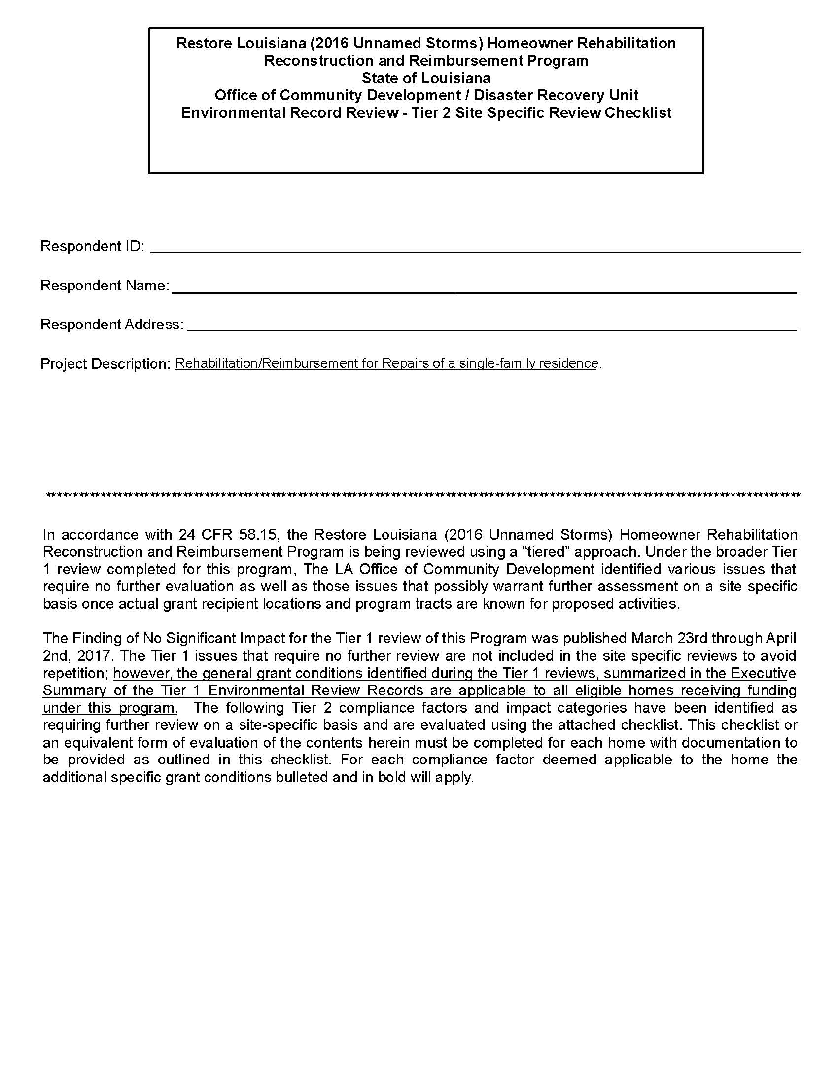

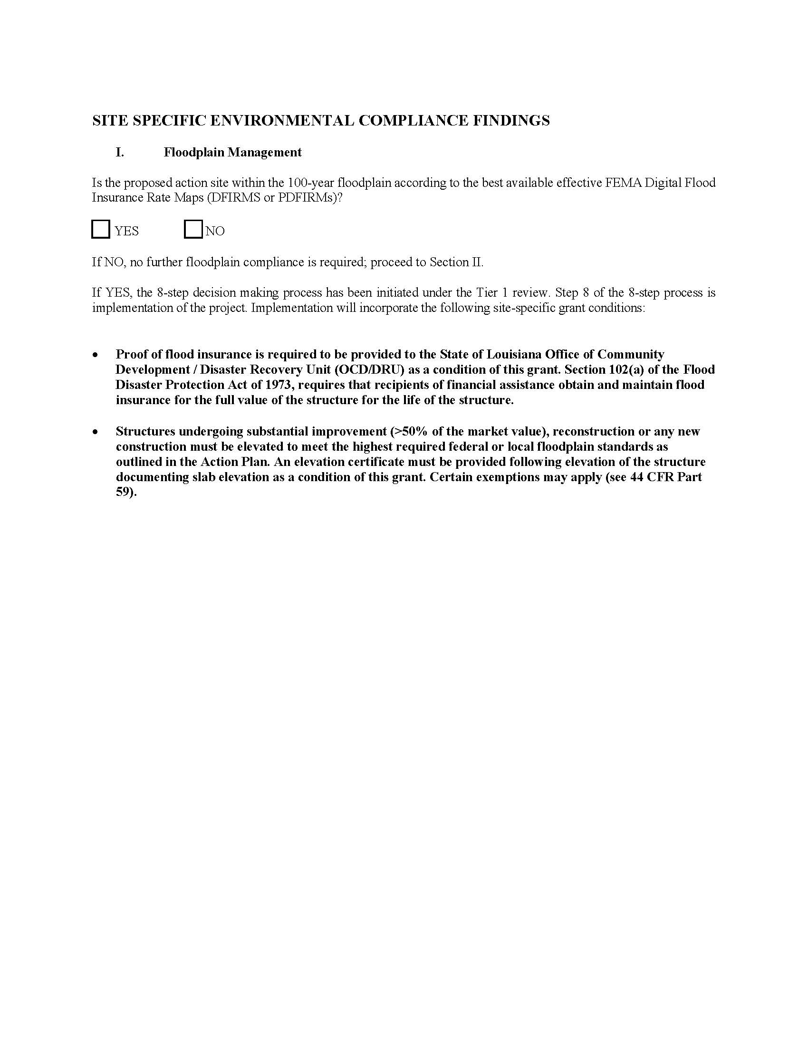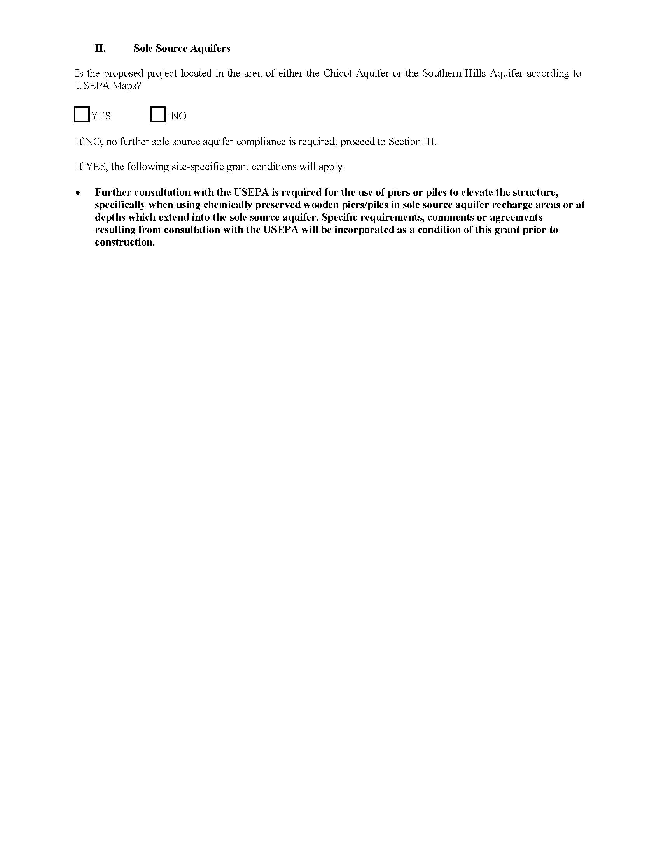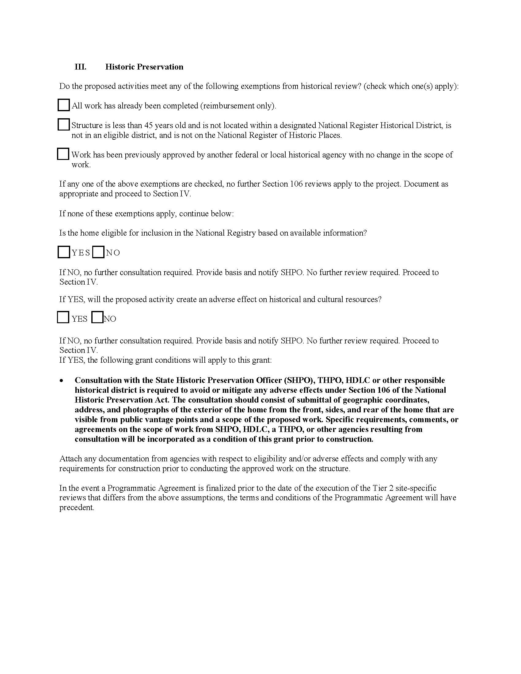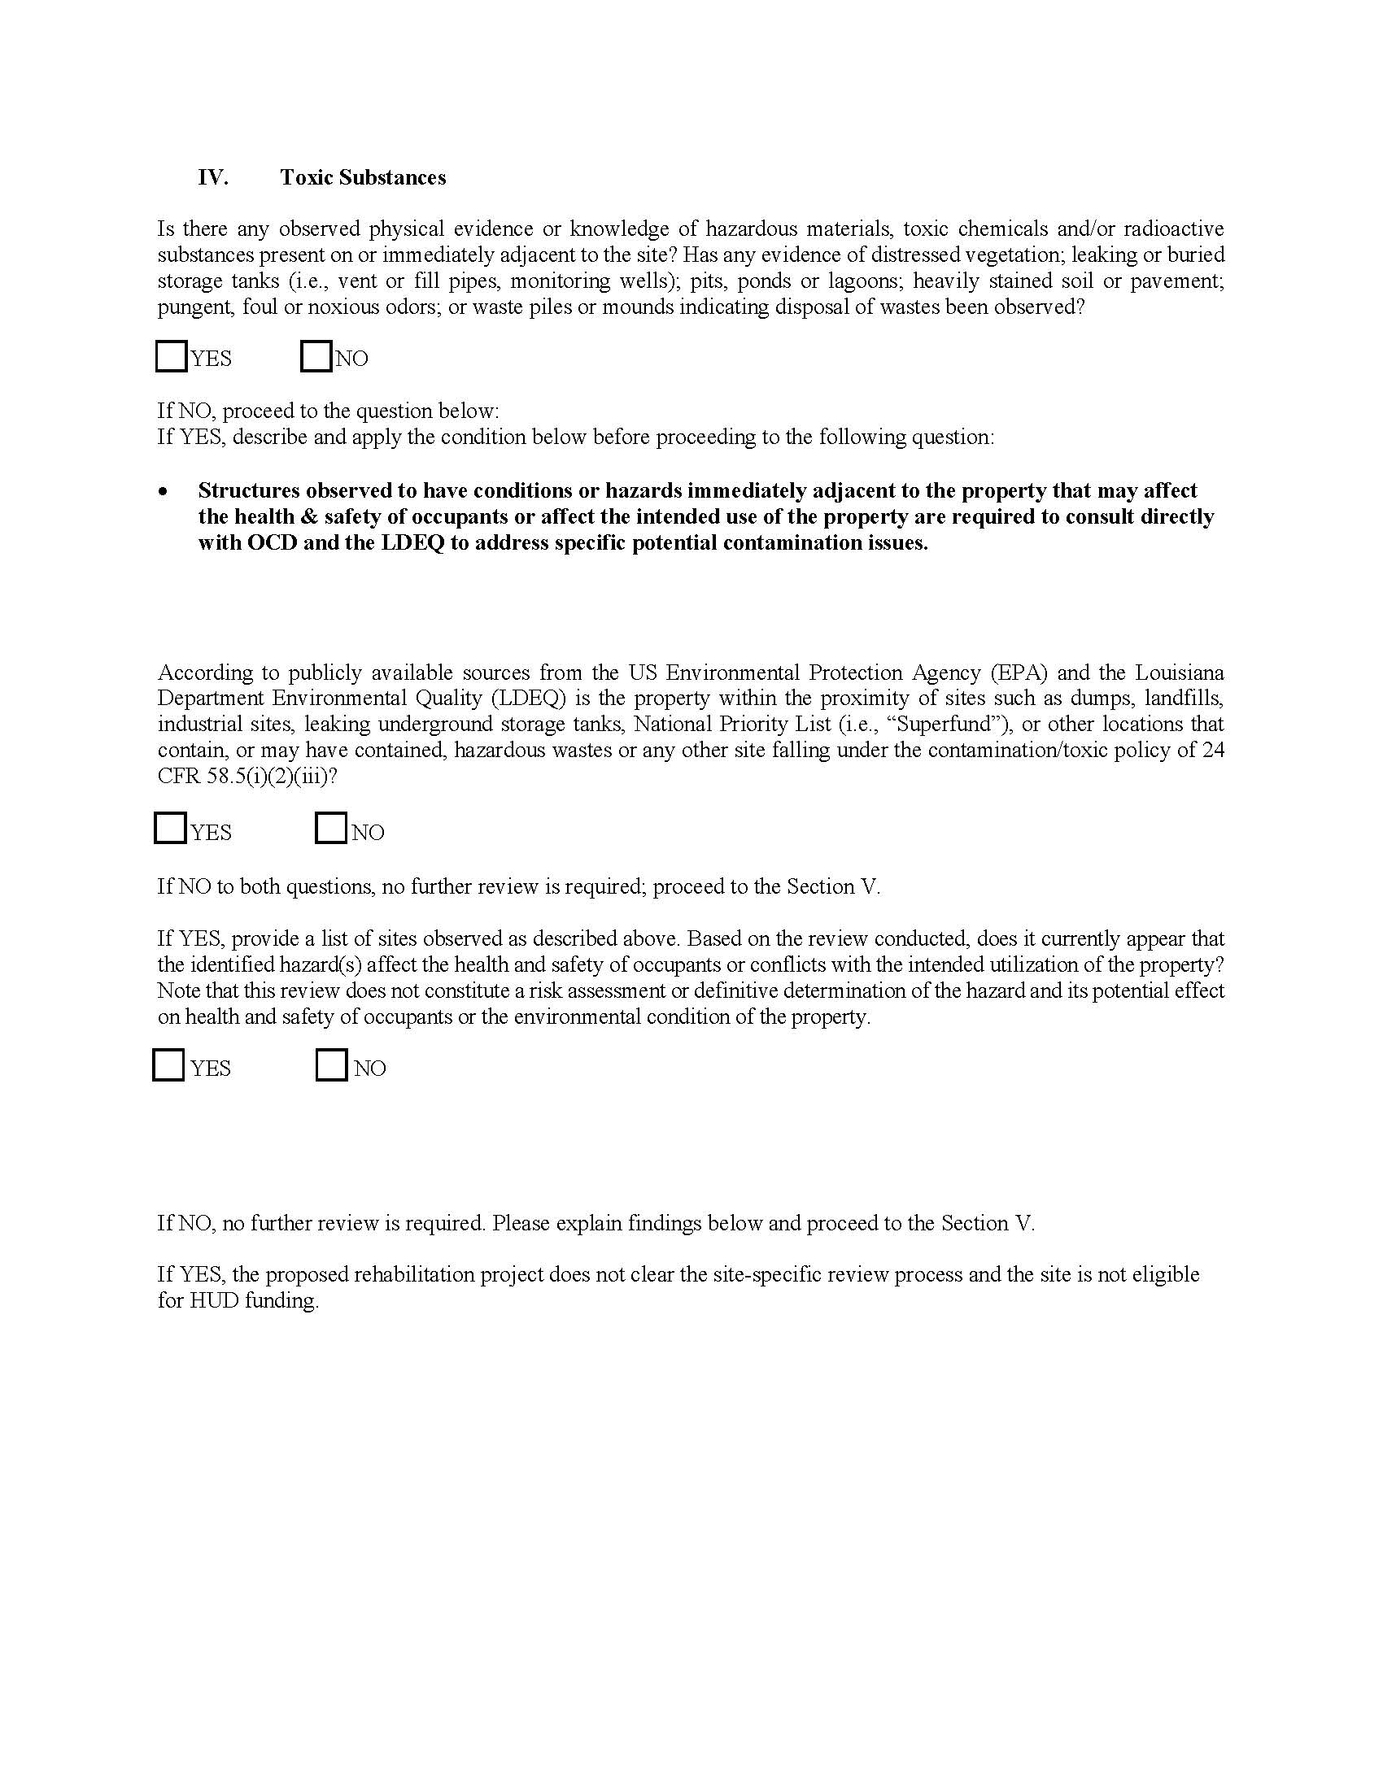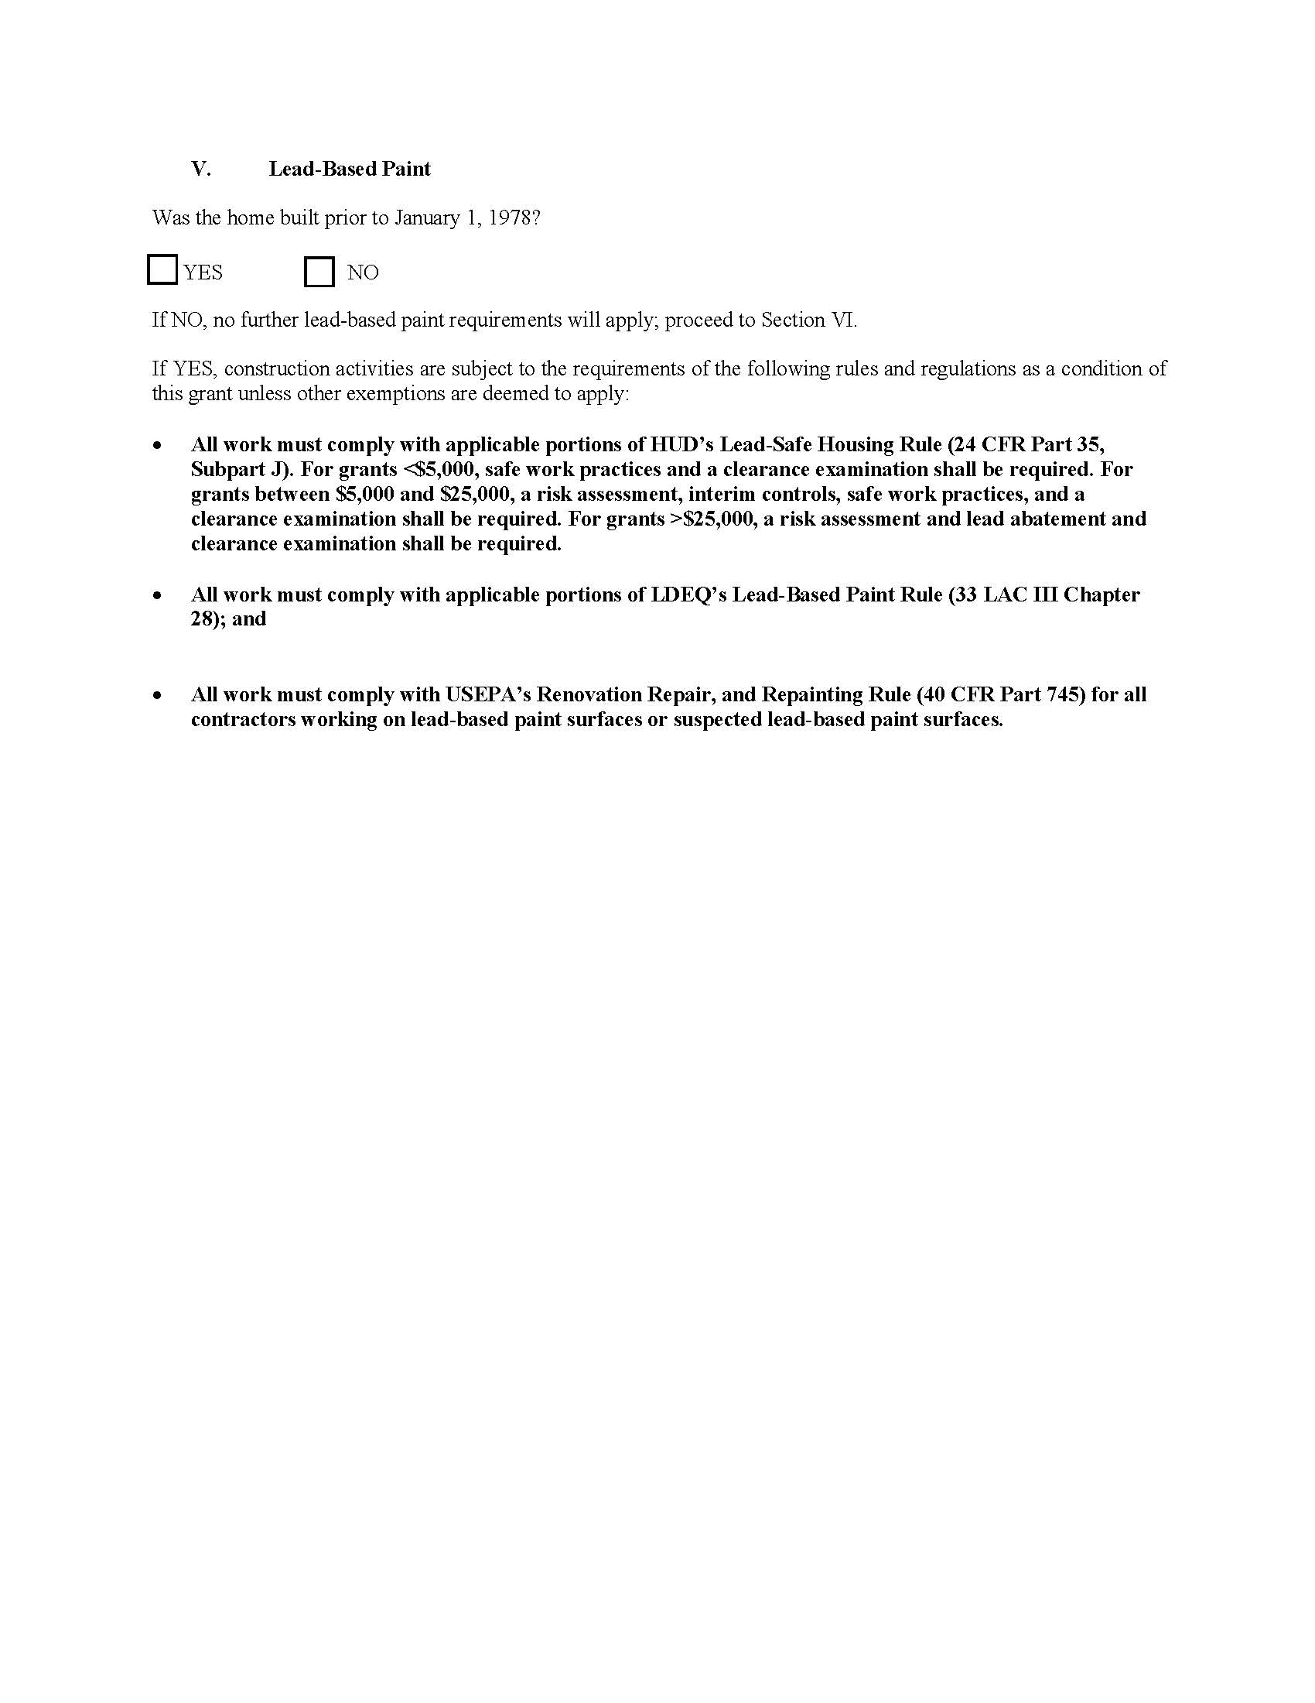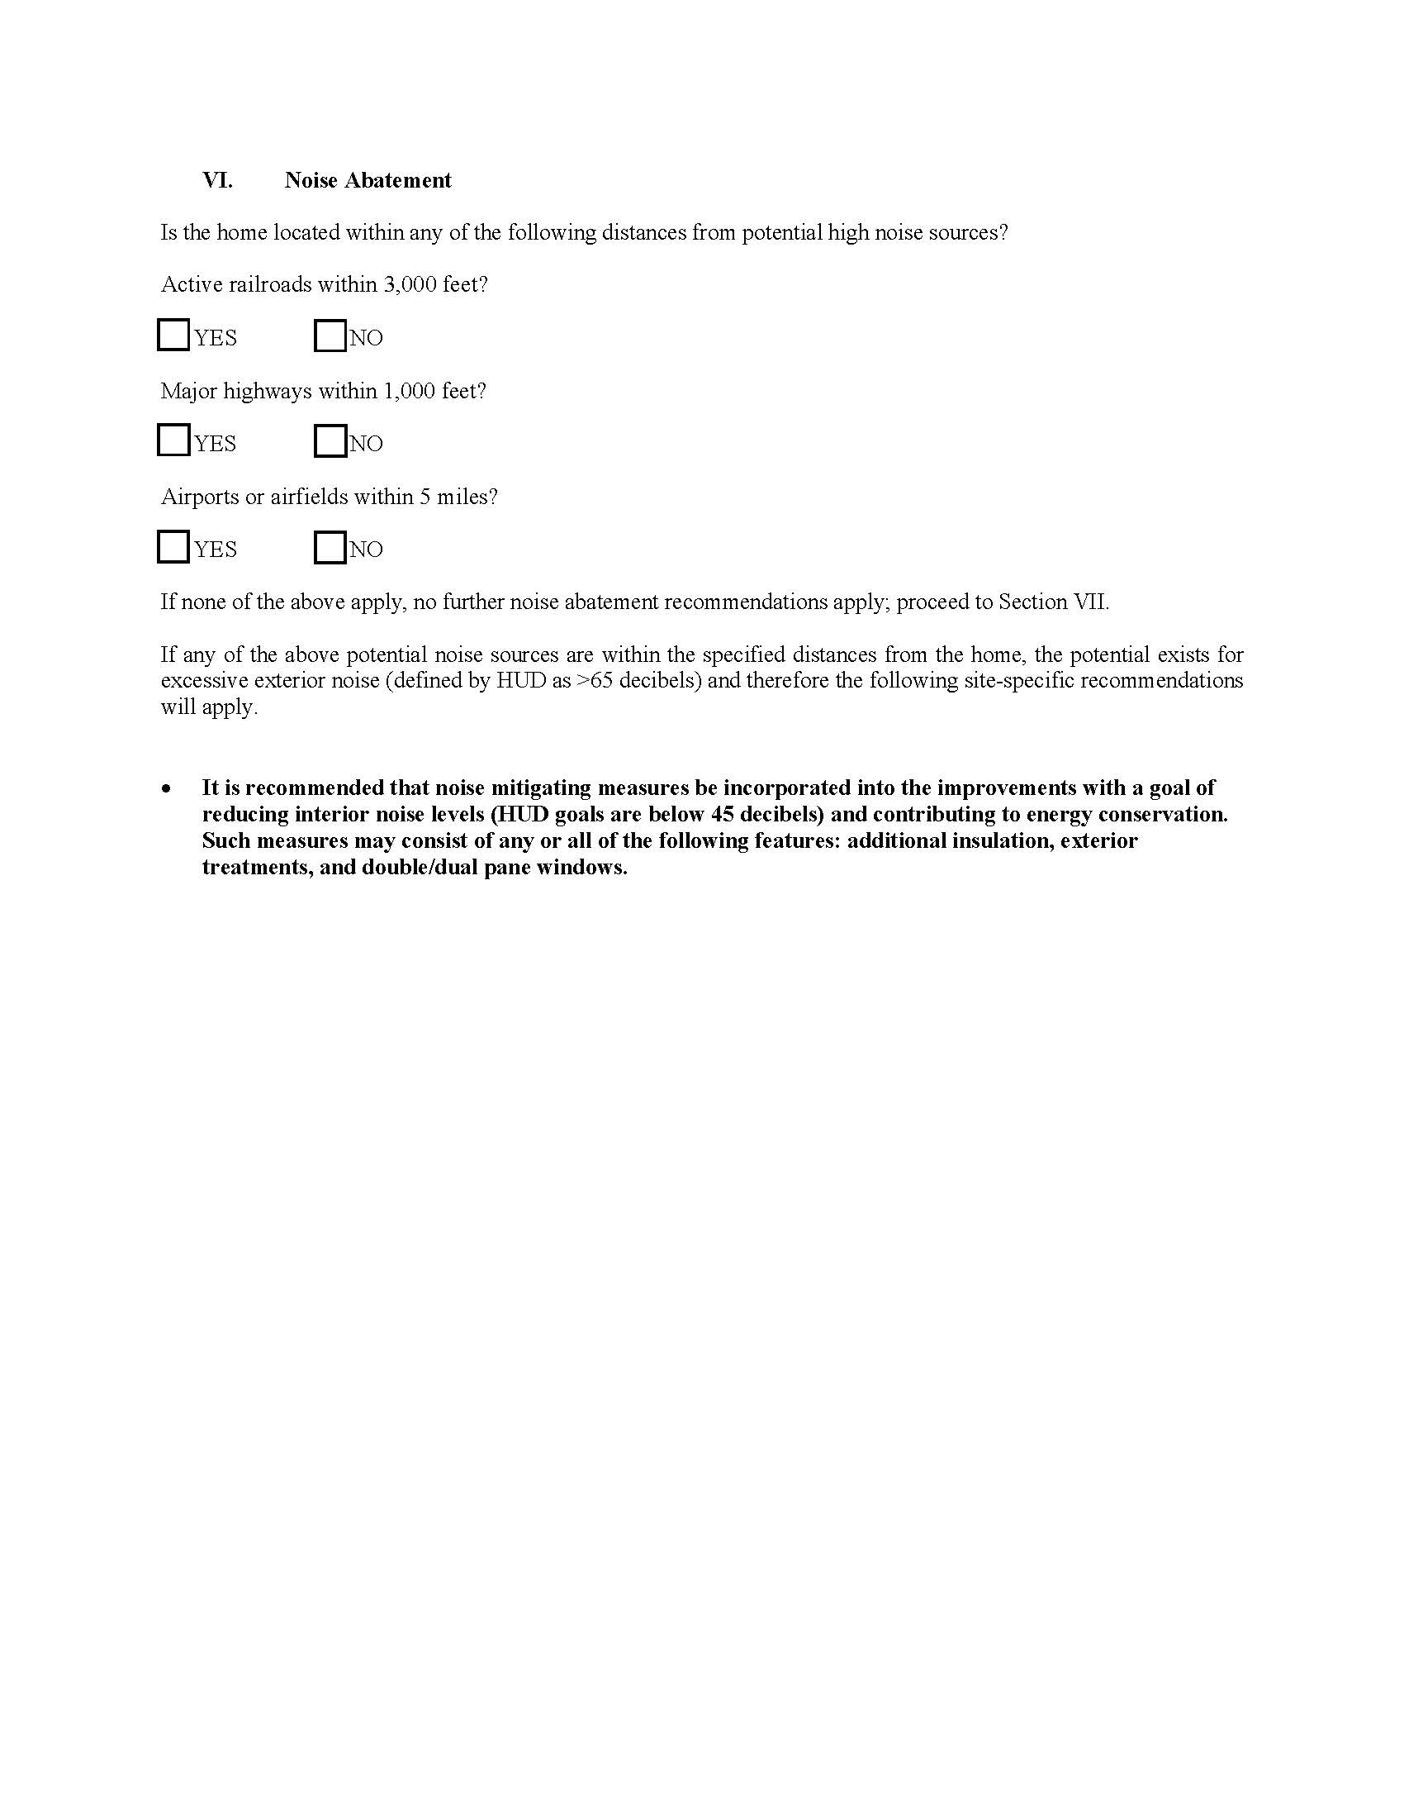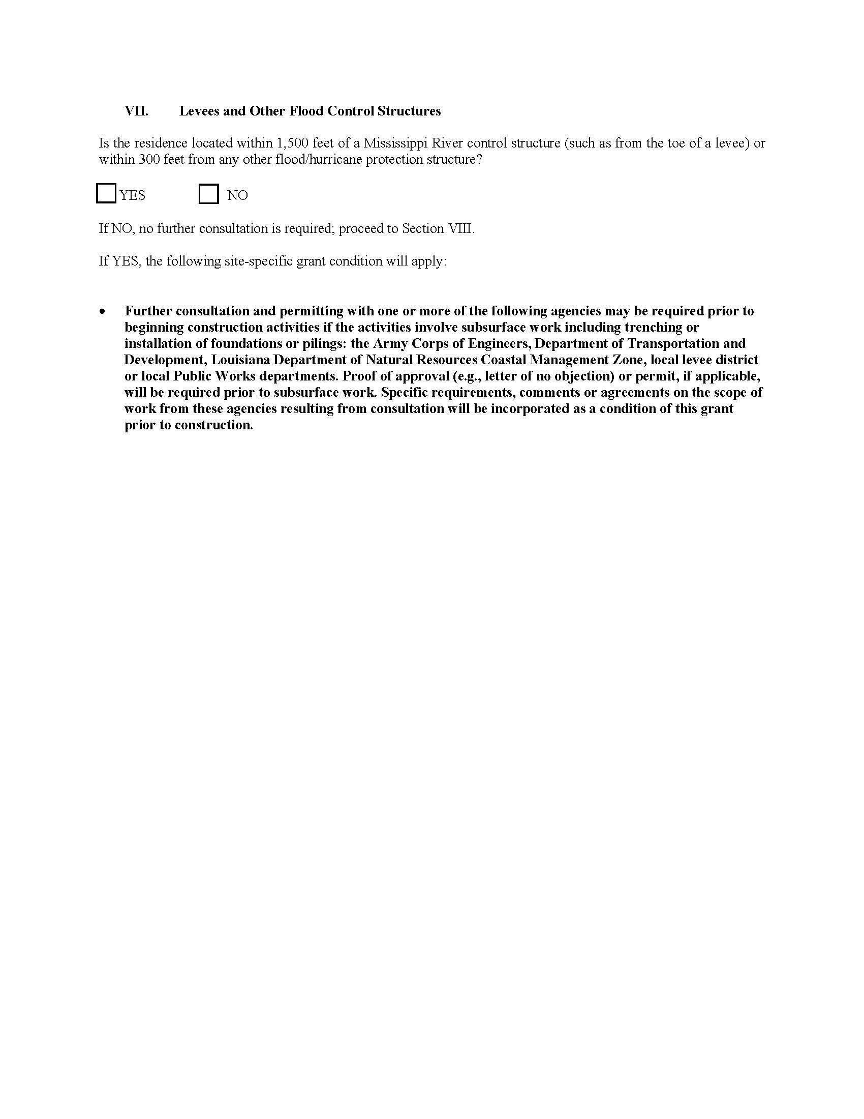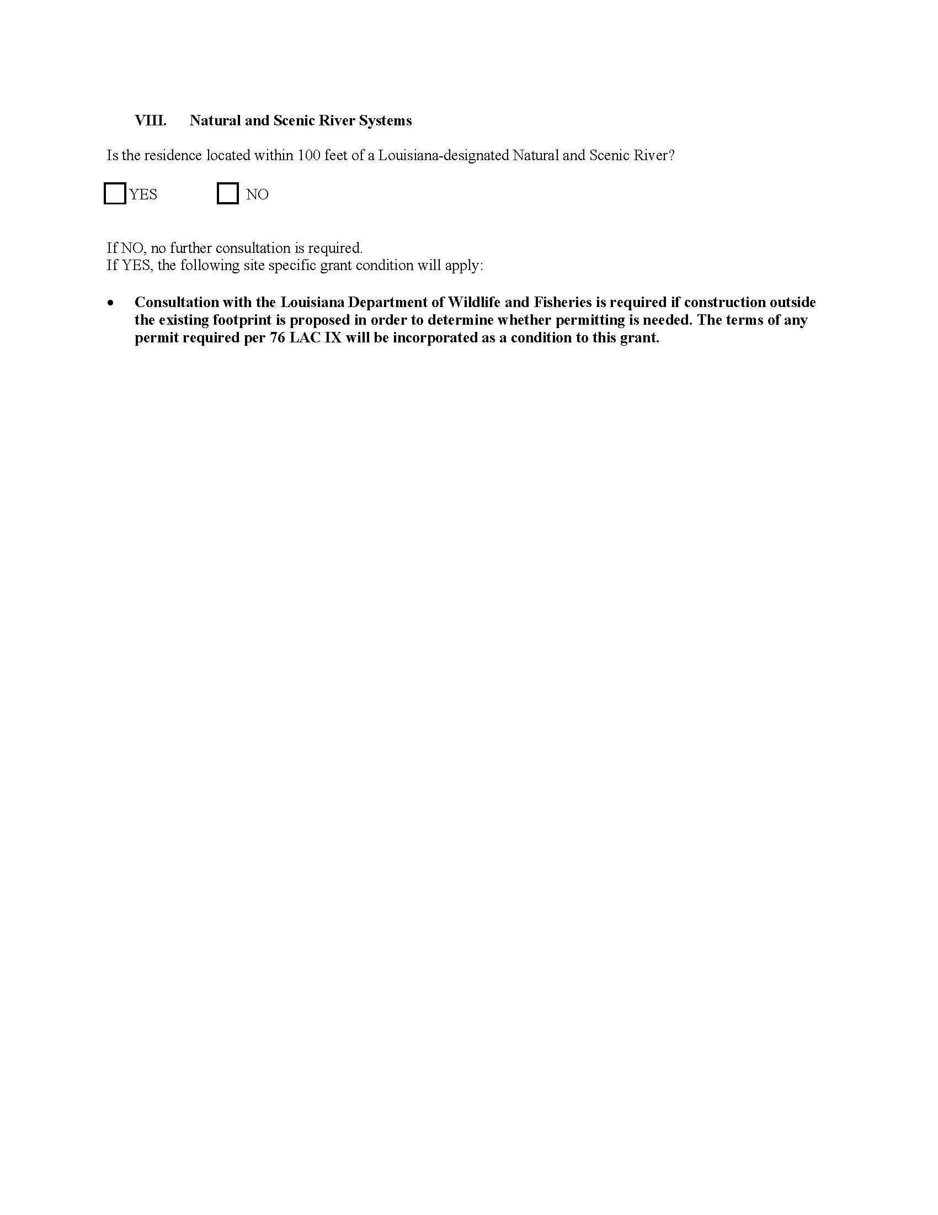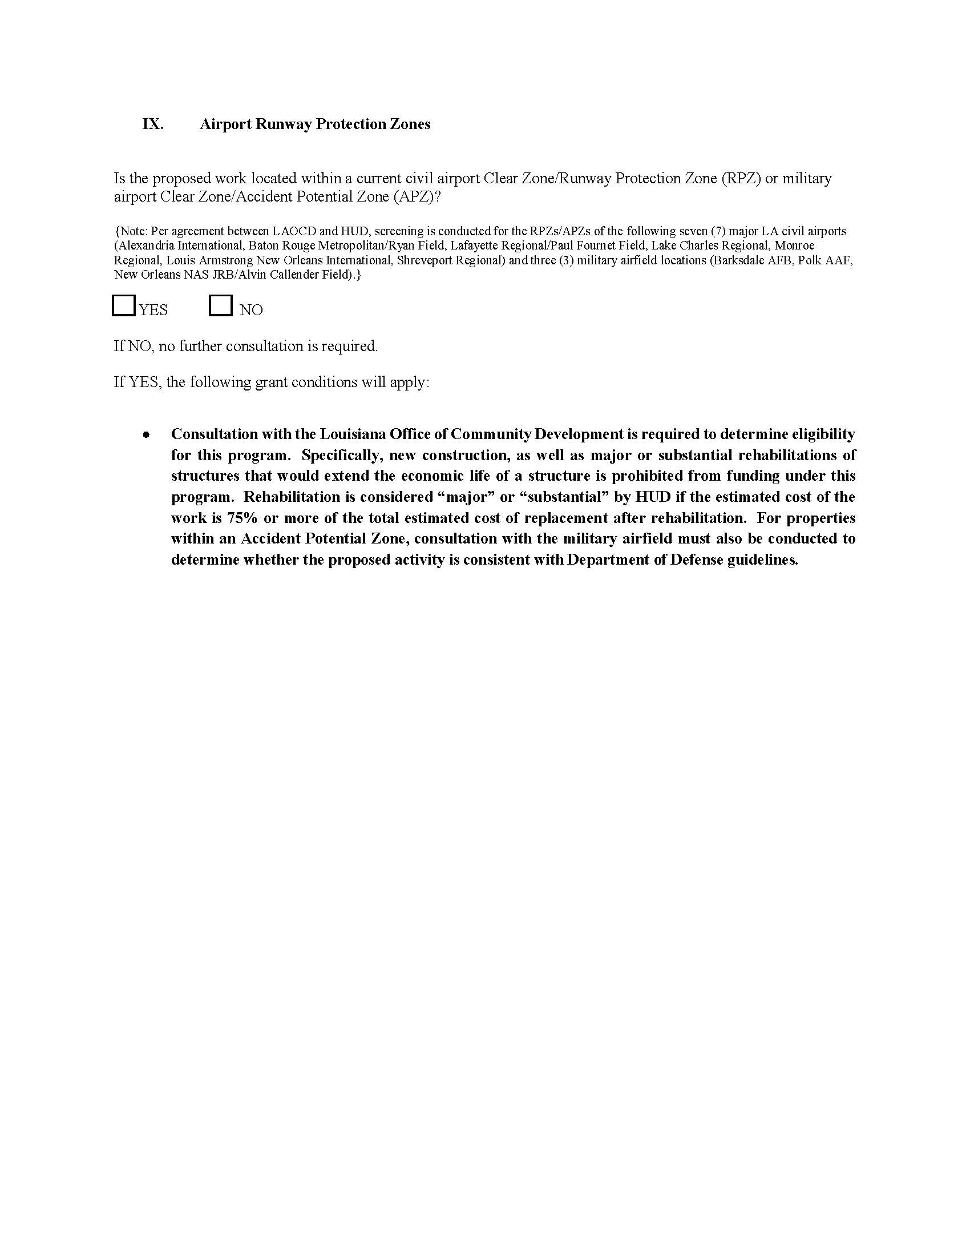

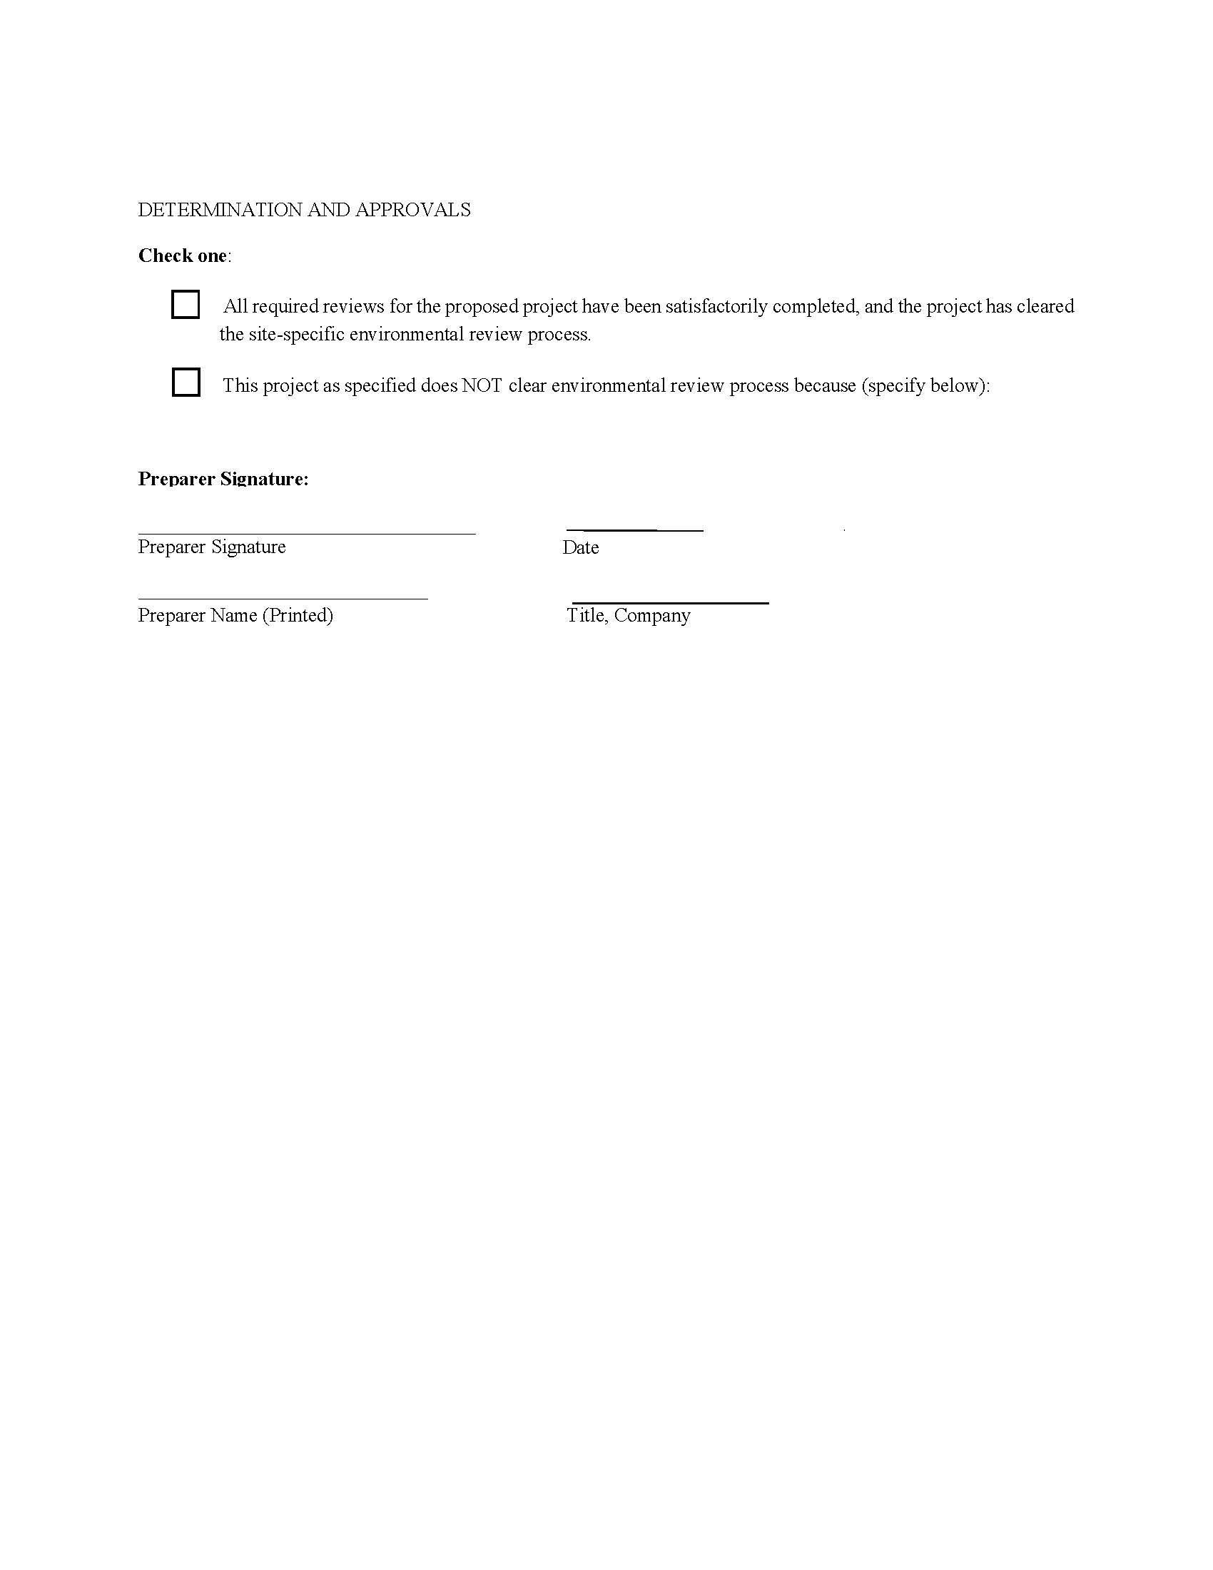

ATTACHMENT V: CATEGORICAL EXCLUSION (SUBJECT TO 58.5) REVIEW CHECKLIST

Certification of Categorical Exclusion (subject to 58.5)

Determination of activities listed at 24 CFR 58.35(a)

May be subject to provisions of Sec 58.6, as applicable

Grant Recipient: ______________________ Project Name:
Project Description (Include all actions which are either geographically or functionally related):
_____________________________________________________________________________________________________________________________________________________________________________________________________________________________________________________________________Location: ___________________________________________________
Funding Source: CDBG HOME ESG HOPWA EDI Capital Fund Operating Subsidy Hope VI Other
Funding Amount: Grant Number:

I hereby certify that the abovementioned project has been reviewed and determined to be a Categorically Excluded activity (subject to 58.5) per 24 CFR 58.35(a) as follows:

1. Acquisition, repair, improvement, reconstruction, or rehabilitation of public facilities and improvements (other than buildings) when the facilities and improvements are in place and will be retained in the same use without change in size or capacity of more than 20 percent (e.g., replacement of water or sewer lines, reconstruction of curbs and sidewalks, repaving of streets);
2. Special projects directed to the removal of material and architectural barriers that restrict the mobility of and accessibility to elderly and handicapped persons;
3. Rehabilitation of buildings and improvements when the following conditions are met:
i. In the case of a building for residential use (with one to four units), the density is not increased beyond four units, the land use is not changed, and the footprint of the building is not increased in a floodplain or in a wetland;
ii. In the case of multifamily residential buildings: (A) Unit density is not changed more than 20 percent; (B) The project does not involve changes in land use from residential to non-residential; and (C) The estimated cost of rehabilitation is less than 75 percent of the total estimated cost of replacement after rehabilitation.
iii. In the case of non-residential structures, including commercial, industrial, and public buildings: (A) The facilities and improvements are in place and will not be changed in size or capacity by more than 20 percent; and (B) The activity does not involve a change in land use, such as from non-residential to residential, commercial to industrial, or from one industrial use to another.
4. (i) An individual action on up to four dwelling units where there is a maximum of four units on any one site. The units can be four one-unit buildings or one four-unit building or any combination in between; or
(ii) An individual action on a project of five or more housing units developed on scattered sites when the sites are more than 2,000 feet apart and there are not more than four housing units on any one site.
(iii) Paragraphs (a)(4)(i) and (ii) of this section do not apply to rehabilitation of a building for residential use (with one to four units) (see paragraph (a)(3)(i) of this section).
5. Acquisition (including leasing) or disposition of, or equity loans on an existing structure, or acquisition (including leasing) of vacant land provided that the structure or land acquired, financed, or disposed of will be retained for the same use.
6. Combinations of the above activities.

The responsible entity must also complete and attach a Statutory Checklist. By signing below the Responsible Entity certifies in writing that each activity or project is Categorically Excluded (subject to 58.5) and meets the conditions specified for such exemption under section 24 CFR 58.35(a). Please keep a copy of this determination in your project files.

____________ ___________________
Responsible Entity Certifying Official Name Title (please print)

Responsible Entity Certifying Official Signature Date

Compliance Documentation Checklist
24 CFR 58.6

Grant Recipient: _________________ Project Name: _________________________________
Project Description (Include all actions which are either geographically or functionally related):
________________________________________________________________________________________________________________________________________________________________________________________________________________________________________________________________________________________________________________________________________________________
Level of Environmental Review Determination: ________________________________
Select One: (1) Exempt per 24 CFR 58.34, or (2) Categorically Excluded not subject to statutes per § 58.35(b), or (3) Categorically Excluded subject to statutes per § 58.35(a), or (4) Environmental Assessment per § 58.36, or (5) EIS per 40 CFR 1500

STATUTES and REGULATIONS listed at 24 CFR 58.6

FLOOD DISASTER PROTECTION ACT
1. Does the project involve acquisition, construction or rehabilitation of structures located in a FEMA-identified Special Flood Hazard?
No; Cite Source Document: ______________________________
Yes; Source Document:

2. Is the community participating in the National Insurance Program (or has less than one year passed since FEMA notification of Special Flood Hazards)?
Yes (Flood Insurance under the National Flood Insurance Program must be obtained and maintained for the economic life of the project, in the amount of the total project cost. A copy of the flood insurance policy declaration must be kept on file). (Appendix I)
No (Federal assistance may not be used in the Special Flood Hazards Area).

COASTAL BARRIERS RESOURCES ACT
1. Is the project located in a coastal barrier resource area?
No; Cite Source Documentation: _______________________
(This element is completed).
Yes - Federal assistance may not be used in such an area.

AIRPORT RUNWAY CLEAR ZONES AND CLEAR ZONES DISCLOSURES
1. Does the project involve the sale or acquisition of existing property within a Civil Airport's Runway Clear Zone or a Military Installation's Clear Zone?
No; Source Documentation:
Project complies with 24 CFR 51.303(a)(3).

Yes; Disclosure statement must be provided to buyer and a copy of the signed disclosure must be maintained in this Environmental Review Record (Appendix II)

Prepared by (name and title, please print):
Signature:
Date:

24 CFR 58.6 - ERR Document 12/05 HUD Region VI

